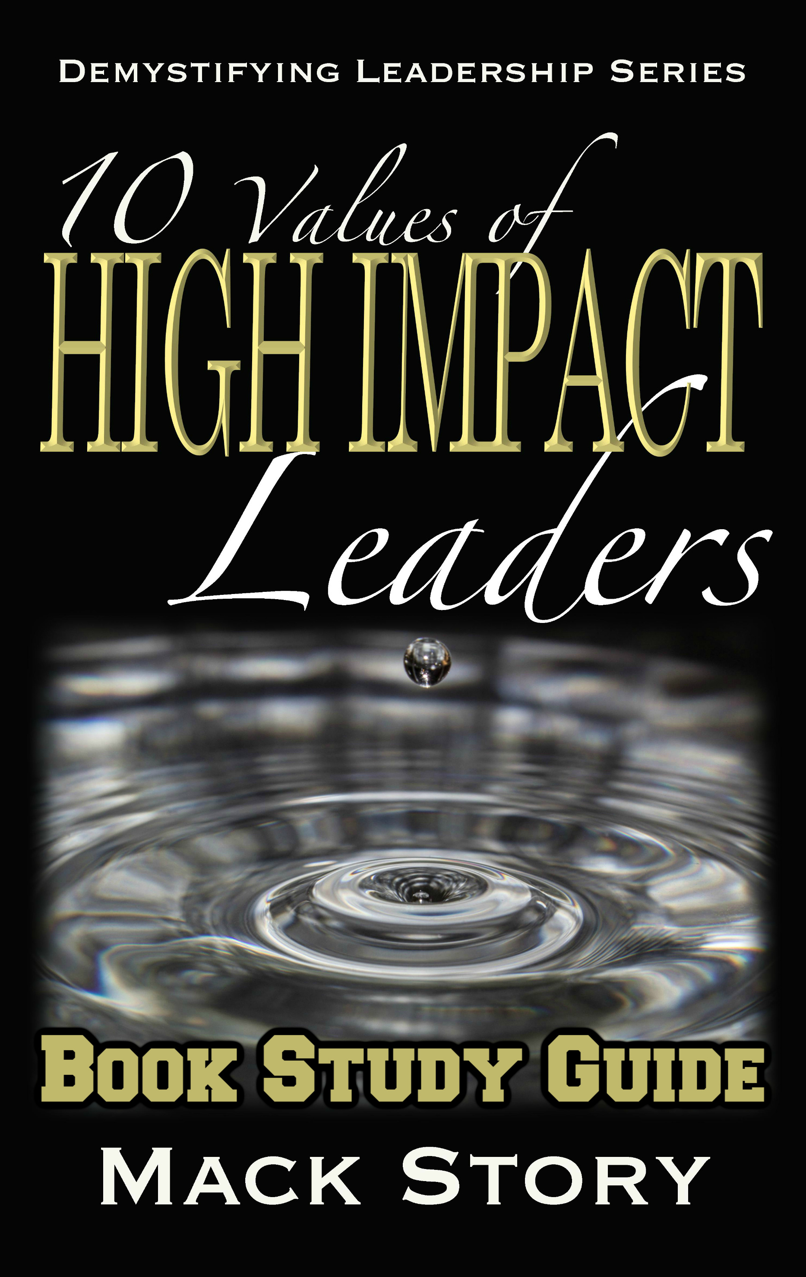
10 Values of High Impact Leaders
By Mack Story

“Ultimately, when you choose your values, you are also choosing who you will attract and who you will repel. You attract those who share your values and repel those who don’t.”
~ Mack Story

Introduction: When You Increase Your Influence, You Increase Your Options

- Our values are the foundation upon which we build our character.
  - Character is developed daily, not in a day. Explain.
  - What do you consider to be the most important value?
  - What are your top three values?
  - Why we do what we do is about our purpose. Explain.
  - How we do what we do is about our performance. Explain.
  - What we do is about our potential. Explain
“Before you can lead others, you have to believe that you can have a positive impact on others. You have to believe that your values are worthy and that what you do matters. You have to believe that your words can inspire and your actions can move others. Moreover, you have to be able to convince others that the same is true for them.” ~ Kouzes & Posner

Ch. 1…The Value of Vision: Vision Is The Foundation of Hope

“Vision of a better future provides hope in the current moment.” ~ Mack Story

- Vision is about keeping people in the know, not in the dark.
  - How does personal growth as a leader impact your vision? Explain.
  - How does personal growth as a leader help you provide vision to others? Explain.
  - Why does vision provide hope? Explain.
  - Share about a time when someone lifted you up by sharing their vision about your future. Why did it lift you up?
  - Which one of the 10 Foundational Elements of Transformation provoked the most thought when you read it? Why?
  - When you intentionally change your thoughts, your thoughts will automatically change your life. Explain how this applies to leadership.
“High impact, secure leaders want their teams to understand because they know the impact it will have on morale, buy-in, trust, and productivity. They also know that if their team understands the purpose, the vision, and the mission, they can help ensure success, help avoid and identify obstacles, and hold each other accountable.” ~ Mack Story

Ch. 2…The Value of Modeling: Someone Is Always Watching You

“Leaders are always teaching what they’re modeling, regardless of what they're teaching.”
~ Mack Story

- Those who are the best at leading themselves well will also be the best at modeling and teaching others to do the same.
  - John C. Maxwell stated, “What we say accounts for only 7% of what is believed. The way we say it accounts for 38%. But, what others see accounts for 55%.” Discuss how this principle applies when making an apology.
  - How do you feel about leaders who don’t live what they teach? How does it impact their influence?
  - Do two-faced leaders build trust or create distrust? Explain.
  - Discuss examples of leaders saying one thing and doing another.
  - Leaders can hide what they think, but they can’t hide who they are. Explain.
  - Can what a leader does away from work impact their influence at work? Explain.
“There is but one way to train up a child in the way he should go,
and that is to travel it yourself.” ~ Abraham Lincoln

Ch. 3…The Value of Responsibility: When You Take Responsibility, You Take Control

“Delegate authority but maintain responsibility...
If you contrast this to corporate America, you’ll find that most bosses do just the opposite: They delegate responsibility but maintain authority.” ~ Jon S. Rennie

- Until a leader chooses to be responsible, they’re being responsible.
  - As a leader, which team member would you value most? A team member who has a habit of asking for responsibility or a team member who has a habit of asking for a raise? Explain.
  - In the example above, which team member would you be more likely to promote? If there was a downturn in the economy, which team member would you be more likely to let go? Explain your answer.
  - How can asking for more responsibility make you a more valuable leader in the short-term? In the long-term?
  - How can asking for more responsibility lead to more opportunities in the future?
  - When you ask for more responsibility, you will be positioned to gain more experience. How will having more experience impact you? Professionally? Personally?
  - When a leader refuses to take responsibility, what does it reveal about their character?
“I am responsible for taking action, asking questions, getting answers, and making decisions. I won’t wait for someone to tell me. If I need to know, I’m responsible for asking. I have no right to be offended that I didn’t ‘get this sooner.’ If I’m doing something others should know about, I’m responsible for telling them.” ~ Garry Ridge, CEO WD-40

Ch. 4…The Value of Timing: It Matters When You Do What You Do

“Good leaders make the right move at the right time for the right reason.” ~ John C. Maxwell

- Timing dramatically maximizes or dramatically minimizes your influence.
  - Why is timing so important? Explain.
  - What happens when you do the wrong thing at the wrong time? Explain.
  - What happens when you do the right thing at the wrong time? Explain.
  - What happens when you do the wrong thing at the right time? Explain.
  - What happens when you do the right thing at the right time? Explain.
  - How does awareness impact timing? Explain and provide examples.
“Timing is critical to the presentation of ideas — positive ones and especially negative ones.” ~ Jimmy Collins

Ch. 5…The Value of Respect: To Be Respected, We Must Be Respectful

“A leader- constituent relationship characterized by fear and distrust will never produce anything of lasting value. A relationship characterized by mutual respect and confidence will overcome the greatest adversities and leave a legacy of significance.” ~ Kouzes & Posner

- There’s a big difference between respecting the leader and respecting the leader’s position.
  - What does it mean to respect the leader’s position but not the leader?
  - What are some of the ways leaders lose respect?
  - What are some of the ways leaders gain respect?
  - Respect must be earned. A leader who demands respect seldom gets it. Explain.
  - Describe the behavior of a leader you have respected.
  - Does respect automatically come with a title? Explain.
“We must build relationships with those who follow us in order to maintain the professional respect that both the leader and follower deserve.” ~ Mitchell Boling

Ch. 6…The Value of Empowerment: Leaders Gain Influence By Giving It To Others

“The empowerment leadership model shifts away from ‘position power’ to ‘people power’ where all people are given leadership roles so they can contribute to their fullest capacity.” ~ Lynne Joy McFarland

- High impact leaders empower others. Low impact leaders disengage others.
  - How does a leader empower others?
  - How should a leader prepare others before empowering them?
  - How can delegation be used to empower others?
  - What values must a leader embrace before they will be able to successfully empower others?
  - What did Malcolm Gladwell mean when he stated, “Leadership is not reserved for leaders.”
  - Describe the difference between micromanagement and empowerment.
“Empowerment means you have the freedom to act.
It also means you are accountable for the results.” ~ Ken Blanchard

Ch. 7…The Value of Delegation: We Should Lead With Questions Instead Of Directions

“Easing people into delegation is important. You can't simply dump tasks on people, not if you want them to succeed. Delegate according to the following steps:

1. Ask them to be fact finders only. It gives them a chance to become acquainted with the issues and objectives.
2. Ask them to make suggestions. This gets them thinking and it gives you a chance to become acquainted with their thought processes.
3. Ask them to implement one of their recommendations, but only after you give your approval. Set them up for success, not failure.
4. Ask them to take action on their own, but to report the results immediately. This will give them confidence, and you will still be able to perform damage control if necessary.
5. Give complete authority. This is the final step-what you've been working toward.”
~ John C. Maxwell

- High impact leaders avoid delegating methods and prefer to delegate results.
  - What’s the difference between delegating methods and delegating results?
  - What would cause a leader to fail at delegation? What would be the root cause? Explain.
  - How can the 5 Levels of High Impact Delegation be used to develop the people? The leader?
  - Why would a leader choose to delegate only at levels 1 & 2? Why does delegating at these levels lead to more stress and frustration? For the leader? For the people?
  - Why should a leader always delegate at level 3 or higher? Explain.
  - If the leader doesn’t delegate to the people because he/she doesn’t trust them, how can the leader correct the issue? Explain.
“While delegation is intellectual, entrusting is visceral—it’s something you feel. When people don’t learn to extend trust, they don’t become “leaders” in the full sense of the word
—either at work or at home.” ~ Stephen M. R. Covey

Ch. 8…The Value of Multiplication: None Of Us Is As Influential As All Of Us

“Organizations with the highest quality leaders were 13 times more likely to outperform their competition in key bottom-line metrics such as financial performance, quality of products and services, employee engagement, and customer satisfaction. Specifically, when leaders reported their organization’s current leadership quality as poor, only 6 percent of them were in organizations that outperformed their competition. Compare that with those who rated their organization’s leadership quality as excellent—78 percent were in organizations
that outperformed their competition in bottom-line metrics.”
~ Development Dimensions International

- When you choose to lead leaders, you’re also indirectly leading their followers.
  - What determines if a leader will be capable of leading other leaders? Explain.
  - Why do high impact leaders choose to follow when they don’t have to? What’s the benefit?
  - In your career, have you seen leaders intentionally and methodically developing other leaders? Is this common or uncommon? Why?
  - If someone in a leadership position isn’t a student of leadership, what does this tell you about that leader? Explain.
  - What are the most effective ways for leaders to develop themselves?
  - What are the most effective ways for leaders to develop their team?
“Winning companies win because they have good leaders who nurture the development of other leaders at all levels of the organization.” ~ Noel Tichy

Ch. 9…The Value of Results: Leaders Like To Make Things Happen

“Results give you instant credibility and instant trust.” ~ Stephen M. R. Covey

- There’s a big difference between getting things done and making things happen.
  - As a leader, what do you need to stop doing to improve your results? Why?
  - As a leader, what do you need to keep doing to improve your results? Why?
  - As a leader, what do you need to start doing to improve your results? Why?
  - Why does giving credit to others build trust? Improve results?
  - If a leader wants to make all the decisions, is this more likely to lead to better or worse results? Explain.
  - What are some key character traits that will lead to better results? Explain the impact of each.
“Different values always lead to different results.” ~ Mack Story

Ch. 10…The Value of Significance: Are You Going To Settle For Success?

“When you achieve significance, your influence is magnified by others
and multiplied through others.” ~ Mack Story

- Success is about getting results. Significance is about helping others get results.
  - Significance is not about you, but it starts with you. What does this mean?
  - Why do so many leaders settle for success? Explain.
  - Relative to the leaders who are living a life of significance, how do they benefit from helping others live a better life? Explain.
  - There are endless numbers of successful leaders. Provide examples of leaders who are focused on significance. What makes them different?
  - Explain the differences between a selfish leader and a selfless leader.
  - Why do successful leaders want to retire? Significant leaders have no desire to retire. Why?
“For high impact leaders, success is the starting point for significance.
For all other leaders, success is the stopping point.” ~ Mack Story

Conclusion…Momentum: High Impact Leadership Is All About Creating Momentum

“It takes a leader to create momentum. Followers catch it. And managers are able to continue it once it has begun. But creating momentum requires someone who can motivate others, not one who needs to be motivated. Just as every sailor knows you can't steer a ship that isn't moving forward, strong leaders understand that to change direction, you first have to create forward progress. Without momentum, even the simplest tasks can seem insurmountable. But with momentum on your side, nearly any kind of change is possible.” ~John C. Maxwell

- Many leaders can maintain momentum. But, few leaders can create momentum.
  - What is the foundation of momentum?
  - How does a leader create momentum when there is none?
  - How does a leader maintain momentum?
  - List and describe momentum killers?
  - What role does timing play when it comes to creating momentum?
  - How can leadership intuition create momentum?
“When you create momentum, don't rest upon it. Build upon it.” ~ Mack Story

