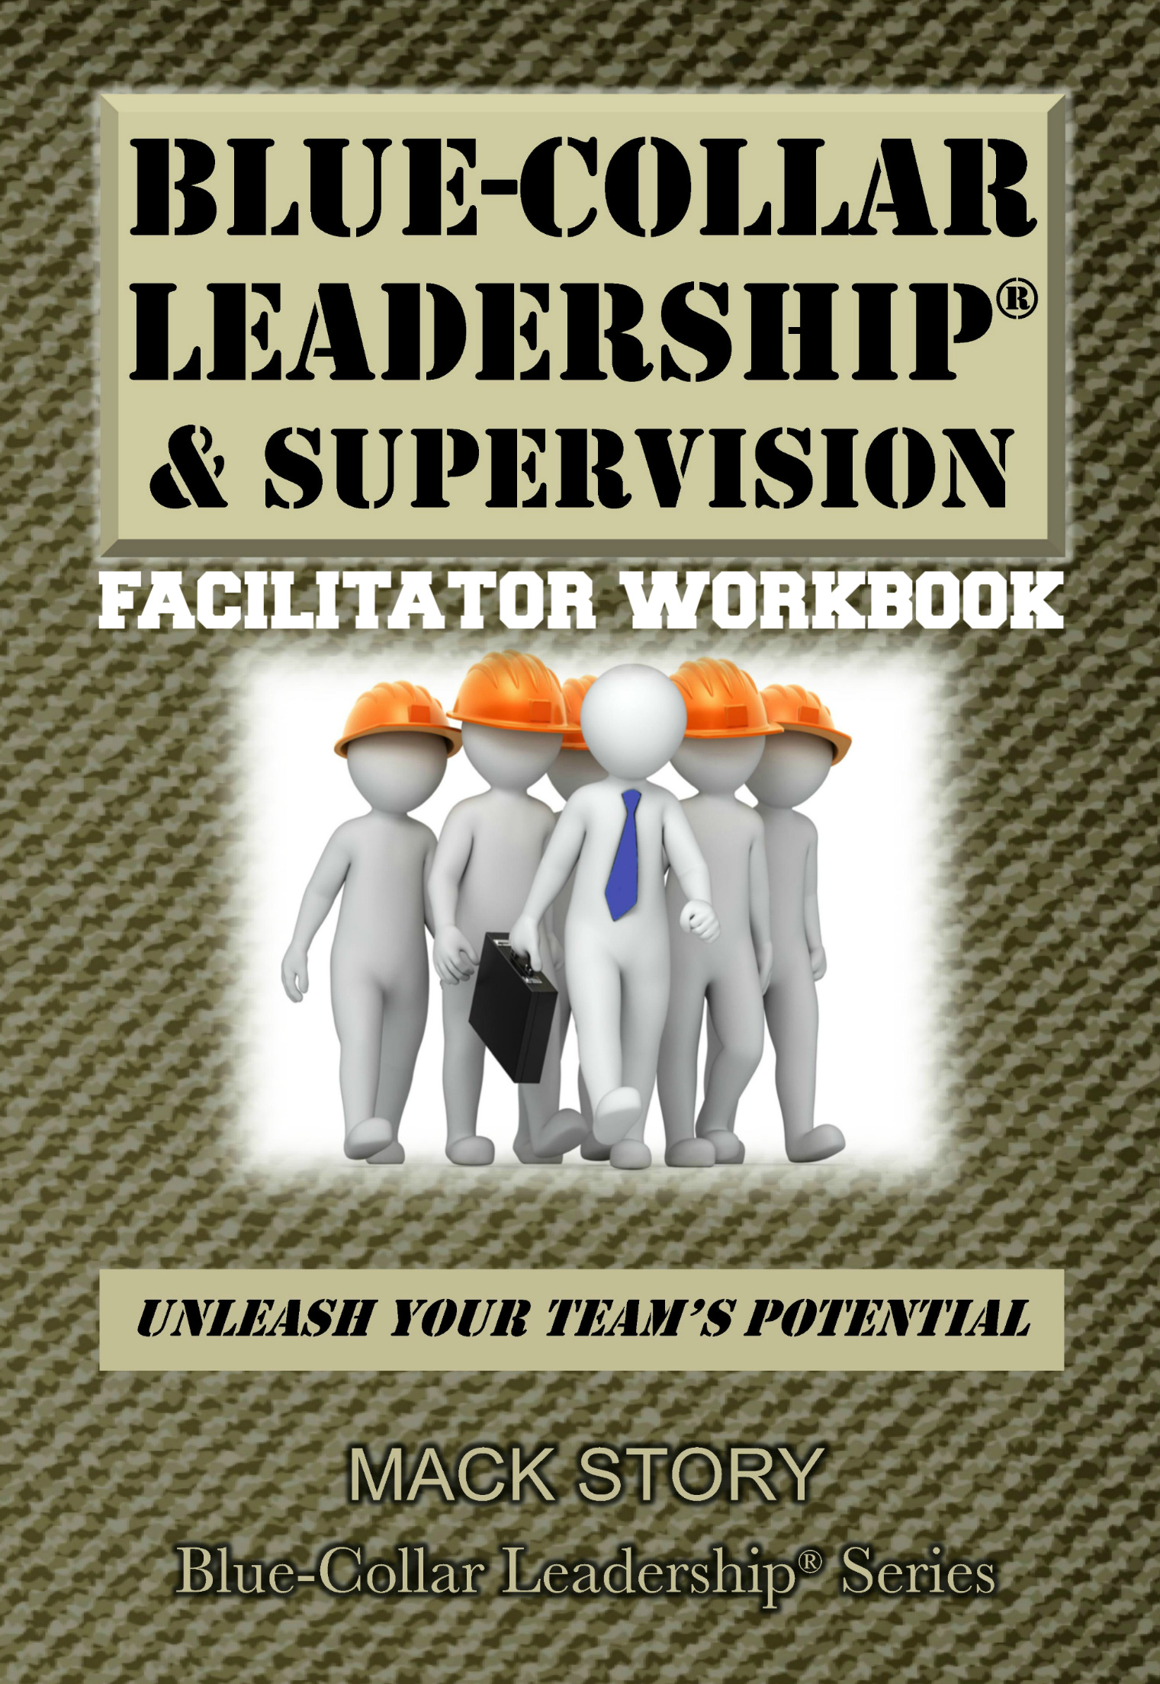

**A note from Mack**

**Dear friend,**

**As a leader (person of influence), you have a remarkable responsibility to impact the lives of those around you, personally and professionally. Remember that as you work your way through this material.**

**You and I will be partners as we explore the values of high impact blue-collar leaders with others. We can’t raise the bar for others if we can’t reach it ourselves. As you study and teach, I already know you will reach new levels of knowledge, growth, and understanding. I’m also confident that you will motivate and inspire others to also reach higher as they climb to the next level and beyond.**

**The values (principles) contained in *Blue-Collar Leadership® & Supervision* are timeless and have been tested and proven again and again by high impact leaders across multiple generations around the world. I encourage you to read, study, and familiarize yourself with the ideas in this book in order to prepare to lead others effectively through this information. The key to facilitating this content is to teach the principles. Then, support them with practices (stories) from your own life. As you teach it, make it your own.**

**Ultimately, your ability to effectively teach these principles will be based on your ability to first effectively apply them in your own life. We’re always teaching what we’re modeling, regardless of what we’re teaching.**

**I have devoted my life to helping people make a high impact by making what is common sense also common practice. It is my hope that you will have as much fun as I do while you lead people to a greater understanding of the values that will unleash their leadership potential. High impact leaders always have high impact values.**

**Make it happen!**

**Your friend,**

**Mack Story**

**Mack Story**



***Blue-Collar Leadership®***

***& Supervision***

*Unleash Your Team’s Potential*

by Mack Story

*“Two of the greatest lessons I learned from those in a leadership position:*

*1) The most respected leaders always* ***respect*** *others.*

*2) The most effective leaders walk through the door to* ***serve*** *their**team, not to be served by their team.” ~ Mack Story*

1. **In the Beginning:** The **challenge** of not knowing what you don’t know.

*“Principle-centered people are constantly educated by their experiences. They read, they seek training, they take classes, they listen to others, they learn through both their ears and eyes...they discover that the more they know, the more they realize they don’t know.”*

*~ Stephen R. Covey*

* 1. Circle of **Knowledge** – what we actually know
  2. Perimeter of **Awareness** – the outer edge of our circle of knowledge where we have an awareness about what we don’t know
  3. Area of **Ignorance** – everything beyond our perimeter of awareness
  4. When your circle of knowledge expands, your perimeter of awareness **automatically** expands. As it does, you become aware of some things previously in your area of ignorance.

*“If you have already been trying hard, maybe trying harder is not the way.*

*Try different.” ~ Henry Cloud*

1. **Demystifying Leadership:** Moving **beyond** management & supervision.

*“Leadership is about taking responsibility for lives not numbers.*

*Managers look after our numbers and our results, and leaders look after us.” ~ Simon Sinek*

* 1. The reality is most people are **managed**, and **few** people are led.
  2. How does your boss treat you? Like a person or an object? Does it matter? How does it make you feel? Does it impact your **performance**?
  3. What is your team’s **reality**? How do you treat them? Like a person or an object? Would some say a person? Would some say an object? Does it matter?
  4. Every high impact leader’s journey begins in the **mirror**.
  5. You must do a lot of work on the **inside** if you want to be highly effective on the **outside**.
  6. We **must** manage things and processes because they don’t think or feel. But, we **should** lead people because they do think and feel.

*You don’t work for high impact leaders. You work with them. They know it, and you know it.*

*You don’t work with managers. You work for them. They know it, and you know it.*

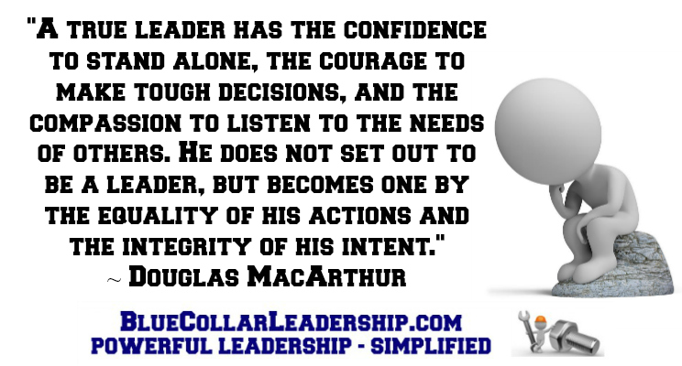

1. **Climbing the Leadership Mountain:** You’ve been given a leadership position, but will you **lead**?

*“Management is about persuading people to do things they do not want to do, while leadership is about inspiring people to do things they never thought they could.” ~ Steve Jobs*

* 1. Will you move beyond management and supervision and **choose** to lead? Will you be become bigger than your **position**?
  2. Becoming a high impact leader has **little** to do with your boss developing you and **everything** to do with you developing yourself.
  3. The leadership mountain is always there waiting to be climbed. However, you must **choose** to climb it.
  4. **Position** has a lot to do with managing things, processes, and people, but position has very little to do with **leading** people.
  5. Managing people from a position of authority is about **motivating** them to do what is expected. Motivation comes from the outside, from someone else.
  6. Leading people is about **inspiring** them to choose to do more than expected, to do it better than expected, and to do it before it’s expected. Inspiration comes from within.

*As you build trust, people become inspired by you instead of driven by you. Your influence increases far beyond what comes with your position. You still have your position, but now you’re leading with influence instead of managing with authority. This increased influence with your team translates into better results: increased engagement, retention, and productivity along with improved morale and teamwork.*

*“To* ***excel*** *in leadership, you must first master* ***followership****.” ~ Truett Cathy*

1. **Understanding Artificial Influence:** There is a difference between someone respecting your position and someone respecting you.

*“Into the hands of every individual is given a marvelous power for good or evil - the silent, unconscious, unseen influence of his life. This is simply the constant radiation of*

*what man really is, not what he pretends to be.” ~ William George Jordan*

1. In order to lead beyond your position, you must first be **respected** by those you want to influence.
2. You must respect a leader’s **position** to keep your job. But, you don’t have to respect the **leader** to keep your job.
3. A position will give you **authority** but not influence. Influence must be **earned** by first earning respect. The more you are respected the more influence you will gain.
4. Having a position or title such as Mom, Dad, Coach, Boss, Supervisor, Manager, VP, President, CEO, Owner, etc. gives you authority and control over other people. This is **artificial** **influence**. Artificial influence creates the **illusion** that you have **real** influence.

*Listen to the voices of those with artificial influence:*

* *How am I supposed to make something happen when those people don’t report to me?*
* *I can’t make them do anything. They don’t report to me and won’t do anything I tell them to do.*
* *I can’t get anything done in that department. They report to someone else, not me.*

*It’s useless to try.*

* *How can I be responsible for their results when they don’t report to me?*
* *If you want me to make it happen, you’ve got to give me the authority over those people.*
* *My hands are tied. They don’t report to me.*

*“When we look at people who disobey their leaders, the first question we ought to ask is not, ‘What’s wrong with those people?’ but rather, ‘What’s wrong with their leader?’*

*It says that responsibility begins at the top.” ~ Malcolm Gladwell*

1. **Defining Your Leadership Style:** Do others follow you because they **have** to or because they **want** to?

*“I suppose leadership at one time meant muscles;*

*but today it means getting along with people.” ~ Mahatma Gandhi*

1. You’re given a position, and you’re told what and who to **manage**. But, how you **lead** is up to you. The position does not define you. You define the position.
2. Your **values** will determine if people follow you because they have to or because they want to.
3. When it comes to climbing the leadership mountain, your leadership **style** can launch you like a rocket, or it can hold you back like an anchor.
4. Your values will **determine** your style. Who you are will determine how you lead.
5. Who you are on the **inside** is what people will experience on the **outside**.
6. Low impact leaders like to **control** their team. High impact leaders like to **empower** their team.
7. Low impact leaders **suppress** their team. High impact leaders **release** their team.

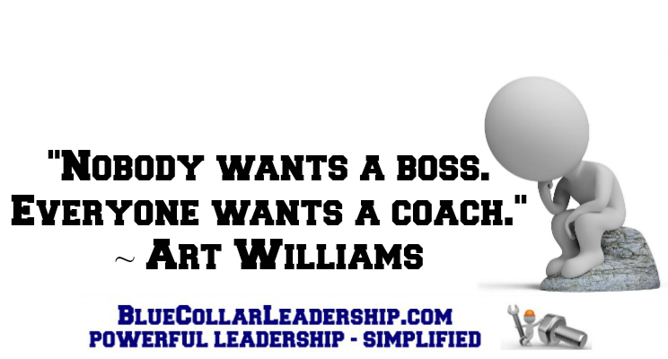

1. **High Impact Leadership:** Leadership **starts** with you, but it’s not **about** you.

*“What stands between you and your goal is your behavior.” ~ Darren Hardy*

1. You must **act**. Then, **influence** others to act.
2. You already have 100% control and influence over the hardest person you will ever lead: **yourself**.

*Do you want to get promoted? Then, you must get better. Do you want to earn a bigger salary? Then, you must get better. Do you want to have a better job? Then, you must get better. Do you want to provide a better life for your family? Then, you must get better.* *If you want to be more, do more, and have more in any area in your life, you must get better.*

1. Relative to your **character**, develop your weaknesses.

Relative to your **competency**, develop your strengths.

*I know you want to be more just like I do. In your mind, you may not truly believe you can do whatever it is you want to do. I’m not asking you to do that if you have doubts. But, can you at least agree with me that it’s possible?*

*Maybe, you want to be more effective where you are. It’s possible. Maybe, you want to steadily climb the corporate ladder. It’s possible. Maybe, you want to lead the company. It’s possible. Maybe, you want to own your own business. It’s possible.*

1. Character development is the **key** to high impact leadership.
2. **Moral** authority will always leverage your **formal** authority.

*“It is the capacity to* ***develop*** *and* ***improve*** *themselves that distinguishes leaders from followers.”*

*~ Bennis and Nanus*

1. **Mirror, Mirror on the Wall:** The best leaders are the most **secure** of all.

*“No amount of personal* ***competency*** *can compensate for personal* ***insecurity****.”*

*~ Wayne Smith*

1. When it comes to leadership, **security** equals **stability**.
2. When you’re clearing your own path forward, you will have complete peace of mind. Why? Because you are in total control.

Secure leaders **eliminate** problems. Insecure leaders **cause** problems.

To better understand secure leaders, let’s look at insecure leaders.

*1.* ***Employee Turnover*** *- There’s nothing worse than reporting to an insecure leader. They terminate the good, strong team members, or they cause good, strong team members to leave.*

*2.* ***Employee Disengagement*** *- Insecure leaders create distrust. An insecure leader is the first to take credit when things go well and the first to blame the team when things don’t go well.*

*3.* ***Lack of Communication*** *- Insecure leaders do not openly and freely share information because they want those on their team to know only what they need to know to do their job, and unfortunately, sometimes even less.*

*4.* ***Lack of Accountability*** *- Insecure leaders are quick to point the finger of blame at anyone other than themselves. The insecure leader’s tactics cause others to waste time and energy defending themselves.*

*5.* ***Lack of Teamwork*** *- Insecure leaders do not value teamwork because they think they should have all the answers. The insecure leader also doesn’t want his/her thinking to be challenged in front of others.*

*6.* ***Lack of Succession Planning*** *- Insecure leaders do not have a plan for succession. The thought of training and developing someone to take their position goes against every fiber of their being. They want to keep their team members right where they are, doing what they’re doing.*

*7.* ***Low Morale*** *- Insecure leaders create an atmosphere of low morale. The previous six problems reveal themselves as low morale. Team members come to the company hoping to be respected, to matter, to advance, and to grow. However, insecure leaders leverage their position in threatening ways to create and maintain an anxious tension among the team.*

*“Saying ‘I don’t know’ when you don’t know is a sign of good leadership. Pretending to know when you don’t is a sign of insecurity. By expressing your lack of uncertainty,*

*you give the leaders around you permission to do the same thing.*

*You send them an important message: In this organization, it is okay not to know.*

*It is not okay to pretend you know when you don’t.” ~ Andy Stanley*

1. **First Impressions Count:** Is your **intention** to serve or be served?

*“Having the tenacity to lead, and the* ***humility*** *to serve are the key ingredients*

*of Transformative Leadership.” ~ Amir Ghannad*

1. When it comes to leadership and first impressions, others want to know three things about you:
   1. Can I **trust** you?
   2. Can you **help** me?
   3. Do I **matter** to you?

By choosing to serve others, high impact leaders answer these questions with **action**.

1. Servant leaders are **strong** and **secure**, not weak and insecure.
2. Servant leadership or high impact leadership simply means your mission is to help other people **succeed**. There’s nothing weak about that.

*“I’m not a softy. I say this because I’ve heard so many whine and moan that servant leadership is a weak way to lead. They say, “You don’t understand. That stuff won’t work here. We’re different.” Often, the military veterans are the worst. What they say is, “We need more command and control. People just need to do what they’re told to do, and everything will run smoothly.”*

*What is always interesting to me is this: the same people that say “servant leadership is a weak leadership model” prefer to work with a secure, servant leader instead of for a dictating, insecure manager. It’s good enough for them, but it’s not good enough for their team.*

*They prefer it when looking up at their boss. But, they don’t want their team to see it when they look up at them. Why is that? Because becoming a high impact, servant leader takes a lot of internal work. The “it’s weak” comments are an excuse people make because they don’t want to do the character work required to transform themselves and their leadership style. Doing that work on yourself is not easy. It’s hard. But, it’s always worth it!” ~ Mack Story*

*“Without a doubt, one of the most significant factors in Chick-fil-A’s cultural sustainability has been its commitment to the principle of servant leadership…We recognize the tremendous responsibility not only to lead, but also to serve those we lead.” ~ Dee Ann Turner*

1. **Who you are matters: Lead with confidence, not arrogance.**

*“Leaders with confidence* ***help*** *people. Leaders with ego* ***hurt*** *people because*

*they use and abuse other people.” ~ John C. Maxwell*

1. Management is about **competency**. Leadership is about **character** and competency.
2. As a leader, your character will either **launch** you or **limit** you. Leaders with highly developed character **shine**. Just as shiny objects get noticed, so do shiny leaders.
3. Character **leverages** competency.
4. C.S. Lewis said it best, *“Humility is not thinking less of yourself. It’s thinking of yourself less.”* There’s a fine line between confidence and arrogance. It’s called **humility**. Humility is a **choice**.

Confidence – Humility = Arrogance

*If you choose to serve your team as a high impact leader, that alone will show your humility to the team. Only leaders who are truly humble will make the choice to serve their team. Managers of people walk through the door every day to be served by their team. High impact leaders walk through the door every day to serve their team. Which do you prefer? Which are you?*

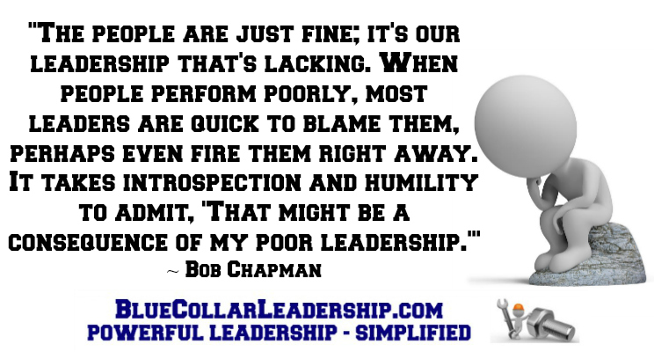

1. **Walk the Talk: Trust is a leader’s best friend.**

*“Trust is the one thing that changes* ***everything****.” ~ Stephen M. R. Covey*

1. Trust is the foundation of **leadership**.
2. The more trust you have, the more **influence** you will have.
3. The more influence you have, the greater the **impact** you will have.
4. The greater the impact, the greater the **leader**.

*With trust, everything is* ***possible****. Without trust, everything is* ***questioned****.*

*With trust, things happen* ***fast****. Without trust, things happen* ***slowly****, if at all.*

*With trust, relationships* ***grow****. Without trust, relationships* ***slow****.*

*With trust, we* ***always*** *know. Without trust, we* ***never*** *know.*

*With trust, there is* ***authentic*** *influence. Without trust, there is only* ***artificial*** *influence.*

*“I was in Guatemala in 2013 as part of a 150 person team led by leadership guru John C. Maxwell. I’ve been mentored by John for many years, so it was a privilege to be there with him. Together, we all trained over 20,000 Guatemalan leaders in just three days. I want to share a story on intention, trust, and humility from one of my training classes.*

*On that day, I had a room full of 50 business executives. I was speaking on much of what I’ve covered with you so far. I had mentioned one way to build trust is to acknowledge your weaknesses with your team and let them know your intention is to improve.*

*Wouldn’t you like that from your boss? Your team would also like it from you. If you have humility, this is an easy thing to do. If you have too much pride and ego, it will be difficult.*

*At the end of the training session, I was asked by one of the executives, “Why should I tell my team my weaknesses? Wouldn’t it be better if they didn’t know? Telling them will make it harder for me to lead?” I said, “Sir, you obviously have a false assumption. You assume your team doesn’t already know your weaknesses.”*

*Do you know your bosses weaknesses? Absolutely. Did he/she have to tell you? Absolutely not.*

*Telling your team lets them know you know your weaknesses too, and you care about improving in those areas. If you improve, that builds trust. If you don’t, that creates distrust.” ~ Mack Story*

*“A warm, trustworthy person who is also strong elicits admiration, but only after you’ve established trust does your strength*

*become a gift rather than a threat.” ~ Amy Cuddy*

1. **Moving Beyond Communication:** The best leaders **intentionally** connect.

*“When dealing with people, you are not dealing with creatures of* ***logic****.*

*You are dealing with creatures of* ***emotion****.” ~ Dale Carnegie*

1. When you’re able to build trust with your team, you move beyond communication and begin to **connect**.
2. When you connect with your team, you’re building **relationships**.
3. When you build relationships, people begin doing things to **help** you succeed because they *want* *to*, not because they *have to*.
4. **Managers** communicate. High impact leaders connect.
5. Does your team **trust** you? Do you know, or do you **think** you know? You can’t make someone trust you no matter how much **authority** you have.
6. If others don’t trust us, it’s not their fault. It’s our fault. Who we are on the inside will determine if we are trusted on the outside.

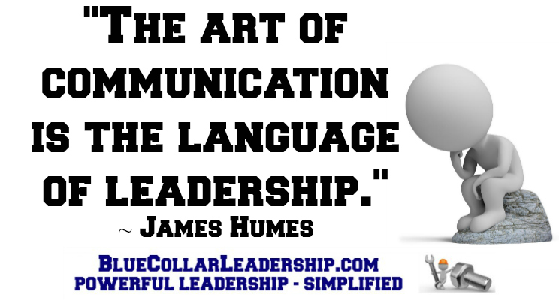

1. **Squint with Your Ears:** Listen with the intent to **understand**.

*“Authentic listening is not easy. We hear the words, but rarely do we really* ***slow******down***

*to listen and squint with our ears to hear the emotions, fears, and underlying concerns.”*

*~ Kevin Cashman*

1. If connecting is so important, what’s the most effective way to do it? You **listen**.
2. When you listen to understand, you are not **agreeing** or **disagreeing**. You are simply trying to ensure you truly understand the other person.
3. If you want to connect quickly, squint with your ears to listen **between** the words for emotion, concern, fear, restraint, anger, distrust, uncertainty, etc.
4. A high impact leader’s goal is to create an atmosphere of emotional **safety**, built on trust, for the team members.
5. Andy Stanley stated so well, *“Leaders who* ***don’t*** *listen will eventually be surrounded by people that have* ***nothing*** *to say.”*

*If you had a choice between two bosses, and one was only concerned with ensuring you understood him, and the other was concerned with first ensuring he understood you, which would you prefer to have as a boss? Which would have more influence with you? The one who wants to understand you. It’s common sense right? But, is that what most bosses do? Is that what your boss does? Is that what you do?*

*“The most important thing in communication*

*is to hear what* ***isn’t*** *being said.” ~ Peter Drucker*

1. **Leading by Example:** You’re always teaching what you’re **modeling**, regardless of what you’re teaching.

*“****Example*** *isn’t another way to teach, it’s the only way to teach.” ~ Albert Einstein*

1. Someone is always watching, so the question is not, *“Are you a role model?”* The real question is, “What **kind** of role model will you be?”

* *Do you want your team to listen to you? Then, you must listen to them.*
* *Do you want your team to trust you? Then, you must trust them.*
* *Do you want your team to accept and embrace change in a positive way? Then, you must accept and embrace change in a positive way.*
* *Do you prefer your team not to blame you? Then, you must not blame others.*

1. When you **talk** about and **blame** others behind their back, you are modeling who you are on the inside to those watching from the outside. Without actually saying it, you are communicating to everyone, *“If I’ll talk about and blame others behind their back, I’ll do the* ***same*** *to you.”*
2. High impact leaders model well developed character and **accept** responsibility for improving morale, increasing productivity, improving opinions of others, and building trust among their team and in their organizations.
3. Modeling is very important because who you are is who you **attract**. High impact leaders are able to build high impact teams because they attract team members that are like them.
4. If you want to achieve more on the outside, you must first become more on the inside. You get better by **choice**, not by **chance**.

*“We don’t tend to* ***drift*** *into better behavior.” ~ Bill Hybels*

1. **Unleashing Your Team:** The front line determines the **bottom** **line**.

*“To truly get smart, you’ll have to* ***strain*** *yourself on many levels. You’ll read more than you ever thought you would. You’ll have to think purposefully about what you’ve read and digest it into nuggets of* ***insight****. You’ll need to put yourself out there, discussing these nuggets with colleagues and be willing to debate the issues. Often, you’ll have to employ creative powers, associating* ***unrelated*** *facts or examples to give new insights.” ~ Tim Sanders*

1. If high impact leadership begins with you, but it’s not about you, what is it about? It’s about you unleashing your team to **perform** at a higher level.
2. High impact leaders **release** their team while managers of people **suppress** their team.
3. One reason managers don’t focus on leading themselves well is because they’re not focused on leading their team at all. Their focus is on **management** of the team and the processes.
4. Your team’s **results** are based upon your ability to lead them. The foundation for leading them well begins with leading yourself well.
5. High impact leaders don’t focus on the things they can’t do. It’s a waste of time and energy because their goal is to make things happen, not watch things happen. High impact leaders don’t think *“Can I?”* They think *“****How*** *can I?”*

*“Praise isn’t merely a reaction to a great performance; it is a* ***cause*** *of it. Less than a third of people report that they frequently receive praise or recognition for good work. This suggests that they did something at a level of excellence and no one praised them for it, or that they haven’t performed at a level of excellence recently. Of course, neither*

*is a good thing.” ~ Marcus Buckingham*

1. **Two Powerful Things:** The **mirror** and the **window**.

*“You can’t change what you can’t change. But,*

*you’ve got to change what you can.” ~ Nick Vujicic*

1. The mirror and the window are tools used by both high impact leaders and managers of people, although they use them in completely opposite ways.
2. When it comes to responsibility, high impact leaders look in the mirror and **accept** responsibility. Managers look out the window and **transfer** responsibility.
3. When things go **wrong**, high impact leaders look in the mirror and take the blame. Managers look out the window and transfer the blame.

*If a high impact leader’s team is not performing as well as it should be, the leader looks in the mirror asking:*

*• How can I help?*

*• What am I not doing that I should be doing?*

*• What can I do better?*

*• What do I need to know that I don’t know?*

*If a manager’s team is not performing as well as it should be, the manager looks out the window saying:*

*• They aren’t working hard enough.*

*• They don’t do what I tell them to do.*

*• They don’t listen.*

1. What about when things are going well? Who gets the credit for the success? High impact leaders look through the window and **give** credit to others. Managers of people look in the mirror and **take** the credit.

*“A good leader takes a little more than his share of the* ***blame****,*

*a little less than his share of the* ***credit****.” ~ Arnold Glasow*

1. **Make It Happen:** **Leaders** get results, managers plan to get results.

*“The command-and-control approach is far from the most efficient way to tap people’s intelligence and skills. To the contrary, I found that the more* ***control*** *I gave up,*

*the more* ***command*** *I got.” ~ Capt. D. Michael Abrashoff*

1. When high impact leaders want to know what’s happening, they go to the front lines and find out for themselves. They eliminate the middle men, get in the trenches with their team, **talk** to the people, and ask a lot of questions.
2. Because they fully embrace the responsibility of getting results, they are not satisfied with **thinking** they know. They want to **know** they know.
3. **Accidental** growth strategy: *“I hope it happens.”*
4. **Intentional** growth strategy: *“I'm going to make it happen!”*
5. Living intentionally leads to **amazing** results. Living accidentally leads to **depressing** disappointments. A better tomorrow doesn't just happen. We must be intentional and make it happen.

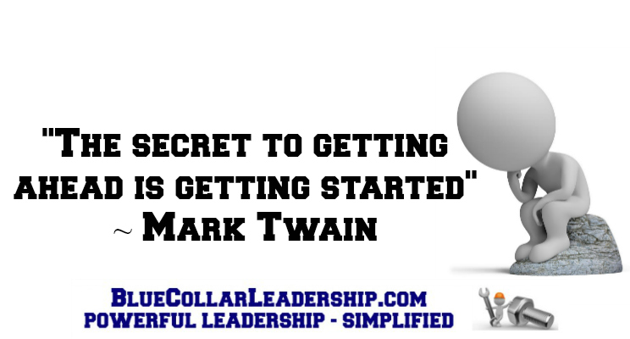

1. **Clearing the Path:** Leaders remove the **obstacles**.

*“Leaders who* ***navigate*** *do even more than* ***control*** *the direction in which they and their people travel. They see the whole trip in their minds before they leave the dock. They have a* ***vision*** *for their destination, they understand what it will take to get there, they know who they’ll need on the team to be successful, and they recognize the obstacles long*

*before they appear on the horizon.” ~ John C. Maxwell*

*“If you were the CEO, what would you do right now to make your job better? This is one of the questions I often ask after introducing myself to front line team members. I’m sometimes amazed by the simple answers I often hear.” ~ Mack Story*

*• Buy everybody a broom*

*• Add a hook here to hold my tool*

*• Put trash cans in all the work areas*

*• Go out and personally thank the people for the job they do*

*• Buy some tools, so I won’t have to bring my own*

*• Add a light to my area, so I can read my gauges better*

1. What do these answers all have in common? They were made by people who have a manager of people for a boss. Anyone on a high impact leader’s team would have already had these issues addressed because the leader would have been asking *“How can I help you?”*
2. Leaders intentionally remove obstacles which also builds **trust** and strengthens **relationships**.
3. These things appear to be insignificant when viewed through the eyes of a manager. But to a leader, the little things are the big things. Why? Leaders know when it comes to people, the **little** things are the **big** things.
4. If you’re a high impact leader, removing obstacles is not your job. It’s your **responsibility**. Will you help your team help you?

*“When you are an* ***individual*** *contributor, you try to have all the* ***answers****.*

*When you are a* ***leader****, your job is to have all the* ***questions****.” ~ Jack Welch*

1. **Leading with Questions:** The **best** leaders ask the **most** questions.

*“High impact leaders lead with* ***questions*** *instead of* ***directions****." ~ Mack Story*

**7 Reasons to Ask Your Team Questions**

1. **To show them respect.** Asking questions demonstrates respect. It lets them know they matter and shows their opinions are valued and appreciated. It builds trust into the relationship. It allows the leader to model teamwork.
2. **To transfer influence to them.** Asking questions allows them to influence the leader. It allows them to feel understood which creates more buy-in. When the team feels understood, they are more likely to support the path forward.
3. **To give them a voice.** Asking questions allows the team to be involved in finding the solution. It allows them to have ownership in the process and the decision.
4. **To learn how they think.** Asking questions is a valuable tool because it allows the leader to learn how each individual thinks. It allows the leader to learn which team members are ready and want to lead.
5. **To engage them in the process.** Asking questions allows the leader to share the responsibility and engage the team. It gets team members involved who may otherwise keep their opinions to themselves. It empowers the team to act instead of being acted upon.
6. **To uncover hidden concerns.** Asking questions allows team members to express concerns that may have otherwise remained unknown. It allows the leader to confirm the facts and minimize the rumors that spread so quickly along the front lines.
7. **To develop a better solution.** Asking questions creates a synergistic environment which allows the leader to think with many minds instead of just one. It helps all team members to realize that none of them is as smart as all of them.

*“Some people assume we stumble onto our success,*

*but the path of discovery is paved with interesting questions.” ~ Bryan Cioffi*

1. **How high will you climb?** Develop yourself with the intention of developing others.

*“Your capacity to* ***grow*** *determines your capacity to* ***lead****.” ~ Mark Miller*

1. Managers of people don’t develop their team members because they are **insecure**. They feel threatened by anyone and everyone for various reasons. Actually, their goal is to make sure everyone stays in their place, doesn’t threaten them, and learns to do their job.
2. Great leaders are very **secure**. They have made it to the top. However, these leaders are unwilling to pay the additional price of developing themselves or their team **beyond** what is required to do the job. They are not **growth** oriented. They are **goal** oriented. Unfortunately, their goal was getting to the top.
3. Getting to the top will make you a great leader, but it will not make you a high impact leader. If you want to become a high impact leader, you must go back down and **help** **others** **climb** their way to the top effectively and efficiently.
4. To truly become an exceptional high impact leader, you must choose to work on developing yourself when you’re **not** **at** **work**. Very few leaders are willing to make this kind of sacrifice.

*“If you work hard on your* ***job*** *you can make a living,*

*but if you work hard on* ***yourself*** *you can make a fortune.”*

*~ Jim Rohn*

**20. Motivation is Never Enough:** Motivation comes from the **outside**, but inspiration comes from the **inside**.

*“Every once in a while I will hear someone in leadership complain about the performance or competency of the people around him...We must never forget that the people*

*who follow us are* ***exactly*** *where we have* ***led*** *them.” ~ Andy Stanley*

1. How is your team doing? Where have you led your team?
2. When you look at them, it’s like looking in the mirror and seeing yourself.
3. What you see when you look at your team is a **reflection** of how you’re doing as their leader.
4. Unmotivated leaders will **never** motivate their teams.
5. Their performance reflects your ability to **motivate** and **inspire** them.
6. Your ability to lead is reflected in your team’s willingness to **follow** you and their **desire** to achieve results.
7. If you truly want to motivate and inspire someone to take action, help them **look** good because that will make them **feel** good.
8. To change your results, you must take action. Taking action requires something beyond motivation. Taking action requires **inspiration**.

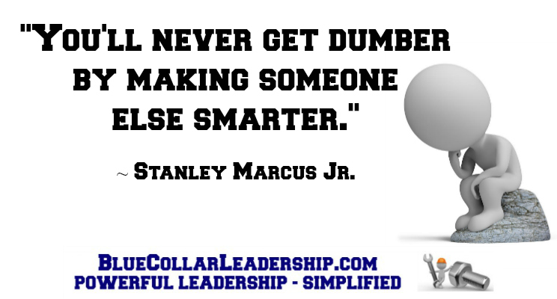

**21. Abundance Allows You to Accelerate:** Be a **river**, not a reservoir.

*“A candle loses nothing when it lights another candle.” ~ Thomas Jefferson*

1. When we are rivers, we allow what flows into us to also flow through us and into others in an effort to give our **team** an advantage. When we are reservoirs, we hoard what flows into us in an effort to give **ourselves** an advantage over others.
2. High impact leaders are “rivers” and are very intentional about **sharing** knowledge and **teaching** others how to do what they do.
3. **Secure** leaders are not threatened by others having knowledge. They are strengthened by it.
4. Managers of people do not function as rivers, but instead are like reservoirs. They are intent on **collecting** knowledge. They don’t want it to pass through them into others.
5. Managers want to be **needed**. High impact leaders want to be **succeeded**.
6. Which leader is more valuable to an organization? One that shares knowledge, or one that hoards it?

*Assume you are the boss and someone is going to be promoted and/or receive a raise. You can only offer this to one person. However, you have two top notch “A” players on your team. There’s really only one difference between them.*

*One of them is a knowledge hoarder, self-centered, and loves being the hero. She is very skilled in certain areas but has been on the team for years without any concern for teaching others what she knows. She actually doesn’t want others to know what she knows. When she is not at work, the team pays the price because there are some things only she can do.*

*The other person teaches everyone everything she knows. She does it without being asked. When she learns something new, she quickly passes it on to the rest of the team. She wants to be sure if she’s not at work, the show will still go on without skipping a beat. She is team-centered, not self-centered.*

*You’re the boss. Which one of them is more valuable to you? Which one of them gets the promotion/raise? If you must let one go due to a downturn in business, who goes?*

**22. Supercharging Your Team:** Focus on **character** first and competency second.

*“Do not tolerate brilliant* ***jerks****. The cost to* ***teamwork*** *is too high.” ~ Reed Hastings*

1. Help your team look in the mirror and understand why the team’s success **adds** to their success.
2. Help your team understand **why** and **how** they should work together.
3. Help your team understand their success is **important** to you.
4. Make sure you **earn** your team’s trust by **investing** in their development.
5. Make sure your team knows they will get all the credit for their success.
6. As your team becomes high impact team players, help them begin to **think** like high impact leaders. Prepare them for the next level.
7. Your character is the key to your team’s character.
8. The team’s character is a **reflection** of the leader’s character.
9. You must walk the talk.
10. **Your success depends on your team’s success.**

*“I want to help you be more successful. How? By helping you help your team be more successful. I intentionally made Blue-Collar Leadership® & Supervision the second in this series because I wanted to be sure I had the first one, Blue-Collar Leadership®, ready for you to use to develop your team. I want to help you help your team begin to think like high impact leaders while they are still on the front lines.*

*I wrote Blue-Collar Leadership®: Leading from the Front Lines specifically for leaders to use to develop their teams. You can learn about it and even download the first five chapters for free at www.BlueCollarLeadership.com. You will also learn a lot from it, and you will see how beneficial it will be for your team and the impact it will have on your ability to increase your influence with them.” ~ Mack Story*

*“The ability to mobilize the skills and competencies of the people around us has a bigger impact on our performance than does the amount of experience we have.”*

*~ Liz Wiseman*

**23. Everybody Matters:** There is **potential** in everyone.

*“Treat a man as he appears to be and you make him* ***worse****. But treat a man as if he already were what he potentially could be, and you make him what he should be.”*

*~ Johann Wolfgang von Goethe*

1. High impact leaders know everyone matters **equally**. It’s also obvious to all because they are always trying to find ways to **unleash** their team’s potential.
2. High impact leaders think **abundance**, be a river, grow and develop others, there is plenty of success for everyone. Their focus is on others.
3. Managers of people think **scarcity**, be a reservoir, don’t develop others, there is only so much success to be had. Their focus is on themselves.

***7 Simple Ways to Make Everybody Matter***

*1. Talk to them regularly, especially when there’s no reason to do so.*

*2. Give them special assignments where they can be successful and get noticed.*

*3. Ask their opinion about things not directly related to them or their job.*

*4. Ask them what their dreams are and what they would like to do in the future.*

*5. Find a way to* ***help******them******shine****.*

*6. Help them network by introducing them to other leaders in the organization.*

*7. Sincerely and regularly thank them for their contribution to the team’s success, your success, and the organization’s success.*

*“If we lose sight of* ***people****,*

*we lose sight of the very* ***purpose*** *of leadership.” ~ Tony Dungy*

**24. Believe in Your Team:** They need to **feel** it, not hear it.

*“The very best leaders make us feel as if we are in control.” ~ Jimmy Collins*

1. Do you believe in your team? I mean, really believe in them as **people**, not as **producers** of results and profits.

*Joshua Encarnacion explained that if you look up the word “belief” in the dictionary, you’ll discover words like trust, faith, and confidence are used to define it. He went on to say believing in others this way is* ***selfish*** *and requires* ***judgment****. He proposed we should redefine the way we believe in people.*

*Joshua said we should redefine belief in people as encouragement, engagement, and empowerment. He expressed that believing in people this way is* ***selfless*** *and doesn’t require judgment.*

1. Truett Cathy, Founder of Chick-fil-A, had this to say about encouragement, *“How do you know if someone needs encouragement? If they’re breathing they need encouragement.”* We all **need** encouragement. And, it won’t cost you a penny to give encouragement to someone else.
2. John C. Maxwell remarked, *"Give others money, and it's soon spent. Give resources, and they may not be used to the greatest advantage. Give help, and they'll often find themselves back where they started in a short period of time. But give them your* ***faith****, and they become confident, energized, and self-reliant."*

*“It is a big step in your development when you come to realize that* ***other******people*** *can help you do a better job than you could do alone.” ~ Andrew Carnegie*

**25. Focus on Your Leaders:** When you lead leaders, you also lead their **followers**.

*“There is something more scarce than* ***ability****. It is the ability to* ***recognize*** *ability.”*

*~ Robert Half*

1. Unfortunately, most leaders tend to be **reactive** and focus on their **low** performers. However, high impact leaders are **proactive** and focus on their **top** performers.

*Managers of people focus on the low performers. Managers like to be in charge. They like to control everything. They like to flex their positional muscle of authority. As a result, they do what comes naturally. They look for those who are not following orders or performing as they think they should be and spend a lot of time and energy trying to get them to “get with the program.”*

*High impact leaders do exactly the opposite. They focus heavily on their top performers. They also do what comes naturally to them: Work where they have the most influence. They like to influence people who are making things happen because those people have influence with others on the team that will help them make things happen.*

1. I suggest that high impact leaders should invest **80**% of their available time for team development with their top leaders, **15**% with those in the middle of the pack, and **5**% with their lowest performers.
2. You and your team will be much more productive when you **invest** your time instead of **waste** your time.
3. When you **directly** lead leaders, you are **indirectly** leading their followers.

*“Everyone wants to* ***contribute****.* ***Trust*** *them. Leaders are* ***everywhere****.* ***Find*** *them. Some people are on a* ***mission****.* ***Celebrate*** *them. Others wish things were* ***different****.* ***Listen***

*to them. Everyone* ***matters****.* ***Show*** *them.” ~ Bob Chapman*

**26. The Weak Links:** Don’t fire them, fire them up.

*“As a leader, and ultimately a* ***mentor****, you have the* ***responsibility*** *and privilege to grow those around you and help them become their absolute best.” ~ Mike Davis*

1. The team is only as strong as the weakest link on the team.
2. Often, the weak link on a team is the **leader**. Don’t be the weak link.
3. Most weak links can be made strong if they are led by a **high** **impact** leader.
4. Managers of people do not have the necessary **character** to grow and develop the weak links.

*Most often, they don’t choose to grow and develop themselves. If they won’t grow and develop themselves, how can they be expected to grow and develop others? They can’t. In this case, the leader is the weak link.*

1. Insecure leaders, managers of people, look out the window and **blame** the weak links. They don’t know what they don’t know. They don’t look in the mirror, take the blame, and **admit** they are the weak link.
2. Insecure leaders don’t develop their people. They **replace** them.

*“When you decide to pursue greatness, you are taking responsibility for your* ***life****. This means that you are choosing to* ***accept*** *the consequences of your* ***actions****, and to become the agent of your mental, physical, spiritual, and material success. You may not always be able to control what life puts in your path, but I believe you can always control* ***who******you******are****.”*

*~ Les Brown*

**27. A Bigger Sacrifice:** Will you choose to lead at a higher level?

*“****Character*** *cannot be developed in ease and quiet. Only through experience of trial and suffering can the soul be strengthened, ambition inspired, and success achieved.”*

*~ Helen Keller*

1. How much are you willing to sacrifice to get from where you are to where you want to be? The answer to that question will determine how **far** up the leadership mountain you will climb and how **many**, if any, you will help climb to the top.
2. The moment you’re done sacrificing is the moment you’re done climbing. You’re either moving **forward** or **backward**. There is no such thing as sitting still in the leadership world.
3. Moving forward doesn’t just naturally occur. You must be **intentional**.
4. There’s always someone out there willing to pay the price when you won’t. If you’re no longer **hungry** for growth, you’ll be easily **passed** by those who are. It’s not their fault. It’s your fault. The problem is always in the **mirror**.
5. Sacrifice is giving up something of value today for something of greater value tomorrow, next week, next month, or next year. Sacrificing today for a better future takes **vision**, **desire**, and **discipline**.
6. You must become disciplined at doing the things that will make you more valuable. If you want to become more successful, don’t focus on becoming more successful. Focus on becoming more valuable.
7. Discipline is the bridge between **knowing** and **doing**. To become more valuable and successful, you must cross this bridge **daily**.

*“A great leader must make the* ***choice*** *to put other people’s needs*

*in front of his or her own.” ~ Ria Story*

**28. Change and Transformation:** It’s **easier** to change, but it’s **better** to transform.

*“****Self****-****mastery*** *is the hardest job you will ever tackle. If you do not conquer self, you will be conquered by self. You may see at the same time both your* ***best*** *friend and your*

***worst*** *enemy, by simply stepping in front of the mirror.” ~ Napoleon Hill*

1. Those who are not willing to pay the price to transform themselves into a high impact leader will pay the **bigger** price of remaining a low impact leader.
2. When we change, we can also change back. But when we grow enough repeatedly and consistently over time, we begin to **transform**. Once we are truly transformed, there is no going back.
3. Do you want to simply make a few changes to improve your team’s results? That’s **easy** and won’t require very much sacrifice. The cost is **low**.
4. Or, do you want to truly transform yourself and your leadership **style**? That’s **hard** and will require a lot of sacrifice. The cost will be **high**, but the **reward** will be **great**.
5. If you choose to only change a little where it’s easy and choose to pick a few principles you’ve learned and move on as you were, very little is going to change. Nearly everything in your life will remain the same. It’s your choice.
6. Transformation isn’t for the **weak**. Transformation is for the **strong**. Those who choose transformation will become high impact leaders and will help others choose transformation. They will impact many lives. They will truly make a difference.
7. What will it be for you? A change? Or, a transformation?

*“When we are faced with change, we either step* ***forward*** *into growth,*

*or we step* ***backward*** *into safety.” ~ Abraham Maslow*

**29. Top Performers:** The challenge of **retaining** your game changers.

*“Those who build great companies understand that the ultimate throttle on* ***growth*** *for any great company is not markets, or technology, or competition, or products. It is the* ***one*** *thing* ***above*** *all others – the* ***ability*** *to* ***get*** *and* ***keep*** *enough of the right* ***people****.” ~ Jim Collins*

1. Why do most people leave the team, department, or the organization? There are many reasons people leave, but the **primary** reason is related to the relationship with their **boss**.
2. People tend to stay or leave because of how their boss makes them **feel**. Do they feel like they **matter**? Do they feel **valued**?
3. There’s something actually worse and more common than having a team member leave. That’s having them **quit** emotionally but **stay** physically. When they quit but stay, it’s the leader’s responsibility to remove them from the team as quickly as possible because they will only contaminate the team and cause problems.
4. While they’re on the team, your leadership will be **questioned**, and you will lose **trust** with the other team members, especially the **top** performers.
5. To **retain** the best, **remove** the worst.
6. Creating a team that works well together, values each other, supports the leader, and the organization isn’t an easy task, but it’s necessary to **attract** and **retain** top performers.

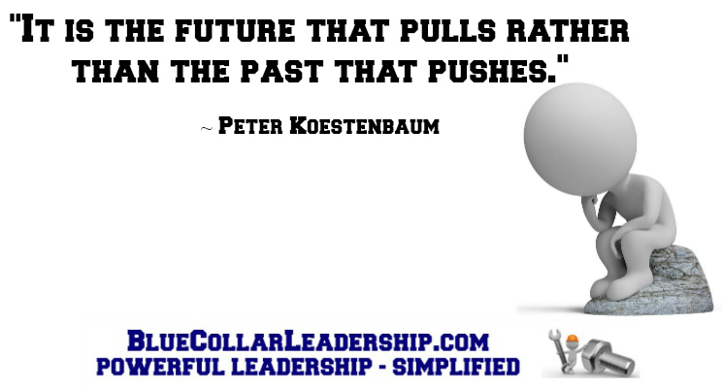

**30. The Ultimate Question:** Will you be an **informer** or a **transformer**?

*“I am not what happened to me, I am what I choose to become.” ~ Carl Jung*

1. Will you simply pass along information? Or, will you passionately pass along **inspiration**. Managers are informers, but high impact leaders are transformers.
2. When a leader **communicates** with their team, they are positioned to inform.
3. When a leader **connects** with their team, they are positioned to transform.
4. Our world is desperate for leaders that will step up, lead at a higher level, and make a **bigger** difference from wherever they are.
5. Managers change processes and procedures, not themselves. They are focused on the **job** and the **results**, not the **people**. They are **goal** oriented.
6. High impact leaders **inspire** people to make **positive** changes in their lives. They are focused on the **people**. They **model** what they expect from others. They are **growth** oriented, not goal oriented.
7. High impact leaders live with purpose on purpose for a purpose.
8. Amir Ghannad had this to say, *“Your transformation will not come from what I tell you, but from what you tell yourself and ultimately* ***what******you******do****.”*
9. The **degree** in which you’re able to transform yourself will determine your **ability** to transform others.

*“****Death*** *is not the greatest loss in life.*

*The greatest loss is what dies* ***inside*** *us while we* ***live****.” ~ Norman Cousins*