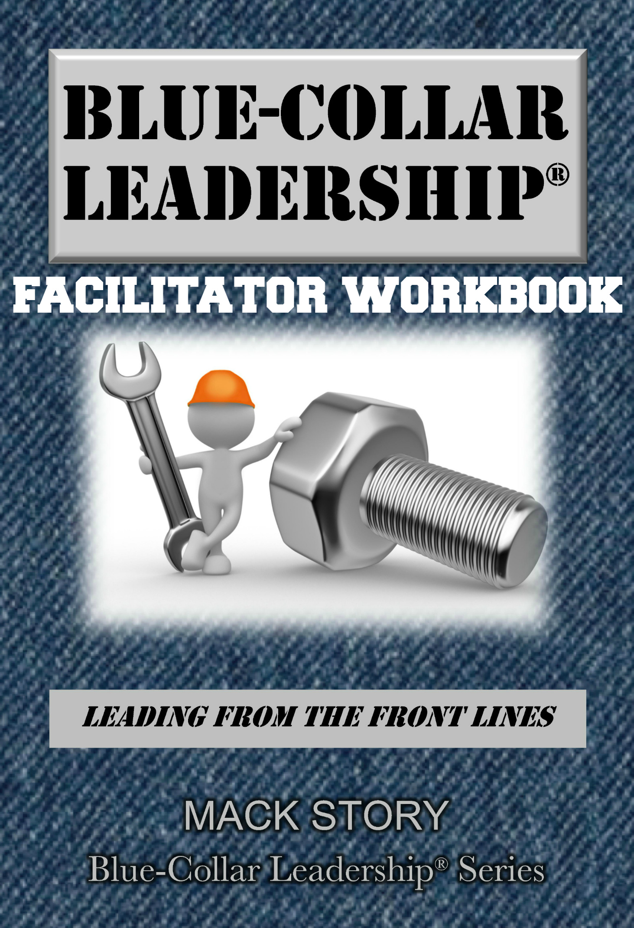
A note from Mack

Dear friend,
As a leader (person of influence), you have a remarkable responsibility to impact the lives of those around you, personally and professionally. Remember that as you work your way through this material.
You and I will be partners as we explore the values of high impact leaders with others. We can’t raise the bar for others if we can’t reach it ourselves. As you study and teach, I already know you will reach new levels of knowledge, growth, and understanding. I’m also confident that you will motivate and inspire others to also reach higher.
The values (principles) contained in this book are timeless and have been tested and proven again and again by high impact leaders across multiple generations around the world. I encourage you to read, study, and familiarize yourself with the ideas in this book in order to be prepared to lead a group through this information. The key to facilitating this content is to teach the principles. Then, support them with practices (stories) from your own life. As you teach it, make it your own.
I have devoted my life to helping people make a high impact by making what is common sense also common practice. It is my hope that you will have as much fun as I do while you lead people to a greater understanding of the values that will unleash their leadership potential. High impact leaders always have high impact values.
Make it happen!

Your friend,
Mack Story
Mack Story
Blue-Collar Leadership®:
Leading from the Front Lines
by Mack Story

“Two of the greatest lessons I learned from front line leaders:

1) Give credit to others when things go right.
2) Take responsibility when things go wrong.”
~ Mack Story

- I’m one of you.
“A few start at the top, but most of us start at the bottom.” ~ Mack Story

  - Merriam-Webster’s simple definition of blue-collar: requiring physical work; relating to or having jobs that require physical work.
  - We should always be grateful but never be satisfied. We can become a lot more. It’s a choice I hope you will make.
  - Most on the front lines have been overlooked and underdeveloped.
  - When you decide to accept responsibility for your future, you will be able to define your future.

“The blue-collar workforce built this country;
they can and must help save this country.

I want you to know: I respect you.
I want you to know: Who you are matters.
I want you to know: I believe in you.” ~ Mack Story

- I believe in you.
“The dictionary defines belief as trust, faith, and confidence. However, that definition is selfish and requires judgment. I think we need to change the way we believe in people. We need to redefine the way we believe in people. We should redefine belief as encouragement, empowerment, and engagement. This definition is selfless and doesn't require judgment.”
~ Joshua Encarnacion
  - I like to refer to this type of belief as “unconditional” belief.
  - Motivation comes from the outside, but inspiration comes from the inside.
  - Believing in someone unconditionally is a choice. It’s a choice that builds trust and strengthens relationships.
“We already live with many scripts that have been handed to us, the process of writing our own script is actually more a process of ‘rescripting,’ … As we recognize the ineffective scripts within us, we can proactively begin to rescript ourselves.” ~ Dr. Stephen R. Covey

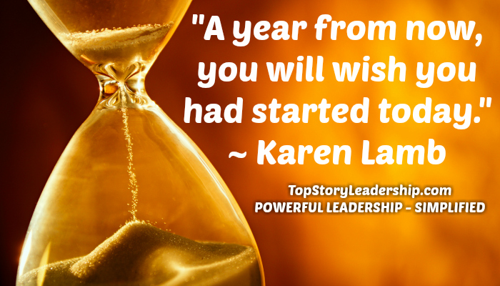

- You’re in the perfect place.

  - You’re exactly where you’re supposed to be but not where you have to be.
There’s a story about a tourist who paused for a rest in a small town in the mountains. He went over to an old man sitting on a bench in front of the only store in town and inquired, “Friend, can you tell me something this town is noted for?”

“Well,” replied the old man, “I don't rightly know except it's the starting point to the world. You can start here and go anywhere you want.”

“An educated person is not the one with the most knowledge, an educated person is the one who is willing to reflect, evaluate, and modify his most cherished beliefs
when a new idea comes along.” ~ Christian Simpson

  - As Maureen Falcone stated, “Most people fail in the getting started.” I agree, but also I think the bigger issue is failing to keep going once you have started.
  - You’re in the exact place you need to be. You’re at the starting line. Getting to the starting line in life is easy. All you must do is step up. Then, you must choose to run.
  - It’s much easier to go from failure to success than it is to go from excuses to success. Why?
  - An excuse is simply a choice not to do what you know you should do.
“If we refuse to become a leader because we don’t believe we can get to the top,
we are limiting ourselves from reaching our potential;
and we are limiting the impact we can have on others.” ~ Ria Story

- Common sense is never enough.
“We only truly know something—that is, have personal knowledge of it—
when we can apply it to get results.” ~ Polanyi

- Common sense means anyone should understand what should be done, but actually doing it often requires uncommon sense.
- To know something and not do it, is not truly knowing it. To understand something and not apply it, is not truly understanding it.
- Nearly all of us know something we should stop doing to improve our lives and know something we should start doing to improve our lives. But, we don’t do it! Why?
Common sense alone will not lead you to success. It will help, but it’s not enough. Knowing and doing are two very different things that will lead you to very different results. Knowing how to lose weight doesn’t mean someone who wants to lose weight will lose weight. We all know how to lose weight. We watch our calories in (what we eat) and exercise (calories out). It’s common sense. Everyone knows it, but everyone doesn’t do it.

- What most people are missing is this: There’s a huge difference between understanding what should be done and doing what is understood. And, it often takes more smarts to do something than it does to understand something.
“The top 5 percent of achievers invest an average of $3,000 per year on
personal growth while the other 95% average only $7 per year.” ~ Les Brown

“It will take uncommon sense to apply what you will learn from this book.”
~ Mack Story

- There is an “I” in team.
“I’m just a plowhand from Arkansas, but I have learned how to hold a team together – how to lift some men up, how to calm others down, until finally they’ve got one heartbeat together as a team. There’s always just three things I say: ‘If anything goes bad, I did it.
If anything goes semi-good, then we did it. If anything goes real good, they did it.’
That’s all it takes to get people to win.” ~ Paul “Bear” Bryant

- Every team is made up of “I”ndividuals.
- Every person on a team is an “I” and has the potential to lead (influence) the team, positively or negatively.
- There’s nothing holding you back but you. As a blue-collar leader, Donovan Weldon, stated so well, “The only person between you and success is you. MOVE! The only person between you and failure is you. STAND FIRM!”
- You are the key to your success.
When you play tall, you choose to contribute because you know it will increase your influence and your impact on the front lines. If you want to play tall, you should want to be noticed, to be selected, to volunteer, to share information, to accept more responsibility, and ultimately, to make a contribution at a higher level.

As a direct result of your choice to step up, your influence increases. You’re demonstrating you can lead from the front lines and will be seen and respected by all high impact leaders as a high impact leader. Your actions will not go unnoticed.

When you play small, you choose not to contribute because you don’t want to do more. If your goal is to coast until pay day, it won’t be a secret you can keep. When you make every effort not to be noticed, not to be selected, not to volunteer, not to share information, not to accept responsibility, and ultimately to not contribute, you will absolutely be noticed.

As a direct result of your choice not to step up, your influence decreases. Your influence on the front lines and with your leaders will be diminished. You are more likely to become reactive and frustrated blaming others for what you have chosen. Blaming others will further reduce your influence.

“The most valuable player is the one that makes the most players valuable.”
~ Peyton Manning

- Be better tomorrow.

“If you have too little confidence, you will think you can't learn.
If you have too much, you will think you don't have to learn.” ~ Eric Hoffer

- When you become more valuable, you will become more successful.
- The only person you need to be better than tomorrow is the one you are today.
Every one of us is someplace. However, many of us want to be in a different place. Most of us are uncertain about what to do to move from where we are to where we want to be. There’s a simple question that will take you there.

The question I’m going to share assumes you know where you’re going. If you don’t know, you need to nail down the answers to the following two sets of questions first.

This first set of questions will establish your starting point: Who am I? And, where am I?

The second set of questions will establish your destination: Who do I want to become? And, where do I want to be?

They also reveal a gap. I call this the "Success Gap." The gap between where you are and where you want to be.

Here’s the question you need to learn to ask yourself:

Will what I’m about to do move me in the right direction?

This question is packed full of potential just like me and you!
The question is important.
The answer is more important.
But, your actions are most important.

It’s a simple concept actually. If the answer is yes, you do it. If the answer is no, you don’t do it. It says easy, but it does hard.

When you ask the question, the answer is yes, and you follow through, you close the gap. When the answer is no, but you do it anyway, you widen the gap.

“It is the capacity to develop and improve themselves that
distinguishes leaders from followers.” ~ Bennis and Nanus

- The secret to your success.
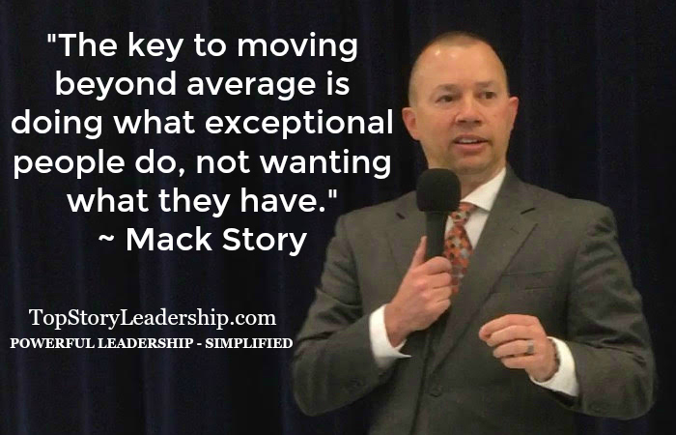

- You get paid by others, but you work for yourself.
- Everyone agrees word of mouth is the best type of advertisement. What are your customers saying about your business: YOU?
- Everyone you interact with is either a customer, potential customer, and/or a potential advertiser spreading either positive or negative word of mouth advertisement about you.
- Your boss is your #1 customer because they are paying you for your work and can help or hurt you the most.
“To generate good profit, it's critical not only to understand but to anticipate what customers value, their expectations, measures, incentives, needs, alternatives,
and decision-making processes.” ~ Charles G. Koch

- Someone is always watching.

- You are a role model whether you want to be one or not because someone is always watching you.
“Nothing is more confusing than people who give good advice, but set a bad example.”
~ Norman Vincent Peale
“Nothing is more convincing than people who give good advice and set a good example.”
~ John C. Maxwell

- The question is not, “Do you want to be a role model?” but rather, “What kind of role model will you be?”
- You are always teaching what you’re modeling, regardless of what you are teaching.
“When we touch a life, we don’t always feel it.” ~ Mack Story

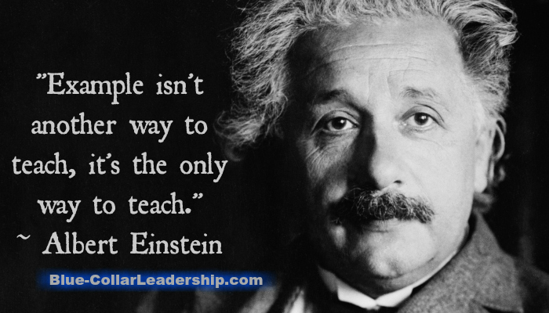

- Your potential is unlimited.

“When we fully develop our potential, we create superior value for others – and that
in turn helps give meaning to our lives…Life is pretty empty without passion for what
we are doing. What a tragedy to reach the end of your life and only be able to say,
‘I got by without having to do too much.’” ~ Charles G. Koch

- The way you see the world has a lot to do with how the world sees you. There’s an old saying that goes like this, “If Bob has a problem everywhere Bob goes, then Bob is the problem.”
- As Christian Simpson stated, “We've all got an endless supply of potential, waiting patiently to express itself through our individualized talents and gifts. The challenge is we're just not conscious of it.....raising your awareness is what has to be done if you're to enjoy greater success in your life.”

“Nothing is given to man on earth except a potential and the material on which to actualize it.

The potential is a superlative machine: his consciousness; but it is a machine without a spark plug, a machine of which his own will has to be the spark plug, the self-starter and the driver; he has to discover how to use it and he has to keep it in constant action.

The material is the whole of the universe, with no limits set to the knowledge he can acquire and to the enjoyment of life he can achieve. But everything he needs or desires has to be learned, discovered and produced by him—by his own choice,
by his own effort, by his own mind.” ~ Ayn Rand

- Focus on the mirror.
“A man’s environment is a merciless mirror of him as a human being.” ~ Earl Nightingale

- The face you see least is your own.
- You must change what needs to be changed, not what is easy to change.
- We can choose our actions but not the consequences that come from our actions.
- We first make our choices, then our choices make us.
“The moment you take responsibility for everything in your life
is the moment you can change anything in your life.” ~ Hal Elrod

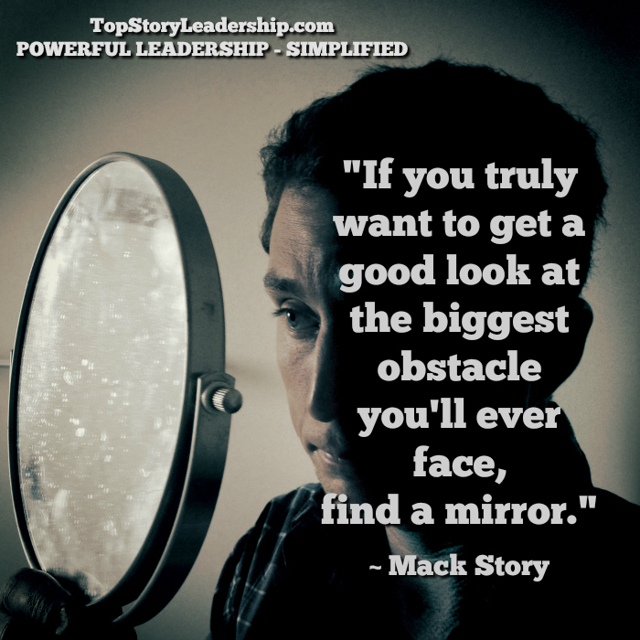

- The power of the pause button.

“Self-mastery is the hardest job you will ever tackle. If you do not conquer self,
you will be conquered by self. You may see at the same time both your best friend and
your worst enemy, by simply stepping in front of the mirror.” ~ Napoleon Hill

- What happens to you is important, but your response to what happens to you is most important.
- As Dr. Stephen R. Covey taught, “Between stimulus and response, there is a space. And in that space, humans have the ability to pause and choose their response.”
- Proactive people respond based on values in alignment with natural laws and principles. But, reactive people respond based on feelings.
“If you do what is easy, your life will be hard.
But if you do what is hard, your life will be easy.” ~ Les Brown

- The future is in you now.
“There’s nothing you have to do. We all have the power to make a decision that will direct us to a new destination. Each of us can make a choice that will change our life.” ~ John G. Miller

- If you don’t choose your future, someone else will.
- Your future is defined and refined by the choices you make every day.

With only a few exceptions, you're exactly where you're supposed to be based on all of the choices you have made leading up to this moment. If you were supposed to be someplace else, you would already be there. You must own the results your choices have produced.

Until you own that you're responsible, you're being irresponsible. That’s the reason those blaming others for their circumstances can't improve their circumstances.

How ridiculous is that thought process? It's my fault, but I'm going to say it's your fault. And then, when you don't fix something that only I can fix, I'm going to blame you for that too while thinking all of this will somehow improve my circumstances. That thought process has a zero chance of making anything in your life better. Many people wake up and live out this model from start to finish every day.

“We are anxious to improve our circumstances but unwilling to improve ourselves.
We therefore remain bound.” ~ James Allen

- Courage is contagious.
“Life shrinks or expands in proportion to one’s courage.”
~ Anais Nin

- Courage allows average people to achieve exceptional results.
- For many, the missing piece of the puzzle is courage. Courage to do the right things at the right time for the right reasons while those around you are constantly trying to get you to do the wrong things for the wrong reasons.
“We often think of courage as a quality required only in times of great danger or stress. But courage is an everyday virtue, needed to live a life without regrets. Why do we need courage?

1. We need courage to seek the truth when we know it may be painful.
2. We need courage to change when it's easier to remain comfortable.
3. We need courage to express our convictions when others challenge us.
4. We need courage to overcome obstacles when progress will come no other way.
5. We need courage to learn and grow when it will display our weakness.
6. We need courage to take the high road when others treat us badly.
7. We need courage to lead when being in front makes us an easy target” ~ John C. Maxwell

“While one person hesitates because he feels inferior,
another person is making mistakes, and becoming superior.” ~ Henry C. Link

- You attract who you are.
“The people with whom you habitually associate are called your ‘reference group,’ and these people determine as much as 95% of your success or failure in life.”
~ Harvard Social Psychologist, Dr. David McClelland

- Those who like you the most are the most like you.
- As Dr. Henry Cloud stated so clearly, “One of the most expensive things you could ever do is pay attention to the wrong people.”
We become the average of the five people we voluntarily hang around the most. It’s true.

We start talking like they talk, acting like they act, dressing like they dress, eating what they eat, drinking what they drink, doing what they do, and most importantly, we begin to think like they think and believe what they believe. And ultimately, get the results that they get.

“In the end, you may not be able to change the people around you,
but you can change the people you choose to be around.” ~ John C. Maxwell

- Character counts.
“Character is like a tree and reputation like a shadow.
The shadow is what we think of it; the tree is the real thing.” ~ Abraham Lincoln

- Who we are on the inside is what others experience and feel on the outside.
- When it comes to your character, it’s not about what you know. It’s about who you are.
“I define high impact character as: thinking, feeling, and acting in a congruent way
while making excellent moral and ethical choices based on self-evident,
natural laws and principles.” ~ Mack Story

- Most often, people are hired for what they know and fired for who they are.
- Mahadev Desai, Mahatma Gandhi’s secretary, when asked how Gandhi could speak for hours, without notes, while mesmerizing his audiences said, “What Gandhi thinks, what he feels, what he says, and what he does are all the same. He does not need notes. You and I, we think one thing, feel another, say a third, and do a fourth, so we need notes and files to keep track.”
- Character is personal, but it’s not private.
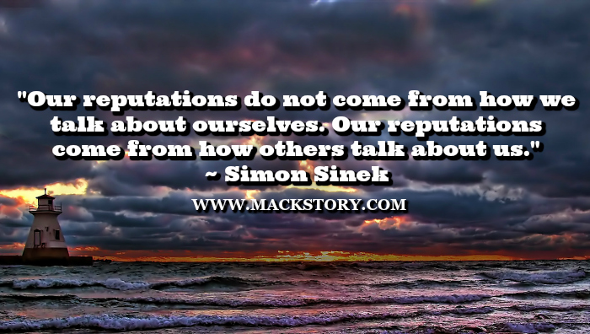

- Character trumps competency.
“You can’t climb to the top of the mountain with base camp character.”
~ Mack Story

- What you know matters. But, who you are matters most. People are typically hired because of their competency. But, people are typically fired because of their character.
- Character serves as a multiplier and leverages your competency.
- You have far more than you need to succeed on the outside because it’s provided for you. The question is do you have what you need to succeed on the inside? In this area, you are fully and completely responsible.
Who we are, our character, is the source of most of our problems.

- How do you deal with things that don't go your way?
- Are you reactive or proactive when it comes to change?
- Are you part of the problem or part of the solution?
- How do you treat others? How do you make them feel?
- Do you talk behind their backs?
- Do you give others credit? Do you take the credit?
- Do you want to serve or be served?
- Do you show up at work on time? Or, are you late?
- Are you on time for meetings? Or, are you late?
- Do you do what you say you will do?
- Do you do it when you said you would do it?

“A sign of wisdom and maturity is when you come to terms with the realization that your decisions cause your rewards and consequences. You are responsible for your life, and your ultimate success depends on the choices you make.” ~ Denis Waitley

- Leaders have followers.
“A leader is someone who has followers. If there are no followers, there is no leader. A person may have subordinates, workers, admirers, associates, co-workers, friends, and people who report to him or her, a person may have authority over other people, a person may hold an elective office, and a person may influence a large number of people, but that does not make that person a leader if there are no followers.” ~ Jimmy Collins

- The difference between a leader and a boss is what they value.
- Bosses value position and power over others (formal authority). Leaders value positive influence with others (moral authority).
You, and your children or spouse if you have either, can actually feel the difference between a boss and a leader. Do you want to be a boss or a leader?

You don't have to be a leadership expert to be able to determine if a person is a boss or a leader. You just need to spend some time with them. The difference is how they make you feel.

- A boss makes you feel used. A leader makes you feel valued.
- A boss makes you feel bad. A leader makes you feel good.
- A boss makes you feel dumb. A leader makes you feel smart.
- A boss makes you feel like it's their idea. A leader makes you feel like it's your idea.
- A boss makes you feel powerless. A leader makes you feel powerful.
- A boss makes you feel guilty. A leader makes you feel responsible.
- A boss makes you feel small. A leader makes you feel tall.
- A boss makes you feel afraid. A leader makes you feel brave.
- A boss makes you feel alone. A leader makes you feel supported.
- A boss makes you feel weak. A leader makes you feel strong.
- A boss makes you feel defeated. A leader makes you feel invincible.
- A boss makes you feel tired. A leader makes you feel inspired.
- A boss makes you feel like an object. A leader makes you feel like a person.
As a child, were your parents bosses or leaders? Maybe one was a boss and one was a leader? Or, were they both bosses or both leaders? Remember, leading yourself well isn’t just about what happens at work. It’s also about what happens at home.

If you’re a parent, now look in the mirror. What do your children see when they look at you? Look at the list again. How do you make them feel? Do you care how you make them feel?

“A true leader has the confidence to stand alone, the courage to make tough decisions, and the compassion to listen to the needs of others. He does not set out to be a leader, but becomes one by the equality of his actions and the integrity of his intent.” ~ Douglas MacArthur

- Positions are overrated.
“If you can’t lead without a position, you won’t lead with a position.” ~ Mack Story

- As USMC Lt. Gen. George Flynn remarked, “The cost of leadership is self-interest.”
- If you learn to lead without a position, it will only be a matter of time before you are recognized for your influence and offered a formal leadership position.
- You will always have more options when you can lead (influence) people without a position. Why? Because your influence is real. It’s authentic. People actually want to follow you. They don’t have to follow you. It’s not tied to or related to a position of formal authority. It’s based on who you are, not what you are. That’s moral authority.
- Bosses make things happen with people who have to help them. Leaders make things happen with people who want to help them.

“The only influence that truly has any meaningful value is based on moral authority, not formal authority. Position or title isn’t important or required. Fear and intimidation doesn't exist. Others choose to follow you because of who you are and how you make them feel.”
~ Mack Story
- Followers choose leaders.
“To excel in leadership, you must first master followership.” ~ S. Truett Cathy

- All great leaders were first great followers.
- John C. Maxwell says it best, “Leadership is influence. Nothing more. Nothing less.” You have influence. Therefore, you are a leader.
Considering this definition, we are all leaders. But there are different levels of leaders, different styles of leaders, and different designations for different types of leaders. One of the many designations of a leader is follower. Confusing right?

How can that be? Well, it gets complicated, but here's a simple illustration. No matter who you are or what position of authority you do or do not hold, if I choose to follow you, I am a follower. At the same time, regardless of whether or not I have a formal position of authority, if someone chooses to follow me, I am a leader.

All people are following and leading (influencing) at the same time. By definition, a follower is also a leader because they also influence others.

- Everything rises and falls on influence. When you increase your influence, you increase your options.
5 Ways High Impact Followers Increase Their Influence

  - They add value to the leader.
  - They value the leader.
  - They add value to the team.
  - They value the team.
  - They invest in personal growth.
“A low impact follower does less than expected alone.
A high impact follower does more than expected with others.” ~ Mack Story

20. Seek first to understand.
“Principles are not invented by us or by society; they are the laws of the universe that pertain to human relationships and human organizations. They are part of the human condition, consciousness, and conscience. To the degree people recognize and live in harmony with such basic principles as fairness, equity, justice, integrity, honesty, and trust, they move toward either survival and stability on the one hand or disintegration and destruction on the other.”
~ Dr. Stephen R. Covey

- You will always learn more from listening than speaking.
- When it comes to influence, one of the best ways to influence another person is to first be influenced by the other person.
- Kevin Cashman had this to say, “Authentic listening is not easy. We hear the words, but rarely do we really slow down to listen and squint with our ears to hear the emotions, fears, and underlying concerns.”
- Harvey Mackay offered this advice, “You can win more friends with your ears than with your mouth. People who feel like they're being listened to feel accepted and appreciated. They feel like they're being taken seriously and what they say really matters.”

“Listening requires giving up our favorite human pastime—involvement in ourselves and our own self-interest. It’s our primary, entirely human focus. And it’s where our motivation to do anything comes from. With this as a base, can you see what a problem is created
when we’re asked to listen to someone else?” ~ Sonya Hamlin

21. Think of yourself less.
“There’s a fine line between arrogance and confidence; it’s called humility.” ~ Mack Story

- Ken Blanchard famously said it this way, “People with humility don't think less of themselves. They just think about themselves less.”
- When it comes to "creating your future" you have a choice to make. Will your future be based on a foundation of arrogance or confidence? It’s a choice only you can make.
- When it comes to leading from the front lines with moral authority, trust is the foundation of influence. If you come across as arrogant, you present a me attitude. If you come across as confident, you present a we attitude.
- People with a me attitude create distrust with others and have less influence. People with a we attitude build trust with others and have more influence.

“Humility means knowing and using your strength for the benefit of others, on behalf of a higher purpose. The humble leader is not weak, but strong…is not pre-occupied with self, but with how best to use his or her strengths for the good of others. A humble leader does not think less of himself, but chooses to consider the needs of others in fulfilling a worthy cause. We love to be in the presence of a humble leader because they bring out the very best in us. Their focus is on our purpose, our contribution, and our ability to accomplish all we set out to accomplish.” ~ Alan Ross

22. Ask for more responsibility.
“If we embrace the chance of living life to the fullest,
then we must be willing to accept responsibility for doing it.” ~ Ria Story
- When you accept more responsibility, you will develop more influence.
- The quickest way you build trust from the front lines with your boss is to get results. The easiest way to ensure you don’t have a boss looking over your shoulder is to get results. The quickest way to increase your influence with the boss is to get results.
- Doing a good job is not a bad thing, but doing a great job is an exceptional thing.
- Don’t ask for a raise ask for more responsibility.
- Average people aren’t willing to do what exceptional people are willing to do.

“Are you living your life by default or by design?” ~ Mack Story

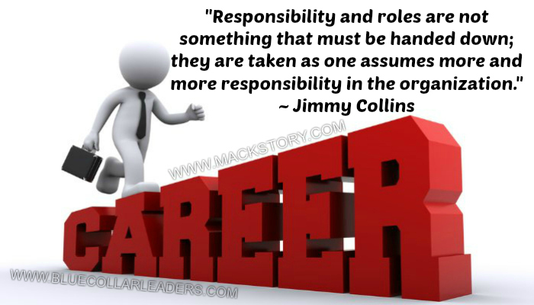
23. There is enough for everyone.
“Coming together is a beginning. Keeping together is progress. Working together is success.”
~ Henry Ford
- Helping others succeed ensures you will succeed.
Insecure people have what’s called a scarcity mindset. They believe there is only so much of a given thing "out there," and everything is limited. They think like this: If you get a raise, I won’t. If you get a promotion, I won’t. If you get credit for doing something, I won’t. If you get noticed, I won’t.

Scarcity minded people also tend to blame others when they don’t get what they want. I didn’t get a raise because someone else got a raise. I didn’t get promoted because someone else got promoted. I didn’t get credit because someone else got credit. I didn’t get noticed because someone else got noticed. And on, and on….

Exceptional, secure people have an abundance mindset. They believe there is enough of everything for everyone. They think like this: If you can get a raise, I can get a raise too. If you can get a promotion, I can get a promotion too. If you can get credit, I can get credit too. If you can get noticed, I can get noticed too.

When you choose abundance, you don’t hoard knowledge. You share it openly and freely. You want to help others get ahead because you know helping others helps you. Common sense again.

“Abundance is not something we acquire. It is something we tune into.” ~ Dr. Wayne Dyer

Assume you’re the boss and can promote one of two people. Everything is equal but one thing. One doesn’t share knowledge and doesn’t want to help others succeed. One shares knowledge intentionally to help others succeed. Which one gets promoted? The one sharing with abundance gets promoted. Look at it from a different angle. There has been a drop in customer orders. Unfortunately, you must let one go. Which one loses their job? Obviously, the knowledge hoarder with scarcity.

“Nothing can stop the man with the right mental attitude from achieving his goals; nothing on earth can help the man with the wrong mental attitude.” ~ Thomas Jefferson

24. Be the first to help.
“Leaders are not always the first to see the need for change, but they are the first to act. And once they move away from the pack, they are positioned to lead.” ~ Andy Stanley
- Everyone remembers the first to help; few, if any, remember the second.
- Helping others helps us. Not sometime, every time. With people, the little things are the big things.
- People may not always remember what you said or what you did, but they will always remember how you made them feel. When they feel good because of you, your influence goes up. When they feel bad because of you, your influence goes down.
- Leadership is contagious. Leadership is better when it’s caught than taught.
“By accident of fortune one may be a leader for a time,
but by helping others succeed one will be a leader forever.” ~ Chinese Proverb

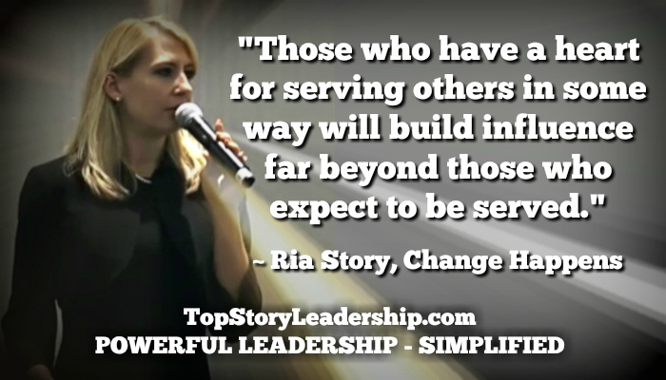

25. Do more than expected.
“Never mistake effort and intentions for results.” ~ Dick Vermeil

- Doing more than expected increases your influence. Doing less than expected decreases your influence.
The rest of this training is about accepting responsibility at higher level. You do that by embracing the challenge of becoming exceptional on the front lines and/or by moving beyond the front lines if that’s the future you want to create for yourself.

Too many people on the front lines wait to be told what to do while often complaining about not liking to be told what to do. They don’t feel responsible for deciding what to do next. You’ll hear things like: “That’s above my pay grade.” Or, “They don’t pay me to think.”

- The first level of responsibility above waiting to be told is to ask what to do next when you’ve completed a task or can no longer do what the boss thinks you are doing.
- If you truly want to step up to the plate, accept more responsibility, and lead from the front lines, move beyond asking what to do next and start recommending what you should do next when you have the opportunity.
- When you recommend, everything changes because you have started thinking. But, what you’re actually doing during the process is learning, demonstrating to the boss you can think, revealing to the boss how you think, and playing a bigger role in deciding what you may actually be doing next.

“Start doing what is necessary; then, do what is possible;
and suddenly you are doing the impossible.” ~ St. Francis of Assisi

26. Do it sooner than expected.
“The wise does at once what the fool does at last.” ~ Jewish Proverb
- Doing things sooner than expected increases your influence; doing things later than expected decreases your influence.
- Making it happen is great, but making it happen sooner than expected can pay huge in the influence department. Why? Because you’re building trust.
“The beauty of trust is that it erases worry and frees you to get on with other matters.
Trust means confidence.” ~ Stephen M. R. Covey

- The front line is the perfect place to build trust and gain influence using the principle of doing it sooner than expected because you don’t need a position. All you need is the desire to excel, to give the extra effort required, and to understand the impact it will have on your relationship with the boss. Don’t forget, the boss is your #1 customer.
- When someone doesn’t trust you, it’s not their fault. It’s your fault. You can’t make someone trust you. You can only make choices that make you trustworthy. Then, others can choose to trust or distrust you based on your choices.
“With trust, we always know.
Without trust, we never know.

With trust, everything is possible.
Without trust, everything is questioned.

With trust, things happen fast.
Without trust, things happen slowly, if at all.

With trust, relationships strengthen.
Without trust, relationships weaken.” ~ Mack Story

“The successful person has the habit of doing the things failures don't like to do.”
~ E. M. Gray

27. Do it better than expected.
“When you do the common things in life in an uncommon way,
you will command the attention of the world.”~ George Washington Carver
- Doing things better than expected increased your influence. Doing things worse than expected decreases your influence.
- When you pay attention to the details and go above and beyond expectations, people pay attention to you.
- If you want to do it better than expected on the front lines, do two things: 1) Focus on developing yourself. 2) Focus on improving the processes where you work.
- You can really create tremendous synergy when you blend doing more than expected with doing it sooner and better than expected. The result is proactive process improvement.

“Don't measure yourself by what you have accomplished,
but rather by what you should have accomplished with your ability.” ~ John Wooden

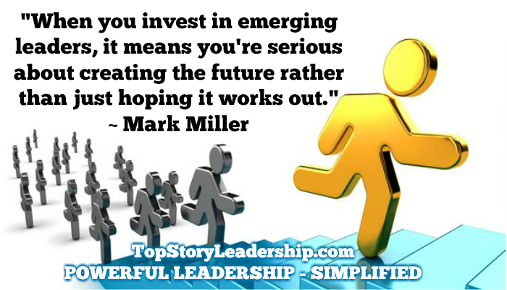

28. Stretch yourself intentionally.
“If you work hard on your job you can make a living,
but if you work hard on yourself you can make a fortune.” ~ Jim Rohn

- All of your growth happens outside of your comfort zone.
- The more you embrace change and challenge, the more valuable you will become to others. Why? Because that’s when all of your learning and personal growth happens. That’s where you gain new experience.
- Choosing to stretch yourself isn’t about how smart you are. It’s about how secure you are.
“No amount of personal competency can compensate for personal insecurity.”
~ Wayne Smith

- If you’re comfortable, you’re not growing. You’re slowing. Growth doesn’t just happen. You must make it happen.
- If you don’t know where you want to be in five years, you’re already there.

“When we are faced with change, we either step forward into growth
or we step backward into safety.” ~ Abraham Maslow

29. Develop yourself intentionally.
“Accidental growth vs. intentional growth is about as effective as accidental exercise compared to intentional exercise....not even close. And the results....not even close.”
~ Mack Story

- If you won’t invest in yourself, why should anyone else?
- There will be many opportunities waiting for you after you have prepared for them, but not before.
- Hope is not a strategy. However, hope is needed to develop a strategy. Without hope, there will be no sacrifice.
- Sacrifice is giving up something of lesser value now for something of greater value later.
- Whenever you place the cause of one of your actions outside of yourself, it's an excuse, not a reason.
“There’s something I learned from my mentor, John C. Maxwell, called The Rule of 5. I use it intentionally every day. You can too.

The Rule of 5 means you determine the most important thing you want to accomplish intentionally. Next, identify the 5 most important things you must do every day to reach the goal. Then, do them every day until the goal is met. Not all day, but do some amount of each, no matter how small of an amount, every day. Modify your list if necessary, but stay focused on it.

You should do these 5 things daily until you reach your goal. Do them after work if necessary. Remember, you’re not doing it for the company. You’re doing it for yourself. Then, develop a new goal and repeat. It’s not about making a list. It’s about taking intentional action.

Here is my current Rule of 5 list to become a sought after leadership expert: 1) Read leadership content 2) Collect and file leadership quotes 3) Write about leadership 4) Connect with people who value leadership 5) Teach others leadership. I’ve been doing these 5 things daily for many years.” ~ Mack Story

“Today I will do what others won't, so tomorrow
I can do what others can't.” ~ Jerry Rice

30. You must bet on yourself.
“Living intentionally leads to amazing results. Living accidentally leads to
depressing disappointments. A better tomorrow won’t just happen.
You must be intentional and make it happen.”
~ Mack Story

- If you won’t bet on yourself, why should anyone else.
- As you grow and develop, new opportunities will appear. You will develop new relationships along the way that will lead to many of those opportunities. People will take notice. Discussions about your future will happen without your knowledge in many different areas. People who have never talked to you will begin talking to you. A lot will happen.
“Don’t give up! Keep hammering away. It may seem like nothing is happening. Real growth takes some time. There are no shortcuts. If you pay the price, you will reap the reward. That’s another natural law. It will happen. Trust me. I know.

I have lived what you’ve been taught on these pages. I’m not telling you what I’ve learned from nearly 30 years of research. I’m telling you what I’ve learned from nearly 30 years of intentional application and transformation. Nearly 30 years of action!

Not 30 minutes. Not 30 days. Not 30 weeks. Not 30 months. 30 YEARS!

As long as you don’t quit, you cannot fail. Failing is only failing if you quit trying to learn how to succeed. If you keep trying, failing is really learning.

Did you fail to walk or did you learn to walk? You learned without knowing how and no one taught you. Your parents didn’t teach you. They may have helped you and supported you, but you learned all by yourself. No one can teach you to balance yourself. That has to happen on the inside.

You also didn’t learn to walk the first time you tried. You actually “failed” at learning to walk hundreds, if not thousands of times, but eventually you figured out what to do by learning what not to do. So, you were never failing, but you were always learning.

Learning to lead (influence) from the front lines may be the same way for you. Don’t give up. Keep trying.” ~ Mack Story

“To grow, you must be willing to let your present and future be totally unlike your past.
Your history is not your destiny.” ~ Alan Cohen

It’s time to place your bet! My money is on you!

