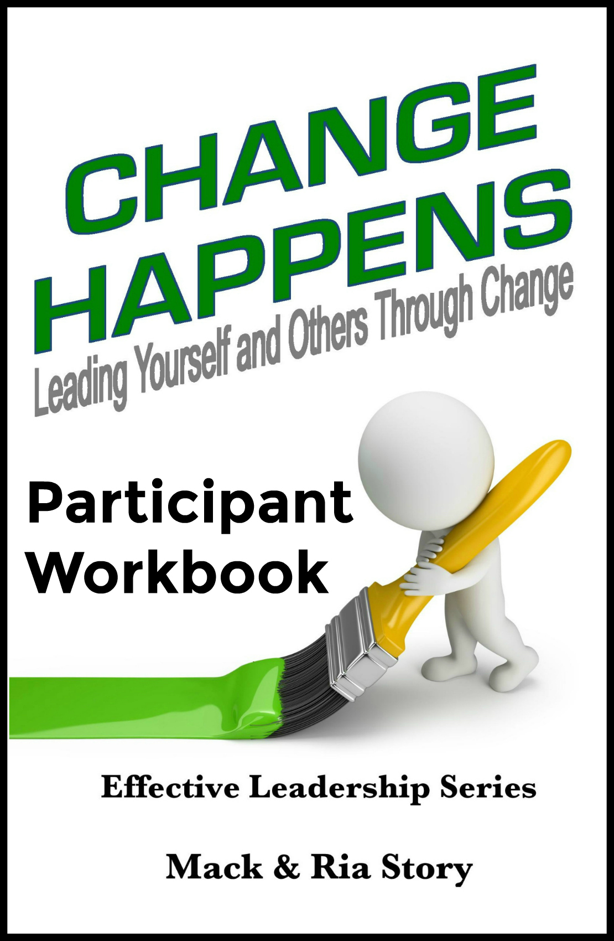
A note from Mack & Ria

Dear friend,
As a leader (person of influence), you have a remarkable responsibility to impact the lives of those around you, personally and professionally. Remember that as you work your way through this material.
We will be partners as we explore the principles related to effectively leading yourself and others through change. We can’t raise the bar for others if we can’t reach it ourselves. As you study and teach, we already know you will reach new levels of knowledge, growth, and understanding. We’re also confident you will motivate and inspire others to also reach higher as they learn to embrace and leverage change.
The values (principles) contained in Change Happens are timeless and have been tested and proven again and again by high impact people across multiple generations around the world. We encourage you to read, study, and familiarize yourself with the ideas in this book in order to prepare to lead others effectively through this information. The key to creating an engaging experience using this content is to teach the principles while supporting them with practices (stories) from your own life. As you teach it, make it your own.
Ultimately, your ability to effectively teach these principles will be based on your ability to effectively apply them in your own life. We’re always teaching what we’re modeling, regardless of what we’re teaching.
We have devoted our lives to helping people make a high impact by making what is common sense also common practice. It is our hope that you will have as much fun as we do while you lead people to a greater understanding of these values that will unleash their true potential. High impact people always have high impact values.
Make it happen or someone else will! It might as well be YOU!
Your friends,
Mack & Ria Story
Mack & Ria Story
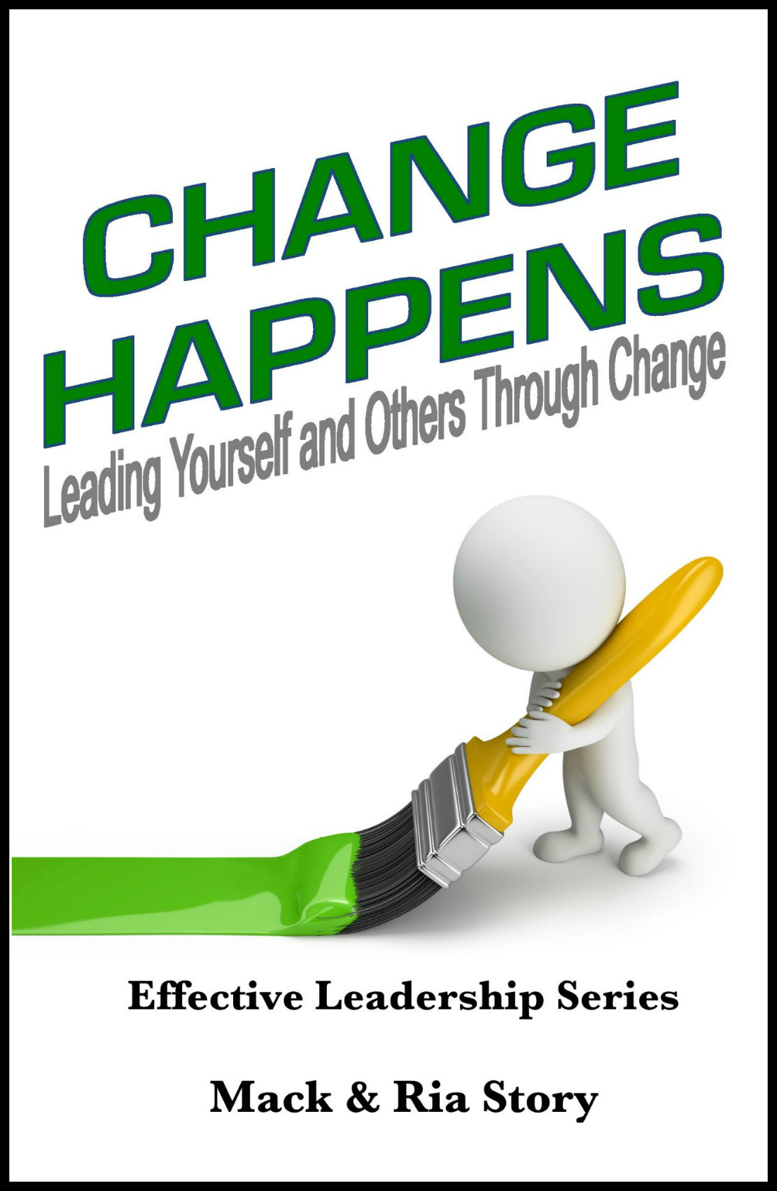
Change Happens
Leading Yourself and Others through Change
by Mack & Ria Story

- Nothing Fails Like _______________

“When a challenge in life is met by a response that is equal to it, you have success. But, when the challenge moves to a higher level, the old, once successful response no longer works –
it fails; thus, nothing fails like success.” ~ Stephen R. Covey

  - The problem with success and why it’s often the precursor to downfall is because success often doesn’t ___________ us anything.
  - Success today is one of the biggest _____________ of future success.
  - Nothing fails like trying to remain the same in a changing world.
  - What was mastered yesterday may no longer be ___________ today.
  - Success often quickly leads to _______________.
  - The successful person “has arrived,” and the temptation to enjoy what was earned, to rest, and to coast lurks just around the corner.
  - The ______ of complacency rises with each level of success, personally and professionally.
  - To become complacent means we quit striving for ______________, for ____________, and for something better.
“You can never get complacent because a loss is always around the corner. It’s in any game that you’re in - a business, game, or whatever - you can’t get complacent.” ~ Venus Williams
- Nothing Fails Like Success (continued)

“The illiterate of the 21st century will not be those who cannot read and write,
but those who cannot ________, ___________, and ___________.” ~ Alvin Toffler

  - Once we’ve achieved success, most of us no longer want to ___________. We want to hold our ground and keep things just the way they are.
  - In today’s busy world, everything is ______________ changing. People change, processes change, customers change, products change, demand changes, suppliers change, expectations change, and many other things will change. Change happens.
  - When everything is constantly changing, the _____________ is also changing.
  - Therefore, the one thing that should also constantly change is: _____.
  - If we’re not willing to change, we should expect to be left behind by those who are.
  - When we choose to constantly change to meet new challenges, we have a chance to continue to achieve personal and organizational success.
  - When we _________ to change in response to new and greater challenges, we and the organizations where we work will ____________ to survive, and some will end up taking a dive.
  - If you want to intentionally accelerate your climb up the corporate ladder and be recognized as a high impact team player by the high impact leaders in your organization, you must become a ___________ at learning, unlearning, and relearning when change happens.

“If you want to make enemies, try to change something.” ~ Woodrow Wilson

- The __________ of Change

“Change is the ______ of life. And those who look only to the past or present
are certain to miss the future.” ~ John F. Kennedy

  - The impact of change means the ______ of something familiar.
  - When change occurs, the predictable, stable situation we have become comfortable with is ending and a new situation is beginning. For most people, that could be, and usually is, considered a ____________ impact of change.
  - There is also a ____________ side to the impact of change.
  - Change brings new situations, new experiences, new challenges, and usually new opportunities. That could be, although often isn’t, considered the positive impact of change.
  - While we cannot control every aspect of the situation, we certainly can __________ how the change impacts us personally.
  - How the change affects us is determined by our ___________ and degree of acceptance of the change.
  - The attitude you choose will determine much of what happens in the ___________.
  - When change impacts us, we become more focused on the negatives of the situation instead of the positives. Often, we spend more time and energy worried about what we don’t know and what we can’t control than we do on looking for the ____________ of the change.

“Uncertainty creates the necessary condition for ______________.” ~ Jim Kouzes

- The Impact of Change (continued)
“The __________ of change is to focus all your energy, not fighting the old,
but on building the new.” ~ Socrates

  - The impact of change brings out the worst in some and the best in others.
  - When change happens, the first thing people want to know is, “How is this change going to impact me?” Until they know the answer, they’re not interested in anything else.
  - It’s the leader’s _____________ to help others feel ______ when change happens.
  - When people are uncertain about the changes happening to them and around them, there’s a tremendous need for ________________.
  - Leaders must ________ their team members focus on what’s ______ and move beyond what’s _____.
  - When change happens, some people will simply ___ through the change passively allowing change to happen to them while others will ______ through the change actively making change happen around them.
  - Those growing through change will be identified by their leaders as _____ ________ team players who are helping them and other team members effectively deal with change.
  - When change happens, those going through change tend to ________. But, those growing through change tend to ________.

“When we are faced with change, we either step forward into __________,
or we step backward into ___________.” ~ Abraham Maslow

- Two Ways to Deal with Change
“You must take personal ______________.
You cannot change the circumstances, the seasons, or the wind, but
you can change _____________. That is something you have charge of.” ~ Jim Rohn

  - Viktor Frankl said it best, “Between ___________ and ____________, there is a space. In that space is our _________ to __________ our response. In our response lies our _________ and our _____________.”
  - Regardless of the situation we find ourselves in, we have the _________ to choose how we respond to it. Even if we cannot change the situation itself, we can choose to change how we look at it and how we respond to it.
  - When we choose to rise above our circumstances or our environment, we find the ultimate freedom in personal growth and development.
  - The ___________ person will rise above his or her situation, take personal responsibility, and choose to be proactive by helping things go right.
  - The ___________ person will blame anything and anyone else for their circumstances and choose to do nothing. They become part of the __________ instead of part of the ____________.
  - Being proactive will help you manage your _____________.
  - Being proactive will allow you to stand out among your peers as someone who is a leader or who has leadership potential.
  - Being proactive will help equip you to meet the challenges of change and turn them into opportunities.
“When we are no longer able to change a _____________,
we are challenged to change ____________.” ~ Viktor Frankl
- Two Ways to Deal with Change (continued)

“Being _____________ about discovering the hidden ways in which we sabotage ourselves empowers us to expose and eliminate these invisible culprits.” ~ Amir Ghannad

  - When change happens, you can rest assured those responsible for implementing the change are ___________ you. They want to know several things:
- Are you with them or against them?
- Can they _______ you?
- Will you ______ them? Or, will you ______ them?
  - Are you a ____________ high impact leadership? When change happens, do others see you whining or shining?
  - The instant change begins to happen, you begin to increase or decrease your ___________ with those around you because change puts you in the spotlight. Your peers are watching and your leaders are watching.
  - When the spotlight is on you, the ___________ is also on you. How will you respond? Will you be seen hanging with the whiners or rising with the shiners?
  - When change happens, reactive leaders instantly begin to let their _________ be seen and heard. They are the first to complain and are the most outspoken.
  - The more we ___________, the less we __________.
  - Proactive leaders choose to become comfortable being uncomfortable.
  - Proactive leaders positively embrace, leverage, and lead change. They intentionally engage their team by modeling the behavior they expect.
“Human beings, by changing the _________ attitudes of their minds,
can change the ________ aspects of their lives.” ~ William James
- Resisting Change

“The first step toward change is ___________. The second step is ______________.”
~ Nathaniel Branden
  - Resistance to change _______ from person to person and from situation to situation.
  - What’s interesting is we can recognize this in other people’s lives, but when it comes to our own, sometimes we don’t even realize we are being resistant to change.
  - Often, we resist change because we ________ the _____________.
  - Some people choose to resist change and go with a known situation, even if it’s not the best choice.
  - If we are resistant to change for the sake of keeping things the same, we make the mistake of missing out in life.
3 Reasons Some of Us Resist Change:
- It’s not ______________. Anytime we are changing, we must get __________ our comfort zone. We leave behind a comfortable, familiar setting and find ourselves dealing with a lot of unknowns.
- It’s not ______. Anytime we are changing, we must put more energy into the situation. Change requires more _________ and _________ than the status quo because your mind must unlearn and relearn.
- It requires ________. We don’t mind risking often if the risk is small or low, and we don’t mind risking as much when we stand to gain big. But, we don’t naturally like to take risks if the odds aren’t good, or we stand to lose a lot.
“Your mind __________ your results.
If you want to change your results, you first must change your mind.” ~ Mack Story

- Resisting Change (continued)

“Managers change ___________. Leaders change the way you __________
without you realizing it.” ~ Daniel Burrus

  - Most often, people are resistant to change because they haven’t been __________ how to ___________ about and leverage change.
  - If the leader openly resists change, they are more likely to have a team that resists change. When change happens, everyone is watching the leader’s ______________.
  - John G. Miller was definitely looking in the mirror and intentionally choosing to accept responsibility when he said, “God grant me the serenity to accept the people I cannot change, the courage to change the one I can, and the wisdom to know...it’s _____!”
  - When change happens, it’s the leader’s responsibility to insure his/her team is _____________ for change.
  - Often, leaders must change how they ________ in order to model a higher level of thinking and a different level of _________ for their team.
  - Leaders must understand those who are avoiding and resisting change are _________ to the team and the organization.
  - As a leader, you must determine how much time and energy you are willing to dedicate to help those who are resisting change begin to embrace change.

“Unfortunately, too often people focus on the negatives and lose sight of the multitude of blessings that surround us and the limitless potential that exists for the future.”
~ Sir John Templeton

- Change or Be Changed

“In times of change, ___________ inherit the earth; while the learned find themselves beautifully equipped to deal with a world that no longer exists.” ~ Eric Hoffer

  - When things change, we can choose to change with them, or we will find ourselves put _______, passed _______, or pushed _____.
  - When we are put aside and passed over, we may never realize the many ____________ we missed as a result.
  - Once we’re identified as someone who is resistant to change and someone who refuses to change when necessary, our influence ___________ as we begin to be consistently overlooked.
  - When we develop a track record of resisting change, we may be terminated, asked to resign, or asked to retire. Often, although not always, this is the direct result of continuously refusing to __________ and _________ to an ever changing world.
  - Opportunities and promotions may go to those with less experience or seniority simply because they demonstrate the ability and willingness to ___________ and _______ their leader when change happens.
  - _____ impact people reactively go through change.
  - ______ impact people proactively grow through change.

“Low impact people __________ go through change.
High impact people _____________ grow through change.” ~ Mack Story

- Change or Be Changed (continued)
“Most people won’t _____ the immediate _________ to change
and end up paying the ___________ price for not changing.” ~ John C. Maxwell

  - ___________ should help their team understand they will pay the price of change, or they will pay the price of being changed. Either way, there will be a price to pay.
  - Leaders should help their team understand the price, relative to change within the organization, refers to two main areas:

- _____/_______ – This is a _______ price and must be paid whenever you decide to change. This is the price that must be paid to learn new skills and adapt to the changes.

- ___________ – This price is a __________ price. _________ is huge in this area. If you lead change and/or accept and embrace change early, you may actually receive a payment with an increase in influence. However, if there’s any delay in accepting, embracing, and supporting the change, you will pay a price by losing influence. You may never know you have lost influence, but it will happen. The longer the delay, the greater the loss.

  - Influence is hard to come by. It’s highly recommend that you ___________ what you already have and _______ your influence when you can.
  - When a person ________ to accept, embrace, and support change, they may potentially be choosing to _____-_____________. They are not being fired because they _______ ___ ______ but wanted to stay.
  - Leaders always prefer to change others (help them change) rather than have to change others (terminate/replace them).
  - If the leader can’t effectively lead change, they will be replaced by someone who will.

“Change is the foundation for __________.” ~ Mack Story
- If You Snooze, You Will ______

“Because things are the way they are, things will not stay the way they are.” ~ Bertolt Brecht

  - Regardless of our wishes, change is going to occur in life, at work, and at home.
  - Anytime change is occurring, there are challenges and opportunities.
  - We only hurt ourselves when we attempt to maintain the ______ while things are changing in the __________.
  - Those who are quick to ______ the opportunities will be able to take __________ of them, while those who are ____________ to change will decrease their influence.
  - We miss out by __________ to embrace changes when they occur.
  - We must ___________ we aren’t entitled to the status quo.
  - The ______ person to respond positively to change has the first chance to stand out as a leader, the first chance to influence others positively, the first chance to have ______ or ______ make decisions, and the first chance to take advantages of new opportunities.
  - It’s true. Change isn’t always for the better. It’s also true that if nothing changes, nothing gets better. If everything stays the same, there will be no improvement.

“It’s easier to _____ your way into a new way of ____________,
than think your way into a new way of acting.” ~ Jerry Sternin

- If You Snooze, You Will Lose (continued)

“Difficulties come to you at the right time to help you ______ and move __________
by overcoming them. The only real misfortune, the only real tragedy,
comes when we suffer without learning the __________.” ~ Emmet Fox

7 Ways You Lose When You Snooze

1) You will have ______ meaningful, positive ___________ in every direction. When your influence goes down, so does your value and your options.
2) You will not be asked for ______. One way a decrease in influence reveals itself is when your boss and other leaders don’t ask your opinions or let you know what’s going on.
3) You will be passed over for ____________. Why would anyone responsible for leading and implementing change consider promoting someone who is resistant to change?
4) You will be passed over for _____ _____________. The people who support and embrace change will be rewarded. Those who don’t will get passed over.
5) You will be seen as part of the _________ instead of part of the ___________. When it comes to change, leaders are constantly discussing who is on board and who is not.
6) You may be ___________. This doesn’t happen too much because if you choose to be a part of the problem, you’re a part of the problem regardless of your position.
7) You may be ______________. The ultimate loss. Not only do you pay the price of your choices, but now those in your family must pay too.

“You can have great academic intelligence and still lack _________ intelligence.”
~ Hyatt & Gottlieb
- The ___________ of Change

“God grant me the serenity to accept the things I cannot change, the courage to change the things I can, and the wisdom to know the difference.” ~ Reinhold Niebuhr

  - Change is hard even when we want it. It’s especially hard if we don’t want it, or it wasn’t our idea.
  - Change of any kind always brings with it the challenges of _________ to something new.
  - Change requires us to use more of our conscious mind than our subconscious mind. _________ that served us in the past are no longer helpful.
  - The challenge of change comes in consciously having to think about the new _______.
  - We must take action in order to respond to the new reality. It requires extra _______ and _________. It won’t happen accidentally.
  - This is difficult when we desire the new reality. It’s much more difficult when we tell ourselves we don’t want the new reality.
  - Change is a challenge because it forces us to cross the gap between _________ and _______.
  - Change requires us to take action and change something on the _________, so we can achieve results on the _________.

“We hear of businesses succeeding or failing, but it is not the business...
it is the __________ who succeed or fail.” ~ Truett Cathy

- The Challenge of Change (continued)

“__________ is always preceded by change. Change is always preceded by _________.
Where there is no challenge, there is no change.
It’s the job of the leader to challenge the ___________.” ~ Andy Stanley

  - If you want a better career and more out of life, change is not an ______. It’s required.
  - If you want to continue to get the same results you’re getting today, then you do not have to do anything differently. You’re safe. You will never have to change a thing. Right? ________.
  - You may have heard someone say, “If you always do what you’ve always done, you will always get what you’ve always gotten.”
That would be absolutely true if everyone else continued to do what they’ve always done. That would mean we live in a world where nothing changes. But, we know we live in a world where everything is changing. Not only is everything changing, but it’s also changing rapidly.

  - If you always do what you’ve always done, you will get _______ because those who are changing for the better will get _______ of everything.
  - Your ability to lead yourself and others through change will determine whether you get a ________ more out of life or a ____ more out of life.
  - You must ___________ your own process. The process of _____ ____ ______ about change.
  - Once you begin to challenge how you think and _____, you will begin to be challenged in another way. Those who don’t embrace change may stop embracing you and start challenging you.
“Leaders ________ to meet the challenge. Followers _______ away from the challenge.”
~ John Kenneth Galbraith
- The Fear of Change

“Everyone thinks of changing the _______, but no one thinks of changing __________.”
~ Leo Tolstoy

  - ______ is what happens when anxiety over something becomes overwhelming.
  - What’s interesting is we often spend a lot of time and energy being _______ of something that may never happen. The vast majority of our fears are completely unfounded.
Here are 3 common fears related to change:
- Fear of the _________. We generally like to know what’s coming. Most of us don’t like big surprises in areas truly important to us. We worry about what might happen. To overcome fear of the unknown, focus on the ________ of the situation, rather than telling yourself a story that may not be true.
- Fear of ________ _________. Having control means we can get what we want. More control equals more options. We fear situations where we lose control because we have fewer options. To overcome the fear of loss of control, we must focus on what we can control about our situation, instead of what we cannot control.
- Fear of _______. Often, we can’t reach what we _______ most because we won’t let go of what we ________ most. When we are fearing a potential loss, we are focused only on the immediate impact. To overcome fear of loss, we must focus on the ________ change will bring, instead of the loss.

“May your __________ reflect your hopes, not your fears.” ~ Nelson Mandela

- The Fear of Change (continued)

“You’re afraid. So what? Everybody’s afraid. Fear is the common ground of humanity. The question you must wrestle to the ground is, ‘Will I allow my fear to ____ me to mediocrity?’”
~ Andy Stanley

  - If you’re going to choose to fear something, don’t fear change. Fear ____________.
  - At this moment, you may or may not realize how much the fear of change may be holding you, and possibly your team, back.
  - That little voice in your head is nudging you ________. It constantly plants and waters the seeds of aspiration within you. What is it inside of you that holds you back? What inside of you prevents you from actually climbing to the next level? It’s one thing. And for everyone, it is the same thing. It is fear. It is ______ ___ ___________.
  - Donovan Weldon, spoke these powerful words, “The only person between you and success is you. ______! The only person between you and failure is you. _______ _______!”
  - Will you embrace change? Or, will you embrace mediocrity? The _________ is yours to make.
  - When you choose to _______ _________, you may be choosing to embrace mediocrity.
  - There’s only _____ person on this earth who can remove the fear barrier and allow you to lead yourself and others to the next level and beyond: _____.
“Courage comes with the sun. You can conquer almost any fear if you will only make up your mind to do so. For remember, fear doesn’t exist anywhere except in ______ _______.”
~ Dale Carnegie

- ____________ Change

“Change ________ you have to.” ~ Jack Welch

  - Learning to embrace change is much __________ than learning to tolerate change.
  - Embracing change means you ___________ the opportunity to try something new.
Here are 5 ways you can embrace change:
1) _____ and _________. Action is the enemy of ___________. Slow down. Spend some time thinking. Sit down somewhere quiet. Think about what needs to change and why. Think about what you need to do in order to create that change.
2) Let go of the _____. It’s strange how nostalgia makes the past seem better than it was. Don’t spend too much time looking back. Resolve to remember the past, but let it go. Move on to the future. The past wasn’t as good as it seems now. Even if it was, it’s gone.
3) Remove the ________. Improve your ____________ environment by getting rid of the things that aren’t serving you. In times of change, two of the most important things to rid ourselves of is toxic __________ and toxic ___________.
4) Try something ______. Read a book by an unfamiliar author – maybe you will gain a new perspective. Meet someone new and listen to their story. Whenever we are facing change, if we can embrace it in small ways, it will become easier to embrace it in big ways.
5) Create a new (good) _______. In times of change, we can feel out of control. The mental ______________ of forming a new habit will create momentum and the sense of accomplishment will empower you. Always start with a small habit to ensure you will be successful.

“All meaningful and lasting change starts first in your ______________
and then works its way out.” ~ Albert Einstein
- Embracing Change (continued)

“It really is amazing what happens when you __________ the importance of the opportunities ahead of you, _________ responsibility for your future,
and take __________ action.” ~ Michael F. Sciortino, Sr.
  - When you embrace change, you are also embracing _______________.
  - When it comes to embracing change, there’s a magic word you can proactively use to begin separating yourself from the crowd in a way that allows you to get _________ by the high impact leaders and ___________ for the __________ reasons. The magic word is “_______?”
  - When you ask, “_____ ______ ___?” or “_____ _____ ____?” instead of “Can I?” or “Can we?” you have started to truly _____________ the way you and others think. “Can I?” indicates self-doubt. You don’t know if you can. But, when you say “How can I?” you have already decided you will and you can. Therefore, your imagination can run wild in the _________ direction.
  - “How can I?” indicates there is a way. You just need to ____________ it. Asking how triggers the proactive muscles in your mind, and you get busy trying to find a way.
Listen to the voices of those proactively embracing change:
- How would a proactive person respond?
- How will I be viewed if I respond positively?
- How can I help others embrace the change?
- How will this benefit me?
- How can I leverage this change to my benefit?
- How will this benefit our team?
- How will this benefit the organization?
- How will this make us more competitive?
- How can I help make it happen?

“If we embrace the __________ of living life to the fullest,
then we must be willing to accept ______________ for doing it.” ~ Ria Story
- Leveraging Change

“I cannot say whether things will get better if we change; what I can say is they
______ change if they are to get better.” ~ Georg Lichtenburg

  - When you find yourself stressed out over a change, it’s especially important to spend time ____________ on how to ____________ it.
  - Leverage (the verb) is defined as “using a quality or advantage to obtain a __________ result.”
  - Leveraging something can be a powerful way to gain _____________ and accelerate _____________.
  - Change always brings _________________.
  - When we leverage change we not only take advantage of the obvious opportunities, we __________ new ones as well.
  - Anytime we are experiencing change, we can learn to leverage it by looking for the opportunities. Ask yourself these six questions:
  - What does this change mean for me personally?
  - What areas (social/relational, mental/emotional, physical, or spiritual) of my life does this change impact?
  - How does this affect my environment?
  - What opportunities does this change bring?
  - How can I create more opportunities from this change?
  - How can I leverage this change to make a bigger improvement with this opportunity?
“A sign of _________ and __________ is when you come to terms with the realization that your ___________ cause your rewards and consequences. You are responsible for your life, and your ultimate success depends on the ________ you make.” ~ Denis Waitley

- Leveraging Change (continued)
“When others are moaning, groaning, and whining, it’s easy for you to start __________.”
~ Mack Story
Leveraging change means you seek ways to intentionally _____ your influence during change.
7 Benefits of Leveraging Change in the Workplace
1) You will be ________ for taking initiative. The first to help always gets the most recognition.
2) You will build strong relationships with the ______ ___________. When you embrace change, you are attracting others who embrace and initiate change.
3) You will get to _______ more about how the business operates. As you interact with more game changers, you will build _________. Be sure to ask questions to learn the thought process behind the change.
4) You will have more _______ in implementing the change. When you get involved with making the change happen, you will be asked your opinion.
5) You will have more input in ________ changes. As you build relationships with leaders during change, they will begin asking your thoughts about future changes.
6) You will become more __________. When leaders start to benefit from your support and your ideas for improving the processes and moving the organization forward, you become more valuable to them and the organization.
7) You will be considered for ____________. Those who make an impact helping the leaders implement change will be given more opportunities to make an impact.

“If someone you’re trying to influence doesn’t _____ you, you’re not going to get very far; in fact, you might even elicit suspicion because you come across as manipulative.” ~ Amy Cuddy

- Leading Change

“Intelligence is the ________ to ________ to change.” ~ Stephen Hawking

  - When we talk about leading change, it’s important to remember the most difficult, and most important, person to ______ is oneself.
3 ways to influence and lead change within yourself:
  - What you _______ about. Leading change with oneself begins by choosing your thoughts carefully. The moment you feel negative about the changes, stop and think about the benefits or positive aspects of the situation. Oprah Winfrey said, “What you focus on ___________,” and that’s especially true for situations where you are dealing with change. Focus on the negatives, and they will ___________ until they overwhelm you. Focus on the positives, and you will find __________ of them.
  - What you ______ yourself. You are the most important person you will ever talk to. Because, whatever you tell yourself carries far more weight in terms of impact on your mental state. You can talk yourself into or out of just about anything. Embrace change by looking at the situation honestly and evaluating how you are talking to yourself about the change. Are you telling yourself it was better the old way? If so, you will never embrace the changes or lead others through them. Tell yourself you are moving on. Times change, and so should you.
  - What you tell _________. It’s almost as if speaking something out loud affirms it and makes it feel true. The more we repeat something to someone else, the more we believe it too – until we know it’s true without a doubt. Your words carry weight. That’s why focusing on the positive is so important.
“Life does not get better by __________. It gets better by ____________.” ~ Jim Rohn

- Leading Change (continued)

“While one person __________ because he feels ______________,
another person is making __________, and becoming ___________.” ~ Henry C. Link

  - ____________ people will forever remain average, and often miserable, as they struggle through life…unless they choose to change.
  - Since leadership is defined as ___________, a formal leadership position isn’t required to lead change. You simply need a __________ to leverage your influence by applying the principles you’ve been learning.
  - Getting __________ is the quickest way to build ________.
  - When you can implement change effectively in support of the leaders in a way that helps them accomplish their mission, they will begin to figure out where you can make a bigger impact and how they can better ___________ and ____________ you.
  - What are the leaders doing? Exactly what you learned about in the last section, ___________ change.
  - When they can change your role and give you more authority and responsibility for making changes, not only will they and the organization benefit, you will also benefit.
  - Everything you ever achieve will be a direct result of your ability to ____________ (lead) other people.
“If you __________ people to change, as a leader, you have no reason to be proud.
Any person with _____ character can _______ and intimidate others into _________.
The result is ____________ not ____________.” ~ Mack Story

- Communicating Change

“_____________ is the most powerful weapon which you can use to change the world.”
~ Nelson Mandela

- How and what we choose to _____________ about change, either at work or at home, _____________ if we build ________ with everyone around us.
- Being ________ and ______________ in your communication builds trust, while ____________ information about what’s going on creates ____________.
- Even if you don’t have all the answers, it’s important to communicate what you do know.
- When change happens, it’s important to be transparent and communicate the changes, with the right people, at the right time.
- To build trust, let your team know about changes as soon as possible, so they don’t hear about them from someone else first.
- The greater the ___________, the greater the ________ for communication.
- _______ and ___________ communication of accurate information can make or break you when things are changing fast.
- Make communicating about change a _____________.
- If your communication efforts don’t meet ______________, neither will _____.

“Communicating is one of the critical _________ skills in life,
but communication during change is even more imperative.” ~ Ria Story

- Communicating Change (continued)

“The most important thing in communication is to ______ what _____ being _______.”
~ Peter Drucker
- As a leader (influencer) of change, your #1 goal is to get _____-___ from those who will be affected by the change and/or responsible for implementing the change. Without buy-in, everything else becomes much more complicated.
- People always buy-in to the ________ before they buy-in to the leader’s ________. You are the key to your own _____________.
- When you allow others to be involved with making changes on the ________ _____, things go much smoother on the _____________.
- One of the most powerful ways to get buy-in is to insure others feel _________ before you try to be understood. Let them go ________.
- Sharing information with those who will be affected by the change builds trust and increases buy-in by giving them a ______ to express concerns and to make suggestions.
- Leaders understand none of us is as _______ as all of us. None of us is as ________ as all of us. And, none of us has as much ______________ as all of us.
- Liz Wiseman was on target when she suggested, “The critical skill of this century is not what you hold in your head, but your ability to tap into and access what other people know. The best leaders and the fastest learners know how to __________ collective intelligence.”
- Kevin Cashman observed, “Authentic listening is not easy. We hear the words, but rarely do we really slow down to listen and squint with our ears to hear the __________, ________, and underlying ____________.”
“Take the ______ it takes, so it takes _____ time.” ~ Pat Parelli
- Initiating Change

“The pessimist __________ about the wind; the optimist __________ it to change;
the realist __________ the sails.” ~ William Arthur Ward

- Initiating change requires a higher level of _____________ intelligence.
- Initiating change requires a ___________ approach. Initiating change requires you to say “I ______” instead of “I _______.”
- Only those who are very proactive will take the initiative to make change happen because they must buy-in to the “_____” of the change enough to overcome the resistance that will certainly surface.
- When you initiate change, you take responsibility.
- “Status quo” is a ______ anyway – nothing stays the same in life. You are either going forward and making _________ or going backward and losing _____________.
- Causing something to improve for the better isn’t easy – but it’s certainly _________.
- Small changes can be extremely powerful, especially when compounded over time. As Lao Tzu said, “The journey of a thousand miles begins with a single step.”
- When we initiate change in others, we must be able to help them _____ and ____________ the “why,” so we can help them embrace the change.
- The best way you can do that is to ask questions related to the ___________ of change.

“Progress is impossible without change, and those
who cannot change their __________ cannot change anything.” ~ George Bernard Shaw

- Initiating Change (continued)

“Responsibility and roles are not something that must be handed down; they are ________ as one assumes more and more responsibility in the organization.” ~ Jimmy Collins

The most valuable team members intentionally ______ problems and ________ processes.
3 Levels of Change Initiation:
1) Identify a ____________. You take responsibility for identifying problems, but you expect someone else to be responsible for solving them. You’re communicating to the leader you don’t want to take responsibility, and you’re unwilling to think for yourself. In this case, you are part of the problem, not part of the solution. The leader must solve the problem.
2) Identify a problem, and provide a ________. You take responsibility for identifying a solution to an identified problem before you notify the leader. You’re responsible for thinking about a solution before you get the leader involved. The leader learns how you think. You’re simply seeking agreement and approval to implement your change. The leader will notice your desire to take more responsibility. The leader will respect, value, and trust you more.
3) Identify a problem, and ________ the problem. Once you’ve earned trust with your leader at level 2, you’re ready to move on to level 3. In this case, you have discovered an opportunity to solve a problem. You have worked alone or with your team, to develop a solution for the problem. You have also implemented the solution and validated it. The problem is solved. When you see the leader, you simply say, “I identified a problem, and this is what I/we did to solve it.” You are now addressing problems and no longer a part of the problem.
“We are anxious to improve our circumstances but unwilling to improve _____________.
We therefore remain _________.” ~ James Allen
- Become a Change Champion

“__________ is not fatal, but failure to change might be.” ~ John Wooden

In order to become a change champion, you must learn to lead others. Leading others well begins with leading yourself well.

7 Ways to grow your influence in order to become a Change Champion:
- Do more than ___________. Go above and beyond, whether it’s at work or at home.
- Do it before it is _____________. If you know something needs to be done, do it. Don’t wait to be asked or “voluntold” because the first person to step up without being asked will be noticed as a leader long before the person who is asked to comply. Look around for tasks that need to be done.
- Be __________ and ___________. There is a fine line between confidence and arrogance – it’s called ___________. Don’t be afraid to speak up when you know the answer to a question, but also don’t be afraid to admit if you don’t know something.
- Admit _____________. We all make mistakes. Admit them. Apologize (sincerely) when necessary. Correct them – and move on.
- _____________ to help others. Those who have a heart for serving others in some way will build influence far beyond those who expect to be served.
- Take more _______________. When you take responsibility for making something happen, you own the situation. Asking how you can do something allows you to think through a solution, instead of asking if you can do something. Little words – big difference.
- Accept less __________ and more ____________. Accept more of the blame when things go wrong and share more of the credit with others when things go right.
“Leadership education is not reserved for people with titles. We focus on people who want to take the next step in their leadership journey, no matter what their official title or role is.”
~ Bob Chapman
- Become a Change Champion (continued)

“Leadership is not a license to do _____; it is a responsibility to do ______.”~ Simon Sinek

- Leadership is about _____ you are, not _______ you are or ________ you sit.
- High impact leaders make the best change champions because they _______ others, they _________ in others, and they _________ strong relationships with others.
- High impact leaders are constantly changing and investing in their own _________, not only to improve themselves, but also to help improve others.
- Joshua Encarnacion remarked, “We need to change the way we believe in people. We need to move beyond trust, faith, and confidence. We need to shift to encouragement, empowerment, and engagement.”
- ________________ others when change happens communicates things are going to get better. Encouragement communicates you believe they can make the necessary adjustments, and they have the ability to deal with the changes going on around them.
- ______________ others when change happens gives them a voice regarding the changes and shows your belief in their ability to identify and solve problems. Empowering others allows them to become responsible for implementing the change.
- _______ others when change happens gets them involved with the process, transfers the responsibility for results to them, and allows them to make a bigger difference.
“________ starts with ‘what is’ and attempts to keep what is working intact and eliminate what is not, ____________ simply starts with ‘nothing’ and is led by a vision of the whole as if it were to be created from scratch today. The former views today as an extension of yesterday and tries to make the most of what is. The latter sees today as the beginning of tomorrow and shapes today’s circumstances as a solid foundation for what will be.”
~ Amir Ghannad
- The Courage to Change

“Our deepest fear is not that we are inadequate. Our deepest fear is that we are powerful beyond measure. It is our light not our darkness that most frightens us. We ask ourselves, who am I to be brilliant, gorgeous, talented and fabulous? Actually, who are you not to be?
...Your playing ________ doesn’t serve the world. There’s nothing enlightened about shrinking so that other people won’t feel insecure around you…And as we let our own light shine, we unconsciously give other people permission to do the same. As we are liberated from our own fear; our presence automatically liberates others.” ~ Marianne Williamson

- If it doesn’t ___________ you, it won’t ____________ you.
- Stephen R. Covey said, “There are three constants in life..._________, _________, and _____________.”
- We all have the potential to do more and be more in life. The problem is, most of us just let life happen rather than living _____________.
- Proactive people embrace change because they realize in order to get different __________, they must do things differently.
- When we embrace the concept of creating the ___________ we want, we can create the _______ we want.
- Every one of us are exactly where we should be based on each of the ___________ we made in the _________.
- When you _____________ start improving your ___________, your thoughts will _______________ start improving your ______.
“There is no ____________ to be found in playing small –
in settling for a life that is less than the one you are capable of living.” ~Nelson Mandela

- The Courage to Change (continued)

“There are two types of courage that you need:
First, you need the courage to _________, and to take action, to take a leap of faith.
You need the courage to go ‘all-in’ without any guarantee of success
and with a high possibility of failure, at least in the short-term.
The second type of courage that you need is called ‘courageous ___________.’ This is the ability to hang in there and continue working and fighting after you have gone all in and before you have yet seen any results or rewards. Many people can muster up the courage to take action toward a new goal, but when they see no immediate results they quickly lose heart and pull back to safety and security. They don’t have staying power.” ~ Brian Tracy

- When you change what you ____, you change what you _____.
- Saying no to something _____ gives you the __________ to say yes to something _____.
- Saying no to the _______ things _______ you up to say yes to the ______ things.
- What you say yes to shapes your _________.
- Ask yourself this question constantly, “Will what I’m about to do move me in the right ____________?”
- Without the courage to change, you will get left behind by those brave enough to take _______ and _______ forward toward a better future.
- If you want to get to a new level, you’ve got to change how you ________ your ______ and _____ you invest it with.
- Courage allows you to transform yourself from who you are today to who you want to become tomorrow. Change what ______ to be changed, not what is _____ to change.
“Life shrinks or expands in proportion to one’s ___________.” ~ Anais Nin

