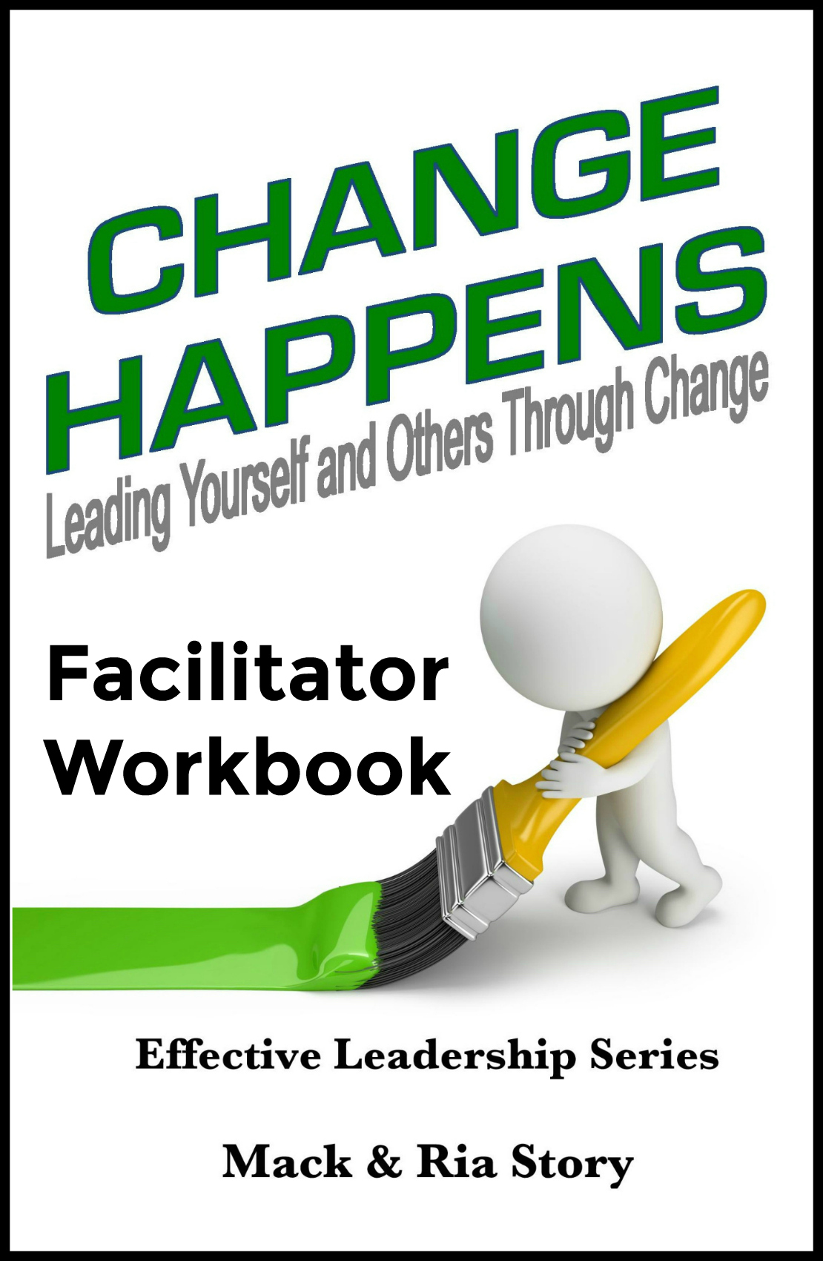
A note from Mack & Ria

Dear friend,
As a leader (person of influence), you have a remarkable responsibility to impact the lives of those around you, personally and professionally. Remember that as you work your way through this material.
We will be partners as we explore the principles related to effectively leading yourself and others through change. We can’t raise the bar for others if we can’t reach it ourselves. As you study and teach, we already know you will reach new levels of knowledge, growth, and understanding. We’re also confident you will motivate and inspire others to also reach higher as they learn to embrace and leverage change.
The values (principles) contained in Change Happens are timeless and have been tested and proven again and again by high impact people across multiple generations around the world. We encourage you to read, study, and familiarize yourself with the ideas in this book in order to prepare to lead others effectively through this information. The key to creating an engaging experience using this content is to teach the principles while supporting them with practices (stories) from your own life. As you teach it, make it your own.
Ultimately, your ability to effectively teach these principles will be based on your ability to effectively apply them in your own life. We’re always teaching what we’re modeling, regardless of what we’re teaching.
We have devoted our lives to helping people make a high impact by making what is common sense also common practice. It is our hope that you will have as much fun as we do while you lead people to a greater understanding of these values that will unleash their true potential. High impact people always have high impact values.
Make it happen or someone else will! It might as well be YOU!
Your friends,
Mack & Ria Story
Mack & Ria Story
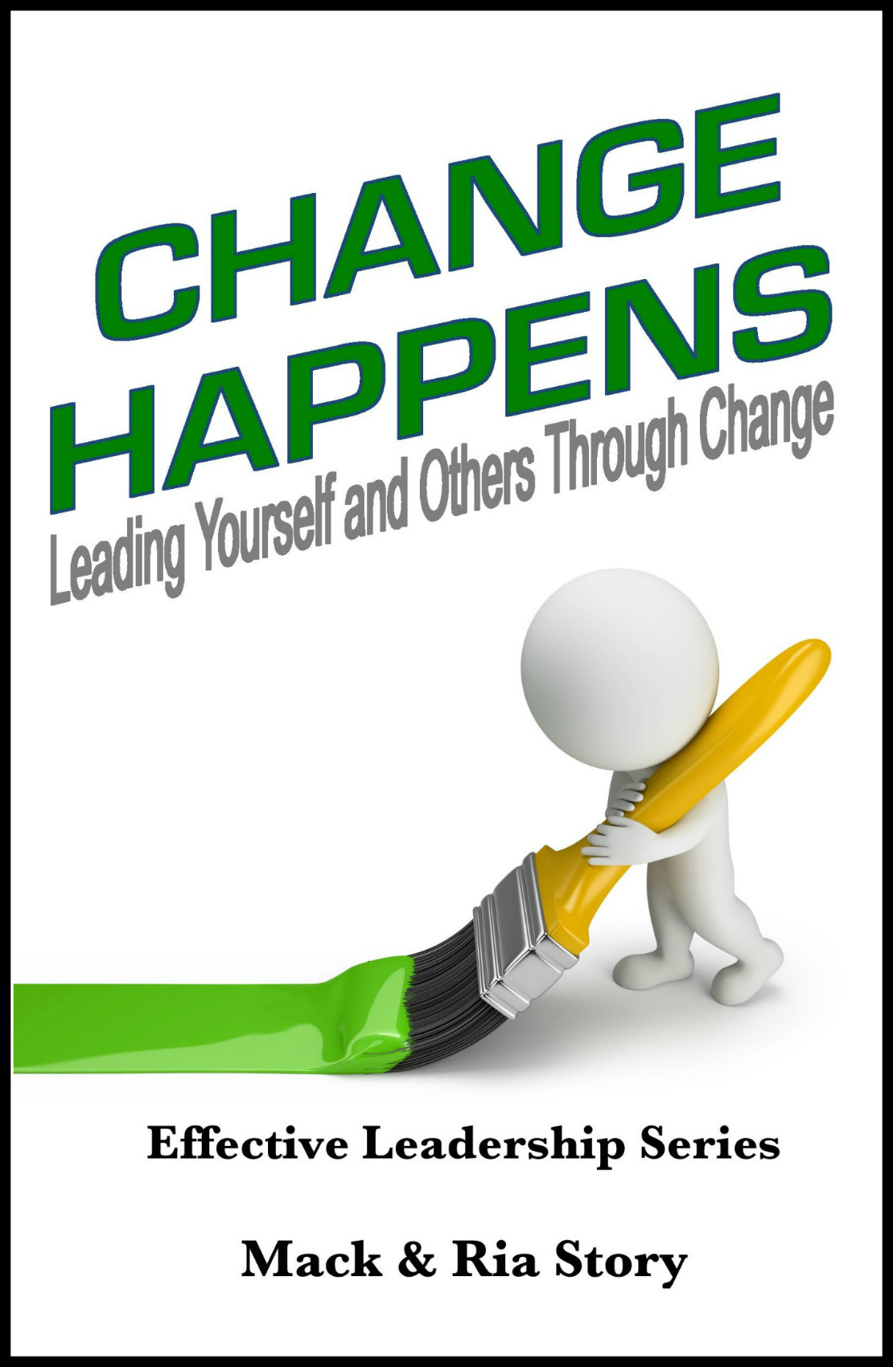
Change Happens
Leading Yourself and Others through Change
by Mack & Ria Story

- Nothing Fails Like Success

“When a challenge in life is met by a response that is equal to it, you have success. But, when the challenge moves to a higher level, the old, once successful response no longer works –
it fails; thus, nothing fails like success.” ~ Stephen R. Covey

  - The problem with success and why it’s often the precursor to downfall is because success often doesn’t teach us anything.
  - Success today is one of the biggest threats of future success.
  - Nothing fails like trying to remain the same in a changing world.
  - What was mastered yesterday may no longer be relevant today.
  - Success often quickly leads to failure.
  - The successful person “has arrived,” and the temptation to enjoy what was earned, to rest, and to coast lurks just around the corner.
  - The risk of complacency rises with each level of success, personally and professionally.
  - To become complacent means we quit striving for improvement, for growth, and for something better.
“You can never get complacent because a loss is always around the corner. It’s in any game that you’re in - a business, game, or whatever - you can’t get complacent.” ~ Venus Williams

- Nothing Fails Like Success (continued)

“The illiterate of the 21st century will not be those who cannot read and write,
but those who cannot learn, unlearn, and relearn.” ~ Alvin Toffler

  - Once we’ve achieved success, most of us no longer want to change. We want to hold our ground and keep things just the way they are.
  - In today’s busy world, everything is constantly changing. People change, processes change, customers change, products change, demand changes, suppliers change, expectations change, and many other things will change. Change happens.
  - When everything is constantly changing, the challenge is also changing.
  - Therefore, the one thing that should also constantly change is: you.
  - If we’re not willing to change, we should expect to be left behind by those who are.
  - When we choose to constantly change to meet new challenges, we have a chance to continue to achieve personal and organizational success.
  - When we refuse to change in response to new and greater challenges, we and the organizations where we work will struggle to survive, and some will end up taking a dive.
  - If you want to intentionally accelerate your climb up the corporate ladder and be recognized as a high impact team player by the high impact leaders in your organization, you must become a master at learning, unlearning, and relearning when change happens.

“If you want to make enemies, try to change something.” ~ Woodrow Wilson

- The Impact of Change

“Change is the law of life. And those who look only to the past or present
are certain to miss the future.” ~ John F. Kennedy

  - The impact of change means the end of something familiar.
  - When change occurs, the predictable, stable situation we have become comfortable with is ending and a new situation is beginning. For most people, that could be, and usually is, considered a negative impact of change.
  - There is also a positive side to the impact of change.
  - Change brings new situations, new experiences, new challenges, and usually new opportunities. That could be, although often isn’t, considered the positive impact of change.
  - While we cannot control every aspect of the situation, we certainly can control how the change impacts us personally.
  - How the change affects us is determined by our attitude and degree of acceptance of the change.
  - The attitude you choose will determine much of what happens in the future.
  - When change impacts us, we become more focused on the negatives of the situation instead of the positives. Often, we spend more time and energy worried about what we don’t know and what we can’t control than we do on looking for the benefits of the change.

“Uncertainty creates the necessary condition for leadership.” ~ Jim Kouzes

- The Impact of Change (continued)
“The secret of change is to focus all your energy, not fighting the old,
but on building the new.” ~ Socrates

  - The impact of change brings out the worst in some and the best in others.
  - When change happens, the first thing people want to know is, “How is this change going to impact me?” Until they know the answer, they’re not interested in anything else.
  - It’s the leader’s responsibility to help others feel safe when change happens.
  - When people are uncertain about the changes happening to them and around them, there’s a tremendous need for leadership.
  - Leaders must help their team members focus on what’s new and move beyond what’s old.
  - When change happens, some people will simply go through the change passively allowing change to happen to them while others will grow through the change actively making change happen around them.
  - Those growing through change will be identified by their leaders as high impact team players who are helping them and other team members effectively deal with change.
  - When change happens, those going through change tend to whine. But, those growing through change tend to shine.

“When we are faced with change, we either step forward into growth,
or we step backward into safety.” ~ Abraham Maslow

- Two Ways to Deal with Change
“You must take personal responsibility.
You cannot change the circumstances, the seasons, or the wind, but
you can change yourself. That is something you have charge of.” ~ Jim Rohn

  - Viktor Frankl said it best, “Between stimulus and response, there is a space. In that space is our power to choose our response. In our response lies our growth and our freedom.”
  - Regardless of the situation we find ourselves in, we have the ability to choose how we respond to it. Even if we cannot change the situation itself, we can choose to change how we look at it and how we respond to it.
  - When we choose to rise above our circumstances or our environment, we find the ultimate freedom in personal growth and development.
  - The proactive person will rise above his or her situation, take personal responsibility, and choose to be proactive by helping things go right.
  - The reactive person will blame anything and anyone else for their circumstances and choose to do nothing. They become part of the problem instead of part of the solution.
  - Being proactive will help you manage your emotions.
  - Being proactive will allow you to stand out among your peers as someone who is a leader or who has leadership potential.
  - Being proactive will help equip you to meet the challenges of change and turn them into opportunities.
“When we are no longer able to change a situation,
we are challenged to change ourselves.” ~ Viktor Frankl
- Two Ways to Deal with Change (continued)

“Being intentional about discovering the hidden ways in which we sabotage ourselves empowers us to expose and eliminate these invisible culprits.” ~ Amir Ghannad

  - When change happens, you can rest assured those responsible for implementing the change are watching you. They want to know several things:
- Are you with them or against them?
- Can they trust you?
- Will you help them? Or, will you hurt them?
  - Are you a modeling high impact leadership? When change happens, do others see you whining or shining?
  - The instant change begins to happen, you begin to increase or decrease your influence with those around you because change puts you in the spotlight. Your peers are watching and your leaders are watching.
  - When the spotlight is on you, the pressure is also on you. How will you respond? Will you be seen hanging with the whiners or rising with the shiners?
  - When change happens, reactive leaders instantly begin to let their feelings be seen and heard. They are the first to complain and are the most outspoken.
  - The more we complain, the less we obtain.
  - Proactive leaders choose to become comfortable being uncomfortable.
  - Proactive leaders positively embrace, leverage, and lead change. They intentionally engage their team by modeling the behavior they expect.
“Human beings, by changing the inner attitudes of their minds,
can change the outer aspects of their lives.” ~ William James
- Resisting Change

“The first step toward change is awareness. The second step is acceptance.”
~ Nathaniel Branden
  - Resistance to change varies from person to person and from situation to situation.
  - What’s interesting is we can recognize this in other people’s lives, but when it comes to our own, sometimes we don’t even realize we are being resistant to change.
  - Often, we resist change because we fear the unknown.
  - Some people choose to resist change and go with a known situation, even if it’s not the best choice.
  - If we are resistant to change for the sake of keeping things the same, we make the mistake of missing out in life.
3 Reasons Some of Us Resist Change:
- It’s not comfortable. Anytime we are changing, we must get outside our comfort zone. We leave behind a comfortable, familiar setting and find ourselves dealing with a lot of unknowns.
- It’s not easy. Anytime we are changing, we must put more energy into the situation. Change requires more energy and effort than the status quo because your mind must unlearn and relearn.
- It requires risk. We don’t mind risking often if the risk is small or low, and we don’t mind risking as much when we stand to gain big. But, we don’t naturally like to take risks if the odds aren’t good, or we stand to lose a lot.
“Your mind creates your results.
If you want to change your results, you first must change your mind.” ~ Mack Story

- Resisting Change (continued)

“Managers change behavior. Leaders change the way you think without you realizing it.”
~ Daniel Burrus

  - Most often, people are resistant to change because they haven’t been taught how to think about and leverage change.
  - If the leader openly resists change, they are more likely to have a team that resists change. When change happens, everyone is watching the leader’s response.
  - John G. Miller was definitely looking in the mirror and intentionally choosing to accept responsibility when he said, “God grant me the serenity to accept the people I cannot change, the courage to change the one I can, and the wisdom to know...it’s me!”
  - When change happens, it’s the leader’s responsibility to insure his/her team is prepared for change.
  - Often, leaders must change how they think in order to model a higher level of thinking and a different level of being for their team.
  - Leaders must understand those who are avoiding and resisting change are toxic to the team and the organization.
  - As a leader, you must determine how much time and energy you are willing to dedicate to help those who are resisting change begin to embrace change.

“Unfortunately, too often people focus on the negatives and lose sight of the multitude of blessings that surround us and the limitless potential that exists for the future.”
~ Sir John Templeton

- Change or Be Changed

“In times of change, learners inherit the earth; while the learned find themselves beautifully equipped to deal with a world that no longer exists.” ~ Eric Hoffer

  - When things change, we can choose to change with them, or we will find ourselves put aside, passed over, or pushed out.
  - When we are put aside and passed over, we may never realize the many opportunities we missed as a result.
  - Once we’re identified as someone who is resistant to change and someone who refuses to change when necessary, our influence decreases as we begin to be consistently overlooked.
  - When we develop a track record of resisting change, we may be terminated, asked to resign, or asked to retire. Often, although not always, this is the direct result of continuously refusing to change and adapt to an ever changing world.
  - Opportunities and promotions may go to those with less experience or seniority simply because they demonstrate the ability and willingness to support and help their leader when change happens.
  - Low impact people reactively go through change.
  - High impact people proactively grow through change.

“Low impact people angrily go through change.
High impact people intentionally grow through change.” ~ Mack Story

- Change or Be Changed (continued)
“Most people won’t pay the immediate price to change
and end up paying the ultimate price for not changing.” ~ John C. Maxwell

  - Leaders should help their team understand they will pay the price of change, or they will pay the price of being changed. Either way, there will be a price to pay.
  - Leaders should help their team understand the price, relative to change within the organization, refers to two main areas:

- Time/Energy – This is a fixed price and must be paid whenever you decide to change. This is the price that must be paid to learn new skills and adapt to the changes.

- Influence – This price is a variable price. Timing is huge in this area. If you lead change and/or accept and embrace change early, you may actually receive a payment with an increase in influence. However, if there’s any delay in accepting, embracing, and supporting the change, you will pay a price by losing influence. You may never know you have lost influence, but it will happen. The longer the delay, the greater the loss.

  - Influence is hard to come by. It’s highly recommend that you maintain what you already have and grow your influence when you can.
  - When a person refuses to accept, embrace, and support change, they may potentially be choosing to self-terminate. They are not being fired because they chose to quit but wanted to stay.
  - Leaders always prefer to change others (help them change) rather than have to change others (terminate/replace them).
  - If the leader can’t effectively lead change, they will be replaced by someone who will.

“Change is the foundation for success.” ~ Mack Story
- If You Snooze, You Will Lose

“Because things are the way they are, things will not stay the way they are.” ~ Bertolt Brecht

  - Regardless of our wishes, change is going to occur in life, at work, and at home.
  - Anytime change is occurring, there are challenges and opportunities.
  - We only hurt ourselves when we attempt to maintain the past while things are changing in the present.
  - Those who are quick to grasp the opportunities will be able to take advantage of them, while those who are resistant to change will decrease their influence.
  - We miss out by refusing to embrace changes when they occur.
  - We must realize we aren’t entitled to the status quo.
  - The first person to respond positively to change has the first chance to stand out as a leader, the first chance to influence others positively, the first chance to have input or help make decisions, and the first chance to take advantages of new opportunities.
  - It’s true. Change isn’t always for the better. It’s also true that if nothing changes, nothing gets better. If everything stays the same, there will be no improvement.

“It’s easier to act your way into a new way of thinking,
than think your way into a new way of acting.” ~ Jerry Sternin

- If You Snooze, You Will Lose (continued)

“Difficulties come to you at the right time to help you grow and move forward
by overcoming them. The only real misfortune, the only real tragedy,
comes when we suffer without learning the lesson.” ~ Emmet Fox

7 Ways You Lose When You Snooze

1) You will have less meaningful, positive influence in every direction. When your influence goes down, so does your value and your options.
2) You will not be asked for input. One way a decrease in influence reveals itself is when your boss and other leaders don’t ask your opinions or let you know what’s going on.
3) You will be passed over for promotions. Why would anyone responsible for leading and implementing change consider promoting someone who is resistant to change?
4) You will be passed over for pay increases. The people who support and embrace change will be rewarded. Those who don’t will get passed over.
5) You will be seen as part of the problem instead of part of the solution. When it comes to change, leaders are constantly discussing who is on board and who is not.
6) You may be demoted. This doesn’t happen too much because if you choose to be a part of the problem, you’re a part of the problem regardless of your position.
7) You may be terminated. The ultimate loss. Not only do you pay the price of your choices, but now those in your family must pay too.

“You can have great academic intelligence and still lack social intelligence.”
~ Hyatt & Gottlieb

- The Challenge of Change

“God grant me the serenity to accept the things I cannot change, the courage to change the things I can, and the wisdom to know the difference.” ~ Reinhold Niebuhr

  - Change is hard even when we want it. It’s especially hard if we don’t want it, or it wasn’t our idea.
  - Change of any kind always brings with it the challenges of adapting to something new.
  - Change requires us to use more of our conscious mind than our subconscious mind. Habits that served us in the past are no longer helpful.
  - The challenge of change comes in consciously having to think about the new reality.
  - We must take action in order to respond to the new reality. It requires extra effort and energy. It won’t happen accidentally.
  - This is difficult when we desire the new reality. It’s much more difficult when we tell ourselves we don’t want the new reality.
  - Change is a challenge because it forces us to cross the gap between knowing and doing.
  - Change requires us to take action and change something on the inside, so we can achieve results on the outside.

“We hear of businesses succeeding or failing, but it is not the business...
it is the people who succeed or fail.” ~ Truett Cathy

- The Challenge of Change (continued)

“Progress is always preceded by change. Change is always preceded by challenge.
Where there is no challenge, there is no change.
It’s the job of the leader to challenge the process.” ~ Andy Stanley

  - If you want a better career and more out of life, change is not an option. It’s required.
  - If you want to continue to get the same results you’re getting today, then you do not have to do anything differently. You’re safe. You will never have to change a thing. Right? Wrong.
  - You may have heard someone say, “If you always do what you’ve always done, you will always get what you’ve always gotten.”
That would be absolutely true if everyone else continued to do what they’ve always done. That would mean we live in a world where nothing changes. But, we know we live in a world where everything is changing. Not only is everything changing, but it’s also changing rapidly.

  - If you always do what you’ve always done, you will get less because those who are changing for the better will get more of everything.
  - Your ability to lead yourself and others through change will determine whether you get a little more out of life or a lot more out of life.
  - You must challenge your own process. The process of how you think about change.
  - Once you begin to challenge how you think and act, you will begin to be challenged in another way. Those who don’t embrace change may stop embracing you and start challenging you.
“Leaders stretch to meet the challenge. Followers shrink away from the challenge.”
~ John Kenneth Galbraith

- The Fear of Change

“Everyone thinks of changing the world, but no one thinks of changing himself.”
~ Leo Tolstoy

  - Fear is what happens when anxiety over something becomes overwhelming.
  - What’s interesting is we often spend a lot of time and energy being afraid of something that may never happen. The vast majority of our fears are completely unfounded.
Here are 3 common fears related to change:
- Fear of the unknown. We generally like to know what’s coming. Most of us don’t like big surprises in areas truly important to us. We worry about what might happen. To overcome fear of the unknown, focus on the facts of the situation, rather than telling yourself a story that may not be true.
- Fear of losing control. Having control means we can get what we want. More control equals more options. We fear situations where we lose control because we have fewer options. To overcome the fear of loss of control, we must focus on what we can control about our situation, instead of what we cannot control.
- Fear of loss. Often, we can’t reach what we need most because we won’t let go of what we want most. When we are fearing a potential loss, we are focused only on the immediate impact. To overcome fear of loss, we must focus on the gains change will bring, instead of the loss.

“May your choices reflect your hopes, not your fears.” ~ Nelson Mandela

- The Fear of Change (continued)

“You’re afraid. So what? Everybody’s afraid. Fear is the common ground of humanity. The question you must wrestle to the ground is, ‘Will I allow my fear to bind me to mediocrity?’”
~ Andy Stanley

  - If you’re going to choose to fear something, don’t fear change. Fear mediocrity.
  - At this moment, you may or may not realize how much the fear of change may be holding you, and possibly your team, back.
  - That little voice in your head is nudging you forward. It constantly plants and waters the seeds of aspiration within you. What is it inside of you that holds you back? What inside of you prevents you from actually climbing to the next level? It’s one thing. And for everyone, it is the same thing. It is fear. It is fear of change.
  - Donovan Weldon, spoke these powerful words, “The only person between you and success is you. MOVE! The only person between you and failure is you. STAND FIRM!”
  - Will you embrace change? Or, will you embrace mediocrity? The choice is yours to make.
  - When you choose to avoid change, you may be choosing to embrace mediocrity.
  - There’s only one person on this earth who can remove the fear barrier and allow you to lead yourself and others to the next level and beyond: You.
“Courage comes with the sun. You can conquer almost any fear if you will only make up your mind to do so. For remember, fear doesn’t exist anywhere except in your mind.”
~ Dale Carnegie

- Embracing Change

“Change before you have to.” ~ Jack Welch

  - Learning to embrace change is much different than learning to tolerate change.
  - Embracing change means you welcome the opportunity to try something new.
Here are 5 ways you can embrace change:
1) Stop and think. Action is the enemy of thought. Slow down. Spend some time thinking. Sit down somewhere quiet. Think about what needs to change and why. Think about what you need to do in order to create that change.
2) Let go of the old. It’s strange how nostalgia makes the past seem better than it was. Don’t spend too much time looking back. Resolve to remember the past, but let it go. Move on to the future. The past wasn’t as good as it seems now. Even if it was, it’s gone.
3) Remove the clutter. Improve your emotional environment by getting rid of the things that aren’t serving you. In times of change, two of the most important things to rid ourselves of is toxic people and toxic habits.
4) Try something new. Read a book by an unfamiliar author – maybe you will gain a new perspective. Meet someone new and listen to their story. Whenever we are facing change, if we can embrace it in small ways, it will become easier to embrace it in big ways.
5) Create a new (good) habit. In times of change, we can feel out of control. The mental discipline of forming a new habit will create momentum and the sense of accomplishment will empower you. Always start with a small habit to ensure you will be successful.

“All meaningful and lasting change starts first in your imagination
and then works its way out.” ~ Albert Einstein

- Embracing Change (continued)

“It really is amazing what happens when you recognize the importance of the opportunities ahead of you, accept responsibility for your future, and take positive action.”
~ Michael F. Sciortino, Sr.

  - When you embrace change, you are also embracing responsibility.
  - When it comes to embracing change, there’s a magic word you can proactively use to begin separating yourself from the crowd in a way that allows you to get noticed by the high impact leaders and promoted for the right reasons. The magic word is “HOW?”
  - When you ask, “How can I?” or “How can we?” instead of “Can I?” or “Can we?” you have started to truly transform the way you and others think. “Can I?” indicates self-doubt. You don’t know if you can. But, when you say “How can I?” you have already decided you will and you can. Therefore, your imagination can run wild in the right direction.
  - “How can I?” indicates there is a way. You just need to discover it. Asking how triggers the proactive muscles in your mind, and you get busy trying to find a way.
Listen to the voices of those proactively embracing change:
- How would a proactive person respond?
- How will I be viewed if I respond positively?
- How can I help others embrace the change?
- How will this benefit me?
- How can I leverage this change to my benefit?
- How will this benefit our team?
- How will this benefit the organization?
- How will this make us more competitive?
- How can I help make it happen?

“If we embrace the chance of living life to the fullest,
then we must be willing to accept responsibility for doing it.” ~ Ria Story
- Leveraging Change

“I cannot say whether things will get better if we change; what I can say is they
must change if they are to get better.” ~ Georg Lichtenburg

  - When you find yourself stressed out over a change, it’s especially important to spend time reflecting on how to leverage it.
  - Leverage (the verb) is defined as “using a quality or advantage to obtain a desired result.”
  - Leveraging something can be a powerful way to gain momentum and accelerate progress.
  - Change always brings opportunities.
  - When we leverage change we not only take advantage of the obvious opportunities, we create new ones as well.
  - Anytime we are experiencing change, we can learn to leverage it by looking for the opportunities. Ask yourself these six questions:
  - What does this change mean for me personally?
  - What areas (social/relational, mental/emotional, physical, or spiritual) of my life does this change impact?
  - How does this affect my environment?
  - What opportunities does this change bring?
  - How can I create more opportunities from this change?
  - How can I leverage this change to make a bigger improvement with this opportunity?
“A sign of wisdom and maturity is when you come to terms with the realization that your decisions cause your rewards and consequences. You are responsible for your life, and your ultimate success depends on the choices you make.” ~ Denis Waitley

- Leveraging Change (continued)
“When others are moaning, groaning, and whining, it’s easy for you to start shining.”
~ Mack Story
Leveraging change means you seek ways to intentionally grow your influence during change.
7 Benefits of Leveraging Change in the Workplace
1) You will be noticed for taking initiative. The first to help always gets the most recognition.
2) You will build strong relationships with the game changers. When you embrace change, you are attracting others who embrace and initiate change.
3) You will get to learn more about how the business operates. As you interact with more game changers, you will build trust. Be sure to ask questions to learn the thought process behind the change.
4) You will have more input in implementing the change. When you get involved with making the change happen, you will be asked your opinion.
5) You will have more input in future changes. As you build relationships with leaders during change, they will begin asking your thoughts about future changes.
6) You will become more valuable. When leaders start to benefit from your support and your ideas for improving the processes and moving the organization forward, you become more valuable to them and the organization.
7) You will be considered for promotions. Those who make an impact helping the leaders implement change will be given more opportunities to make an impact.

“If someone you’re trying to influence doesn’t trust you, you’re not going to get very far; in fact, you might even elicit suspicion because you come across as manipulative.” ~ Amy Cuddy

- Leading Change

“Intelligence is the ability to adapt to change.” ~ Stephen Hawking

  - When we talk about leading change, it’s important to remember the most difficult, and most important, person to lead is oneself.
3 ways to influence and lead change within yourself:
  - What you think about. Leading change with oneself begins by choosing your thoughts carefully. The moment you feel negative about the changes, stop and think about the benefits or positive aspects of the situation. Oprah Winfrey said, “What you focus on expands,” and that’s especially true for situations where you are dealing with change. Focus on the negatives, and they will magnify until they overwhelm you. Focus on the positives, and you will find more of them.
  - What you tell yourself. You are the most important person you will ever talk to. Because, whatever you tell yourself carries far more weight in terms of impact on your mental state. You can talk yourself into or out of just about anything. Embrace change by looking at the situation honestly and evaluating how you are talking to yourself about the change. Are you telling yourself it was better the old way? If so, you will never embrace the changes or lead others through them. Tell yourself you are moving on. Times change, and so should you.
  - What you tell others. It’s almost as if speaking something out loud affirms it and makes it feel true. The more we repeat something to someone else, the more we believe it too – until we know it’s true without a doubt. Your words carry weight. That’s why focusing on the positive is so important.
“Life does not get better by chance. It gets better by change.” ~ Jim Rohn

- Leading Change (continued)

“While one person hesitates because he feels inferior,
another person is making mistakes, and becoming superior.” ~ Henry C. Link

  - Reactive people will forever remain average, and often miserable, as they struggle through life…unless they choose to change.
  - Since leadership is defined as influence, a formal leadership position isn’t required to lead change. You simply need a desire to leverage your influence by applying the principles you’ve been learning.
  - Getting results is the quickest way to build trust.
  - When you can implement change effectively in support of the leaders in a way that helps them accomplish their mission, they will begin to figure out where you can make a bigger impact and how they can better position and utilize you.
  - What are the leaders doing? Exactly what you learned about in the last section, leveraging change.
  - When they can change your role and give you more authority and responsibility for making changes, not only will they and the organization benefit, you will also benefit.
  - Everything you ever achieve will be a direct result of your ability to influence (lead) other people.
“If you force people to change, as a leader, you have no reason to be proud.
Any person with weak character can force and intimidate others into compliance.
The result is resentment not loyalty.” ~ Mack Story

- Communicating Change

“Education is the most powerful weapon which you can use to change the world.”
~ Nelson Mandela

- How and what we choose to communicate about change, either at work or at home, determines if we build trust with everyone around us.
- Being open and transparent in your communication builds trust, while hoarding information about what’s going on creates distrust.
- Even if you don’t have all the answers, it’s important to communicate what you do know.
- When change happens, it’s important to be transparent and communicate the changes, with the right people, at the right time.
- To build trust, let your team know about changes as soon as possible, so they don’t hear about them from someone else first.
- The greater the change, the greater the need for communication.
- Quick and timely communication of accurate information can make or break you when things are changing fast.
- Make communicating about change a priority.
- If your communication efforts don’t meet expectations, neither will you.

“Communicating is one of the critical success skills in life,
but communication during change is even more imperative.” ~ Ria Story

- Communicating Change (continued)

“The most important thing in communication is to hear what isn’t being said.”
~ Peter Drucker
- As a leader (influencer) of change, your #1 goal is to get buy-in from those who will be affected by the change and/or responsible for implementing the change. Without buy-in, everything else becomes much more complicated.
- People always buy-in to the leader before they buy-in to the leader’s vision. You are the key to your own success.
- When you allow others to be involved with making changes on the front end, things go much smoother on the backend.
- One of the most powerful ways to get buy-in is to insure others feel understood before you try to be understood. Let them go first.
- Sharing information with those who will be affected by the change builds trust and increases buy-in by giving them a voice to express concerns and to make suggestions.
- Leaders understand none of us is as smart as all of us. None of us is as creative as all of us. And, none of us has as much experience as all of us.
- Liz Wiseman was on target when she suggested, “The critical skill of this century is not what you hold in your head, but your ability to tap into and access what other people know. The best leaders and the fastest learners know how to harness collective intelligence.”
- Kevin Cashman observed, “Authentic listening is not easy. We hear the words, but rarely do we really slow down to listen and squint with our ears to hear the emotions, fears, and underlying concerns.”

“Take the time it takes, so it takes less time.” ~ Pat Parelli
- Initiating Change

“The pessimist complains about the wind; the optimist expects it to change;
the realist adjusts the sails.” ~ William Arthur Ward

- Initiating change requires a higher level of emotional intelligence.
- Initiating change requires a proactive approach. Initiating change requires you to say “I will” instead of “I wish.”
- Only those who are very proactive will take the initiative to make change happen because they must buy-in to the “why” of the change enough to overcome the resistance that will certainly surface.
- When you initiate change, you take responsibility.
- “Status quo” is a myth anyway – nothing stays the same in life. You are either going forward and making progress or going backward and losing momentum.
- Causing something to improve for the better isn’t easy – but it’s certainly rewarding.
- Small changes can be extremely powerful, especially when compounded over time. As Lao Tzu said, “The journey of a thousand miles begins with a single step.”
- When we initiate change in others, we must be able to help them see and understand the “why,” so we can help them embrace the change.
- The best way you can do that is to ask questions related to the benefits of change.

“Progress is impossible without change, and those
who cannot change their minds cannot change anything.” ~ George Bernard Shaw

- Initiating Change (continued)

“Responsibility and roles are not something that must be handed down; they are taken as one assumes more and more responsibility in the organization.” ~ Jimmy Collins

The most valuable team members intentionally solve problems and improve processes.
3 Levels of Change Initiation:
1) Identify a problem. You take responsibility for identifying problems, but you expect someone else to be responsible for solving them. You’re communicating to the leader you don’t want to take responsibility, and you’re unwilling to think for yourself. In this case, you are part of the problem, not part of the solution. The leader must solve the problem.
2) Identify a problem, and provide a solution. You take responsibility for identifying a solution to an identified problem before you notify the leader. You’re responsible for thinking about a solution before you get the leader involved. The leader learns how you think. You’re simply seeking agreement and approval to implement your change. The leader will notice your desire to take more responsibility. The leader will respect, value, and trust you more.
3) Identify a problem, and solve the problem. Once you’ve earned trust with your leader at level 2, you’re ready to move on to level 3. In this case, you have discovered an opportunity to solve a problem. You have worked alone or with your team, to develop a solution for the problem. You have also implemented the solution and validated it. The problem is solved. When you see the leader, you simply say, “I identified a problem, and this is what I/we did to solve it.” You are now addressing problems and no longer a part of the problem.

“We are anxious to improve our circumstances but unwilling to improve ourselves.
We therefore remain bound.” ~ James Allen

- Become a Change Champion

“Failure is not fatal, but failure to change might be.” ~ John Wooden

In order to become a change champion, you must learn to lead others. Leading others well begins with leading yourself well.

7 Ways to grow your influence in order to become a Change Champion:
- Do more than expected. Go above and beyond, whether it’s at work or at home.
- Do it before it is required. If you know something needs to be done, do it. Don’t wait to be asked or “voluntold” because the first person to step up without being asked will be noticed as a leader long before the person who is asked to comply. Look around for tasks that need to be done.
- Be confident and humble. There is a fine line between confidence and arrogance – it’s called humility. Don’t be afraid to speak up when you know the answer to a question, but also don’t be afraid to admit if you don’t know something.
- Admit mistakes. We all make mistakes. Admit them. Apologize (sincerely) when necessary. Correct them – and move on.
- Volunteer to help others. Those who have a heart for serving others in some way will build influence far beyond those who expect to be served.
- Take more responsibility. When you take responsibility for making something happen, you own the situation. Asking how you can do something allows you to think through a solution, instead of asking if you can do something. Little words – big difference.
- Accept less credit and more blame. Accept more of the blame when things go wrong and share more of the credit with others when things go right.
“Leadership education is not reserved for people with titles. We focus on people who want to take the next step in their leadership journey, no matter what their official title or role is.”
~ Bob Chapman
- Become a Change Champion (continued)

“Leadership is not a license to do less; it is a responsibility to do more.”~ Simon Sinek

- Leadership is about who you are, not what you are or where you sit.
- High impact leaders make the best change champions because they value others, they believe in others, and they build strong relationships with others.
- High impact leaders are constantly changing and investing in their own growth, not only to improve themselves, but also to help improve others.
- Joshua Encarnacion remarked, “We need to change the way we believe in people. We need to move beyond trust, faith, and confidence. We need to shift to encouragement, empowerment, and engagement.”
- Encouraging others when change happens communicates things are going to get better. Encouragement communicates you believe they can make the necessary adjustments, and they have the ability to deal with the changes going on around them.
- Empowering others when change happens gives them a voice regarding the changes and shows your belief in their ability to identify and solve problems. Empowering others allows them to become responsible for implementing the change.
- Engaging others when change happens gets them involved with the process, transfers the responsibility for results to them, and allows them to make a bigger difference.
“Change starts with ‘what is’ and attempts to keep what is working intact and eliminate what is not, transformation simply starts with ‘nothing’ and is led by a vision of the whole as if it were to be created from scratch today. The former views today as an extension of yesterday and tries to make the most of what is. The latter sees today as the beginning of tomorrow and shapes today’s circumstances as a solid foundation for what will be.”
~ Amir Ghannad
- The Courage to Change

“Our deepest fear is not that we are inadequate. Our deepest fear is that we are powerful beyond measure. It is our light not our darkness that most frightens us. We ask ourselves, who am I to be brilliant, gorgeous, talented and fabulous? Actually, who are you not to be?
...Your playing small doesn’t serve the world. There’s nothing enlightened about shrinking so that other people won’t feel insecure around you…And as we let our own light shine, we unconsciously give other people permission to do the same. As we are liberated from our own fear; our presence automatically liberates others.” ~ Marianne Williamson Covey

- If it doesn’t challenge you, it won’t change you.
- Stephen R. Covey said, “There are three constants in life...change, choice, and principles.”
- We all have the potential to do more and be more in life. The problem is, most of us just let life happen rather than living intentionally.
- Proactive people embrace change because they realize in order to get different results, they must do things differently.
- When we embrace the concept of creating the changes we want, we can create the life we want.
- Every one of us are exactly where we should be based on each of the choices we made in the past.
- When you intentionally start improving your thoughts, your thoughts will automatically start improving your life.
“There is no passion to be found in playing small –
in settling for a life that is less than the one you are capable of living.” ~Nelson Mandela

- The Courage to Change (continued)

“There are two types of courage that you need:
First, you need the courage to launch, and to take action, to take a leap of faith.
You need the courage to go ‘all-in’ without any guarantee of success
and with a high possibility of failure, at least in the short-term.
The second type of courage that you need is called ‘courageous patience.’ This is the ability to hang in there and continue working and fighting after you have gone all in and before you have yet seen any results or rewards. Many people can muster up the courage to take action toward a new goal, but when they see no immediate results they quickly lose heart and
pull back to safety and security. They don’t have staying power.” ~ Brian Tracy

- When you change what you do, you change what you get.
- Saying no to something old gives you the freedom to say yes to something new.
- Saying no to the wrong things frees you up to say yes to the right things.
- What you say yes to shapes your future.
- Ask yourself this question constantly, “Will what I’m about to do move me in the right direction?”
- Without the courage to change, you will get left behind by those brave enough to take risks and fail forward toward a better future.
- If you want to get to a new level, you’ve got to change how you invest your time and who you invest it with.
- Courage allows you to transform yourself from who you are today to who you want to become tomorrow. Change what needs to be changed, not what is easy to change.
“Life shrinks or expands in proportion to one’s courage.” ~ Anais Nin

