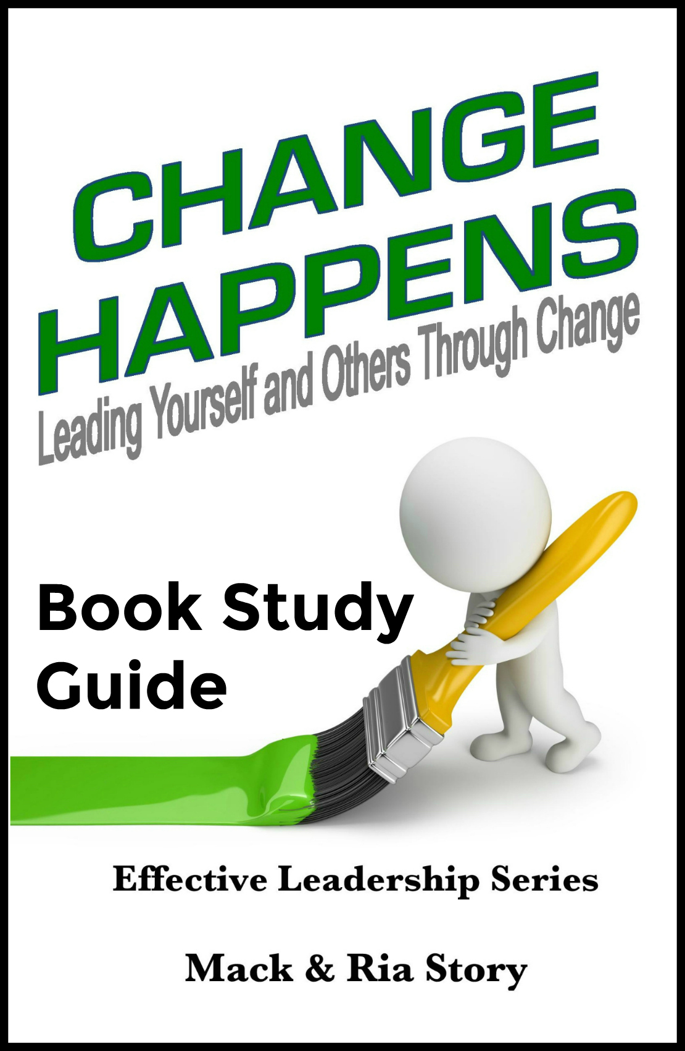
Change Happens:
Leading Yourself and Others through Change
By Mack and Ria Story

“High impact people intentionally
embrace, leverage, and initiate change.” ~ Mack Story

Ch.1: Nothing Fails Like Success

Ria’s Perspective:
- The risk of complacency rises with each level of success, personally and professionally.
  - When have you seen a person fail after achieving success?
  - Why do people rest upon their success? Their education?
  - What’s different about the mindset of those who rest upon their success and those who leverage their success to get to the next level and beyond?
“Intellectual growth should commence at birth and cease only at death.” ~ Albert Einstein

Mack’s Perspective:
- Everything around us is constantly changing and churning at an ever-increasing pace.
  - When change happens, why do some people thrive while others around them take a dive?
  - What’s the difference in being goal-oriented and growth oriented?
  - Describe an area in your life where you are resting upon your success.
“Intentional growth increases your influence and increases your options.” ~ Mack Story

Ch.2: The Impact of Change

Ria’s Perspective:
- When change happens, the predictable, stable situation ends and uncertainty begins.
  - How does change impact negative people?
  - How does change impact positive people?
  - How does the impact of change increase or decrease your influence?
“Change always impacts us. The only question is: How will it impact us?
How we are affected is determined in large part by our attitude.” ~ Ria Story

Mack’s Perspective:
- It’s the leader’s responsibility to help others feel safe when change happens.
  - How can the impact of change be viewed as positive and negative at the same time?
  - What specific things should leaders do to help their team avoid the negative feelings that are caused by the impact of change?
  - How do teams respond when their leaders resist change? When the leaders embrace change?
“The most fundamental success factor is one’s mindset.” ~ Alan Weiss

Ch.3: Two Ways to Deal with Change

Ria’s Perspective:
- Regardless of the situation we find ourselves in, we have the ability to choose how we respond to it.
  - How can two or more people look at the same situation and see it differently?
  - Proactive people respond to change based on values. Explain.
  - Reactive people respond based on feelings. Explain.
“When we are no longer able to change a situation, we are challenged to change ourselves.” ~ Viktor Frankl

Mack’s Perspective:
- The instant change begins to happen, you begin to increase or decrease your influence with those around you because change puts you in the spotlight.
  - When change happens, how can the “spotlight” effect impact your career?
  - When change has happened in the past, how have you seen the “spotlight” effect cause people to be promoted? Demoted? Terminated?
  - Assume two people start working in an entry level position on the same day in the same company. There is constant change. Fast forward 10 years. One has been reactive their entire career. One has been proactive their entire career. What would be different and why? Their position? Their pay? Their future?
“Character is EVERYTHING that determines why you do what you do
and how you do what you do.” ~ Mack Story

Ch.4: Resisting Change

Ria’s Perspective:
- Resistance to change varies from person to person and from situation to situation.
  - Why do we resist some changes and embrace other changes?
  - Read and discuss the quote below. How does it relate to us?
“An infant is learning how to crawl. She begins by pushing herself backward around the house. Backing herself around, she gets lodged beneath the furniture. There she thrashes about, crying and banging her little head against the sides and undersides of the pieces. She is stuck and hates it. So she does the only thing she can think of to get herself out—she pushes even harder, which only worsens her problem. She’s more stuck than ever. If this infant could talk, she would blame the furniture for her troubles. After all, she is doing everything she can think of. The problem couldn’t be hers. But of course the problem is hers, even though she can’t see it. While it’s true that she’s doing everything she can think of, the problem is precisely that she can’t see how she’s the problem. Having the problem she has,
nothing she can think of will be a solution.” ~ The Arbinger Institute

Mack’s Perspective:
- Most often, people are resistant to change because they haven’t been taught why and how they should proactively think their way through change.
  - When you resist change, what are you communicating to the leaders?
  - What are some things you can do to improve the way you view change?
  - What are some things leaders can do to help their teams embrace change?
“If we succeed, it will not be because of what we have, but it will be because of what we are; not because of what we own, but rather because of what we believe.” ~ Lyndon B. Johnson

Ch.5: Change or Be Changed

Ria’s Perspective:
- When change happens, we get to choose our actions, but not the consequences that flow from our actions.
  - If we are asked to change, but we refuse to change, what are the natural consequences? At work? At home?
  - When you initiate change, how do you feel about those who resist you? Why?
  - When you initiate change, how do you feel about those who support you? Why?
“People grow according to the demands they make on themselves.” ~ Peter Drucker

Mack’s Perspective:
- When change happens, there is always a price to pay.
  - What does “Change or Be Changed” mean?
  - When we hear, “We can pay the price for change, or we will pay the higher price for not changing?” what does this mean relative to change at work? At home?
  - Share stories about the price others have paid when they didn’t change. Were they the only ones who paid the price? Did their family pay too? If so, how?
“It’s always easier to dismiss a person than to train him.
No great leader ever built a reputation of firing people.” ~ Truett Cathy

Ch.6: If You Snooze, You Will Lose

Ria’s Perspective:
- Those who are quick to grasp new opportunities will be able to take advantage of them, while those who are resistant are likely to miss out.
  - When have you seen someone miss a new opportunity because they waited too long to act?
  - When change happens, what causes some to act quickly and others too act slowly or not to act at all?
  - What are some of the advantages to being the first to act when change happens? Disadvantages of hesitating?
“While one person hesitates because he feels inferior,
another person is making mistakes, and becoming superior.” ~ Henry C. Link

Mack’s Perspective:
- High impact leaders quickly observe, adapt, and move forward when change happens.
  - When change happens, what character traits determine if leaders act quickly or slowly?
  - What happens to organizations when leaders don’t respond quickly to changes in their market? What are some causes of the delay?
  - What happens to the employees when organizations snooze and lose?
“If we’re not willing to change, we should expect to be left behind by those who are.”
~ Mack Story

Ch.7: The Challenge of Change

Ria’s Perspective:
- Change is often hard when we want it. And, it’s always harder if we don’t want it or if it wasn’t our idea.
  - What are some of the challenges of change? At work? At home?
  - How do habits impact our desire to change? Why?
  - What causes some people to choose suffering over changing?
There’s a story about a dog that sat on a porch and continually moaned and groaned. A man walking by asked the people on the porch why the dog was acting this way. They answered, “Because he’s lying on a nail.” The passerby asked, “Well, why doesn’t he get off the nail?” They responded, “Because it’s not hurting bad enough.” Unfortunately, many of
us are like the dog. We would rather suffer than change.

Mack’s Perspective:
- Without change, there can be no improvement.
  - What is something you need to stop doing? What’s stopping you?
  - What is something you need to start doing? What’s stopping you?
  - Why do leaders struggle to implement change?
“Progress is always preceded by change. Change is always preceded by challenge. Where there is no challenge, there is no change. It’s the job of the leader to challenge the process.”
~ Andy Stanley

Ch.8: The Fear of Change

Ria’s Perspective:
- We often spend a lot of time and energy being afraid of something that may never happen.
  - What types of stories do we tell ourselves that cause us to fear change?
  - When have you seen people cause themselves to stress over things that never happened when things were changing at work? At home?
  - Does your personal fear exist anywhere other than your mind? Explain. What does this mean?
“Fear of the unknown is what keeps us in the bondage of settling
for less than we were created for.” ~ Tom Telesco

Mack’s Perspective:
- If you’re going to choose to fear something, don’t fear change. Fear mediocrity.
  - How can the fear of change keep you from becoming exceptional?
  - When people are afraid of change, what is typically the root cause?
  - How does associating with those who fear change influence your opinion about change? Do their opinions and thoughts determine you or influence you? Why?
“In life, when you don’t have enough courage and insight to know you have outgrown
a situation, and it is time to move on, life will move on you.” ~ Marion White

Ch.9: Embracing Change

Ria’s Perspective:
- Learning to welcome change is quite different than learning to tolerate change.
  - Describe a scenario where change has happened and compare the behavior of someone who tolerated change with the behavior of someone who welcomed change. What was the difference?
  - How will embracing change give you a voice relative to future changes?
  - Share a story about a time when change happened, and you saw someone embrace change while others were actively resisting change. What was the outcome? How was the person embracing change viewed by the others?
“When we are trying to stay motivated through the discomfort of changing ourselves, learning something new, or breaking a bad habit, it’s much easier to stay motivated
when we’re hating the problem instead of loving the solution.” ~ Ria Story

Mack’s Perspective:
- When you embrace change, you are also embracing responsibility. When you embrace responsibility, you are being proactive.
  - How can the choice to embrace change increase a person’s value internally to their organization? Externally to other organizations?
  - How would a responsible person embracing change be viewed by those leading change? How would an irresponsible person resisting change be viewed?
  - How did embracing change in the past lead you to where you are today? How did resisting change in the past slow or prevent you from climbing to the next level?
“The man who will use his skill and constructive imagination to see how much he can give for a dollar, instead of how little he can give for a dollar, is bound to succeed.” ~ Henry Ford
Ch.10: Leveraging Change
Ria’s Perspective:
- When we leverage change, we not only take advantage of the obvious opportunities, we create new ones as well.
  - Discuss recent changes and how they could have, and maybe should have, been leveraged to benefit those who were impacted by the change.
  - How can reflecting on the change before reacting to the change help you more intentionally leverage it for a future benefit?
  - Explain why a bigger change can be leveraged for greater benefit than a smaller change.
“Knowledge has no value except that which can be gained from its
application toward some worthy end.” ~ Napoleon Hill

Mack’s Perspective:
- When you leverage change, you will seek ways to intentionally grow your influence during the change.
  - Discuss specific ways leaders can leverage change.
  - Discuss specific ways followers can leverage change.
  - Discuss the mindset of a person who leverages change. What’s different?
“A sign of wisdom and maturity is when you come to terms with the realization that your decisions cause your rewards and consequences. You are responsible for your life,
and your ultimate success depends on the choices you make.” ~ Denis Waitley

Ch.11: Leading Change

Ria’s Perspective:
- When think about leading change, it’s important to remember the most difficult, and most important, person to lead is oneself.
  - Discuss the definition of leadership. Discuss the definition of a leader.
  - Discuss the definition of a follower. What causes someone to follow another?
  - How does a person become a high impact leader? A high impact follower?
“Leadership. It’s one of the most misunderstood words in the professional world,
and perhaps in the personal development world.” ~ Ria Story

Mack’s Perspective:
- Anyone at any level at any time can choose to lead change. Leading change is about character and competency, not position and title.
  - Discuss how anyone at any level can effectively lead change.
  - What specific things should leaders do to create buy-in before change happens?
  - When change is wrapped in secrecy by a leader, how does it impact their followers? If it’s wrapped in transparency?
“Some leaders feel that by keeping their people in the dark, they maintain a measure of control. But that is a leader’s folly and an organization’s failure. Secrecy spawns isolation, not success. Knowledge is power, yes, but what leaders need is collective power,
and that requires collective knowledge.” ~ Captain D. Michael Abrashoff

Ch.12: Communicating Change

Ria’s Perspective:
- Communicating is one of the critical success skills in life, but communication and connection during change is even more imperative.
  - What is the difference between communicating with people and connecting with people? Provide examples to illustrate the difference.
  - What are the character traits of great communicators? What are the character traits of great connectors?
  - Discuss why communication is necessary before, during, and after change. Discuss why connection is necessary before, during, and after change.
“Communication is about information. Connection is about transformation.” ~ Mack Story

Mack’s Perspective:
- People always buy-in to the leader before they buy-in to the leader’s vision. Until followers embrace and support their leader, they are not as likely to embrace and support the changes the leader makes.
  - How does communication and connection affect the relationship between leaders and followers? Short term? Long term?
  - How can a leader improve their ability to communicate?
  - How can a leader improve their ability to connect?
“The most important thing in communication is to hear what isn’t being said.”
~ Peter Drucker
Ch.13: Initiating Change

Ria’s Perspective:
- Initiating change requires a proactive approach. Initiating change requires you to say “I will.” instead of “I wish.”
  - When people know “why” a change is happening, are they more likely or less likely to embrace the change? Why is this?
  - When people don’t know “why” a change is happening, are they more likely or less likely to embrace the change? Why is this?
  - Discuss how the quote below relates to initiating change.
“The pessimist complains about the wind; the optimist expects it to change;
the realist adjusts the sails.” ~ William Arthur Ward

Mack’s Perspective:
- Leaders take responsibility and do what needs to be done because it needs to be done, not because it’s their job to get it done.
  - Are people who initiate positive change more valuable to their leader? Why?
  - Are people who initiate positive change more valuable to their organization? Why?
  - How does initiating positive change result in a person simultaneously leveraging change?
“Every time I see someone that says, ‘I have a weak leader,’ I always say, ‘Lucky you!’
Take advantage of that. LEAD!” ~ Jocko Willink

Ch.14: Becoming a Change Champion

Ria’s Perspective:
- Highly successful people realize they must become a change champion – seeking change and helping others do the same.
  - Explain the impact of trust on your ability to initiate and lead change.
  - When it comes to leading change, what are some ways leaders can intentionally build trust? What are some ways they accidentally create distrust?
  - What type of person becomes a change agent? How does becoming a change agent impact a person’s professional life? Their personal life?
“Trust is the foundation of influence.” ~ Mack Story
Mack’s Perspective:
- High impact leaders make the best change champions because they value others, they believe in others, and they build strong relationships with others.
  - If you were the official “Change Champion” at your workplace, what is the first thing you would change? Why?
  - How would who you are (character) influence others to embrace this specific change before you introduced the change? During the change?
  - If leaders trained and developed their team on how to deal with, think about, and leverage change, what would change? Why?
“Being a fruitful person, the kind of person who actually changes the world around you, means that you sometimes intentionally enter negative situations
and work hard to transform them.” ~ Henry Cloud

Ch.15: The Courage to Change

Ria’s Perspective:
- We all have the potential to do more and be more in life. The problem is, most of us just let life happen rather than living intentionally.
  - What role does courage play when it comes to leading change? Professionally? Personally?
  - What are you doing, beyond what is required, to grow yourself intentionally? What should could you be doing? What should you be doing?
  - Is courage a choice? Why or why not?
“Courage in a leader inspires commitment from followers.” ~ John C. Maxwell

Mack’s Perspective:
- Without the courage to change, you will get left behind by those brave enough to take risks and fail their way to a better future.
  - When have you seen a lack of courage hold someone back? Professionally? Personally?
  - How does our own self-talk decrease courage? Increase courage?
  - How can we intentionally develop the courage to change? Professionally? Personally?
“Life shrinks or expands in proportion to one’s courage.” ~ Anais Nin

