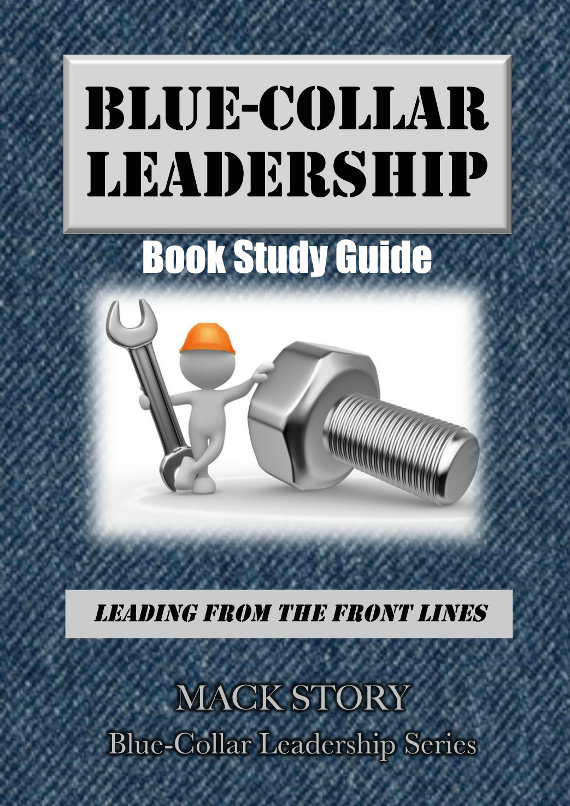Blue-Collar Leadership:
Leading from the Front Lines
By Mack Story

“A few start at the top, but most of us start at the bottom.”
~ Mack Story

Ch.1: I’m one of you. Who we are matters.

- I hope you feel encouraged, empowered, and engaged to make a bigger difference in your own life and those around you.
  - What is one thing you can do tomorrow, something you’re not already doing, to make a bigger difference?
  - Why haven’t you done it already?
  - When will you do it?
“A year from now, you will wish you had started today.” ~ Karen Lamb

Ch.2: I believe in you. Motivation comes from the outside, but inspiration comes from the inside.

- If you want things to change, you must change the way you think.
  - Are you a victim of your own lack of awareness?
  - How would you know?
  - How can you change the way you think?
“We already live with many scripts that have been handed to us, the process of writing our own script is actually more a process of ‘rescripting,’ … As we recognize the ineffective scripts within us, we can proactively begin to rescript ourselves.” ~ Dr. Stephen R. Covey

Ch.3: You’re in the perfect place. You’re exactly where you’re supposed to be but not where you have to be.

- Most of the time people quit growing and going when the price gets too high.
  - What can you do to increase your influence where you are now?
  - What would the price be?
  - What would the benefit be if you chose to pay the price?
“If we refuse to become a leader because we don’t believe we can get to the top, we are limiting ourselves from reaching our potential; and we are limiting
the impact we can have on others.” ~ Ria Story
Ch.4: Common sense is never enough. Common sense means we understand what should be done, but actually doing it often requires
uncommon sense.
- To know something and not do it is not truly knowing it. To understand something and not apply it is not truly understanding it.
  - What do you already know you should be doing that you aren’t already doing?
  - What would change if you started doing it?
  - What’s truly stopping you from doing it?
“You can't climb the ladder of success with your hands in your pockets.” ~ Unknown

Ch.5: There is an “I” in team. Every team is made of “I”ndividuals.

- You are the key to your success. You must believe in yourself.
  - What are you doing beyond what is required?
  - How can you serve your team better?
  - How would your team answer that question?
“The byproduct of growth and development is belief and confidence.
The byproduct of belief and confidence is success.” ~ Mack Story

Ch.6: Be better tomorrow. When you become more valuable, you will become more successful.

- There’s nothing more important to your future than doing something every day to be better tomorrow than you are today.
  - Who are you? Who do you want to become? Does it matter? Does it show?
  - Where are you? Where do you want to be? Do you care? Does it show?
  - What will change if you truly become more valuable?
“There are two types of people who never achieve very much in their lifetimes. One is the person who won't do what he or she is told to do, and the other one is the person who does no more than he or she is told to do.” ~ Andrew Carnegie

“The key to moving beyond average is doing what exceptional people do, not wanting what they have.”
~ Mack Story

Ch.7: The secret to your success. You get paid by others, but you work for yourself.

- You are in business for yourself because you are working for yourself. Your product is physical labor mixed with shared ideas.
  - What type of word of mouth advertising do you get?
  - How do you serve your #1 customer?
  - How do you serve your potential customers?
“Wise choices in the beginning provide a better chance of success in the end.”
~ Dee Ann Turner

Ch.8: Someone is always watching. You are always teaching what you’re modeling, regardless of what you are teaching.

- You are a role model whether you want to be one or not.
  - Do your actions match your words?
  - When change happens, what do people see you do? Embrace it or resist it?
  - Do you lead like you want to be led?
“Nothing is more confusing than people who give good advice, but set a bad example.”
~ Norman Vincent Peale

“Nothing is more convincing than people who give good advice and set a good example.”
~ John C. Maxwell

Ch.9: Your potential is unlimited. You should always be grateful, but never satisfied.

- The way you see the world has a lot to do with how the world sees you.
  - Do you see roadblocks or opportunities?
  - Do you tend to blame others or help others?
  - Do you focus on getting what you want or on helping others get what they want?
“If you truly want to initiate a change that will redirect your life
and unleash your potential, focus on transforming yourself.”
~ Mack Story
Ch.10: Focus on the mirror. The face you see least is your own.
- We don't know about ourselves what we need to know about ourselves.
  - When is the last time you asked for honest feedback on your character?
  - Do you tend to take responsibility or transfer the blame?
  - Are you willing to change what needs to be changed?
“A man’s environment is a merciless mirror of him as a human being.” ~ Earl Nightingale

Ch.11: The power of the pause button. What happens to you is important, but your response to what happens to you is most important.

- We cannot always control what happens to us, but we can always control our response to what happens to us.
  - Do you tend to respond based on feelings or values?
  - How often do you say someone or something made you mad?
  - How often do you raise your voice or show strong emotions?
“Self-mastery is the hardest job you will ever tackle. If you do not conquer self, you will be conquered by self. You may see at the same time both your best friend and your worst enemy, by simply stepping in front of the mirror.” ~ Napoleon Hill

Ch.12: The future is in you now. If you don’t choose your future, someone else will.

“May your choices reflect your hopes, not your fears.” ~ Nelson Mandela

- Your future is defined and refined by the choices you make every day.
  - What do you need to stop doing? What happens if you don’t stop?
  - What do you need to keep doing? What happens if you stop doing it?
  - What do you need to start doing? What happens if you do start?
“We are anxious to improve our circumstances but unwilling to improve ourselves.
We therefore remain bound.” ~ James Allen
“Life shrinks or expands in proportion to one’s courage.”
~ Anais Nin

Ch.13: Courage is contagious. Courage allows average people to achieve exceptional results.

- It takes courage to do the right things at the right time for the right reasons while those around you are constantly trying to get you to do the wrong things for the wrong reasons.

  - Do you have the courage to stand alone? What does your behavior say?
  - Where in your life is lack of courage holding you back?
  - What would change if you had more courage?
“While one person hesitates because he feels inferior,
another person is making mistakes, and becoming superior.” ~ Henry C. Link

Ch.14: You attract who you are. Those who like you the most are the most like you.

- We become the average of the five people we voluntarily hang around the most.
  - What is the true character of the five people you associate with?
  - How are you influenced by them?
  - Where are they headed? Forward? Backward? Are they stuck?
“One of the most expensive things you could ever do is pay attention to the wrong people.”
~ Dr. Henry Cloud

Ch.15: Character counts. Who you are on the inside is what others see on the outside.

“Character is like a tree and reputation like a shadow.
The shadow is what we think of it; the tree is the real thing.” ~ Abraham Lincoln

- You may have noticed nearly all new team members start out strong.
  - What happens to them over time? Why?
  - How does the leader’s ability to lead help or hurt?
  - Do you blame others for your behavior? Should you?
“You can manage without a strong, well-developed character. However, you will never be a high impact leader without strong, well-developed character.” ~ Mack Story
Ch.16: Character trumps competency. Who you are matters more than what you know.

- You have far more than you need to succeed on the outside because it’s provided for you. The question is do you have what you need to succeed on the inside?

  - How do you deal with things that don’t go your way? Why?
  - Do you embrace change or resist change? Why?
  - Do you do what you say you will do?
“We hear of businesses succeeding or failing, but it is not the business ...
It is the people who succeed or fail.” ~ S. Truett Cathy

Ch.17: Leaders have followers. The difference between a leader and a boss is what they value.

- Do you want to be a boss or a leader? Bosses value position and power over others (formal authority). Leaders value positive influence with others (moral authority).

  - Do you like having authority? What does your answer mean?
  - Do you have a problem getting people to do what you say?
  - Do those on your team do more than they have to do?
“When people perform poorly, most leaders are quick to blame them,
perhaps even fire them right away. It takes introspection and humility to admit,
‘That might be a consequence of my poor leadership.’” ~ Bob Chapman

Ch.18: Positions are overrated. If you can’t lead without a position, you won’t lead with a position.

- You will always have more options when you can lead (influence) people without a position.

  - Why would anyone need a position in order to lead others?
  - What character traits do you have that influence people to follow you?
  - What character traits do you have that influence people not to follow you?
“It’s a lot easier to be given a position by your boss because you can manage well than it is to earn respect from your team because you can lead well.” ~ Mack Story

“High impact leaders don't need a position or authority to make something happen.
They only need a team.” ~ Mack Story
“To excel in leadership, you must first master followership.” ~ S. Truett Cathy

Ch.19: Followers choose leaders. All great leaders were first great followers.

- People can be following and leading at the same time.

  - How can someone be leading and following at the same time?
  - How can following increase your influence?
  - Why would you follow someone weaker than yourself?
“A low level follower does less than is expected alone.
A high impact follower does more than is expected with others.” ~ Mack Story

Ch.20: Seek first to understand. You will always learn more from listening than speaking.

- When it comes to influence, one of the best ways to influence another person is to first be influenced by the other person.

  - Why does allowing someone to influence you increase your influence with them?
  - How do you feel when others value your opinion? Why?
  - What happens when you ask someone a question?
“You can win more friends with your ears than with your mouth. People who feel like they’re being listened to feel accepted and appreciated. They feel like they’re being
taken seriously and what they say really matters.” ~ Harvey Mackay

Ch.21: Think of yourself less. There’s a fine line between arrogance and confidence; it’s called humility.

- If you come across as arrogant, you present a me attitude. If you come across as confident, you present a we attitude.

  - Describe the behavior of an arrogant person. Do they build trust or distrust?
  - Describe the behavior of a confident person. Do they build trust or distrust?
  - Which would have the most influence with others? Why?
“Leaders with confidence help people.
Leaders with ego hurt people because they use and abuse other people.” ~ John C. Maxwell
Ch.22: Ask for more responsibility. When you accept more responsibility, you will gain more influence.

- The quickest way to increase your influence with the boss is to get results.

  - Does your boss ever have to ask you to do the same thing repeatedly? Why?
  - What would change if you chose to do what the boss doesn’t like doing?
  - How can you make the boss a better leader?
“It really is amazing what happens when you recognize the importance of the opportunities ahead of you, accept responsibility for your future, and take positive action.”
~ Michael F. Sciortino, Sr.

Ch.23: There is enough for everyone. Helping others succeed ensures you will succeed.

- Insecure people have what’s called a scarcity mindset. Scarcity minded people tend to blame others when they don’t get what they want.

  - What happens to someone’s influence when they hoard knowledge?
  - If there is truly enough of everything for everyone, what’s stopping you from having what you want?
  - How do you feel about people who help you achieve more? Why?
“Abundance is not something we acquire. It is something we tune into.” ~ Dr. Wayne Dyer

Ch.24: Be the first to help. Everyone remembers the first to help; few remember the second.

- People may not always remember what you said or what you did, but they will always remember how you made them feel.

  - How do you respond when your leader makes you feel good?
  - How do you respond when your leader makes you feel bad?
  - What happens to productivity when you feel bad? When you feel good?
“The fine line between helping people and hurting people is valuing people.”
~ John C. Maxwell
“Never mistake effort and intentions for results.”
~ Dick Vermeil

Ch.25: Do more than expected. Doing more increases your influence; doing less decreases your influence

- Too many people wait to be told what to do while often complaining about not liking to be told what to do.
  - How does it make you feel when someone does more than expected? Why?
  - How can you begin to do more than is expected? Why haven’t you done it already?
  - Who will have a brighter future? Those doing more or less than expected? Why?
“If you are willing to do more than you are paid to do,
eventually you will be paid to do more than you do.” ~ Anonymous

Ch.26: Do it sooner than expected. Doing it sooner increases your influence; doing it later decreases your influence.

- Making it happen is great, but making it happen sooner than expected can pay huge in the influence department.
  - How does it make you feel when someone does something sooner than expected?
  - What is it about people that causes them to over deliver?
  - Do you trust those who do things sooner than expected more than those who do things later than expected? What’s the impact on the relationship?
“The wise does at once what the fool does at last.” ~ Jewish Proverb

Ch.27: Do it better than expected. Doing it better increases your influence; doing it worse decreases your influence.

- When you pay attention to the details and go above and beyond expectations, people pay attention to you.
  - If you were choosing a team to work with, would you choose those who do things better than expected or worse than expected? Why?
  - What message does doing a better than expected job communicate?
  - What causes some to do a better job than others?
“When you do the common things in life in an uncommon way,
you will command the attention of the world.” ~ George Washington Carver
Ch.28: Stretch yourself intentionally. All of your growth happens outside your comfort zone.

- You can choose your actions but not the consequences that flow from those actions.
  - What are you doing beyond what is required to stretch yourself?
  - How do you feel when others try to stretch you? Why?
  - When you stretch yourself intentionally and consistently, what message does that send to others? Why?
“If you work hard on your job you can make a living,
but if you work hard on yourself you can make a fortune.” ~ Jim Rohn

Ch.29: Develop yourself intentionally. If you won’t invest in yourself, why should anyone else?

- Until you develop a plan and act on that plan, you will be exactly where you are today with the exception of accidental, incremental growth along the way.
  - What does your intentional development plant look like at this moment?
  - What’s the advantage of personal development?
  - What would change if you were more intentional about your personal growth?
“Accidental growth vs. intentional growth is about as effective as accidental exercise compared to intentional exercise....not even close. And the results....not even close.”
~ Mack Story

Ch.30: You must bet on yourself. If you won’t bet on yourself, why should anyone else?

- As long as you’re willing to continue paying the price, you will continue creating more options and building more relationships.
  - Do you truly believe in yourself? What does your behavior reveal?
  - If you bet on yourself today, would you win or lose? Why?
  - What is it about you that has you brought you to the place you are today? What must change inside of you to take you to the place you want to be? When will it happen?
“Living intentionally leads to amazing results.
Living accidentally leads to depressing disappointments.
A better tomorrow won’t just happen.
You must be intentional and make it happen.” ~ Mack Story

